MEPS Long Lead Items List

Prepared by: | Mahesh Yedla | Date: | 31/07/2026
Checked by: | Cesar Martin | Date: | 31/07/2026
Approved by: | Cesar Martin | Date: | 31/07/2026
Authorised by: | Cesar Martin | Date: | 31/07/2026

CONTENTS
1. Introduction 3
1.1 Overview 3
1.2 Purpose and Scope 7
1.3 Documents 7
2. requirements 8
3. Long Lead ITEM Approach 9
3.1 Objective 9
3.2 LLI Definition 9
3.3 Calculation of Long Lead Items for EEE Parts 9

TABLES

Table 1-1: Proposed MEPS instrument heritage of MEPS from EPT Solar Orbiter Technical Parameters 4
Table 2-4: Long Lead Items 11

FIGURES

Figure 1-1: MEPS single unit CAD-study with two sensor heads, each of which has two double-ended telescopes. One MEPS unit provides eight view cones in total, four for electrons and four for ions 3
Figure 1-2: Boards on the electronics module 4
Figure 1-3: MEPS sensor head 5
Figure 1-4: MEPS Block diagram 6
Figure 1-5: MEPS instrument function block diagram 6

Introduction

Overview
The MEPS instrument is a particle instrument measuring the energy spectra and angular distributions of energetic electrons (30-600 keV) and ions (30-6000 keV/nuc). The full experiment consists of one unit which provides a double-ended telescope pairs (sensor heads) with four view cones per pair, two dedicated for electrons and two for ions. Utilizing any spin of the spacecraft, MEPS observations cover the full sky with a total of eight electron and eight ion view cones. As the L5 S/C is not a spinner, MEPS still provides crucial pitch-angle information to determine whether the event is scatter free. This is an important indicator for interpreting the timing information of the space weather event. Figure 1-1 shows the MEPS unit, with eight view cones.

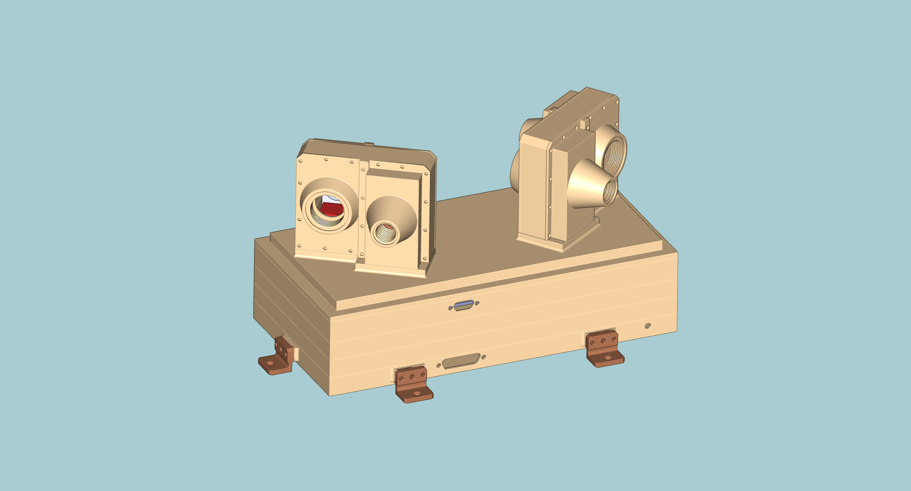
Figure 1-1: MEPS single unit CAD-study with two sensor heads, each of which has two double-ended telescopes. One MEPS unit provides eight view cones in total, four for electrons and four for ions

Units: 1
Sensors: 2 per unit
FoVs: 4 double FoVs per unit. The FOVs for each sensor are separated by 70°
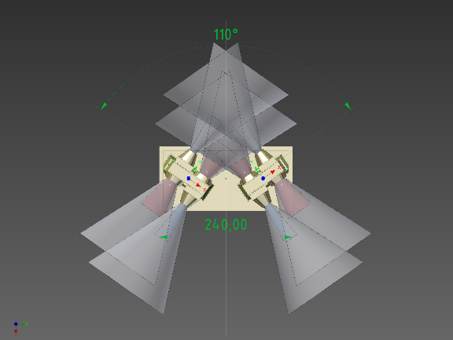

Angular resolution: 45° full angle
Energy range:
- 30keV/n-6MeV/n for the 20-300-300 um detector stack solution
Volume: 300x160x175 mm3 (including potential radiators and MLI)
Power: 5W for 1 unit
Mass: 2.4 kg for 1 unit
Data Products: Particle VDF
Cadence: 5(1) minutes
TRL: 6 (most parts 8-9)
Table 1-1: Proposed MEPS instrument heritage of MEPS from EPT Solar Orbiter Technical Parameters

One unit MEPS consists of mainly three subassemblies, a CAD screenshot is shown in Figure 1-2
- Electronics module containing the power, analog-digital and preamplifier boards.
- MEPS-A sensor
- MEPS-B sensor
CAD screenshots of MEPS unit as well as all subassemblies are shown in Figure 1-2 and Figure 1-3.

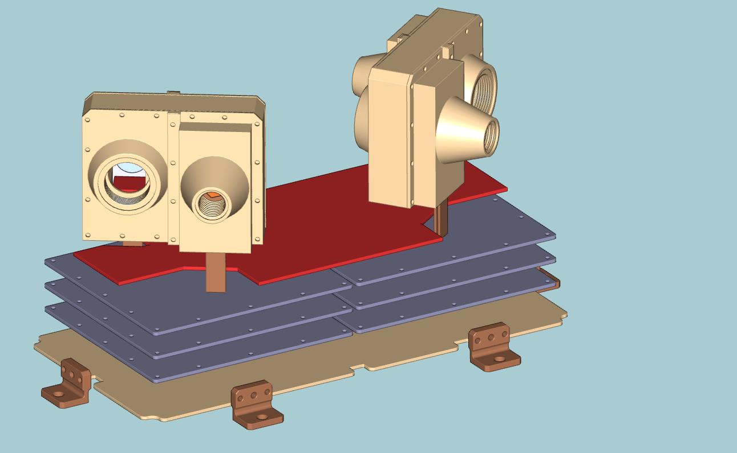
Figure 1-2: Boards on the electronics module

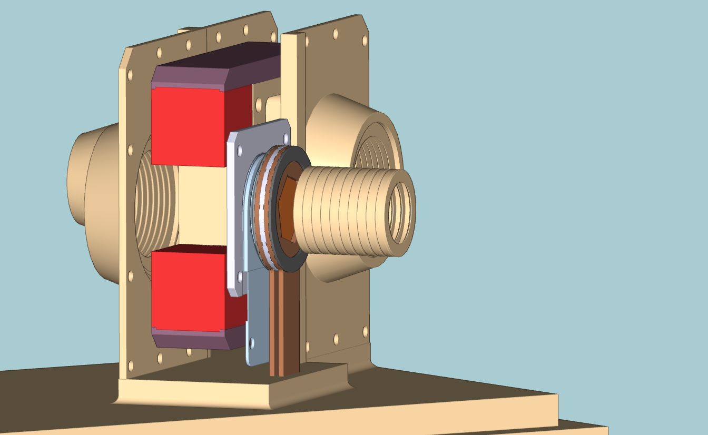
Figure 1-3: MEPS sensor head

All boxes are made of AL-6061 T6. The IF plate is bolted to the Lagrange S/C deck by means of four screws (TBC).

A block diagram of the MEPS electronics is shown in Figure 1-4. MEPS electronics has four boards:

- Preamplifier board
  - Charge Sensitive Preamplifiers for the detector signals
- Analog board
  - Shaping the signals from the preamps and convert to digital ADC values
  - The FPGA on this board detects the peak of the shaper signals
  - Builds the PHA data
  - Contains the housekeeping ADC
- Digital board
  - Builds the data products
  - Manage the communications with the DPU
- Low Voltage Power Supply (LVPS) board
  - Supply different voltages to the different boards.

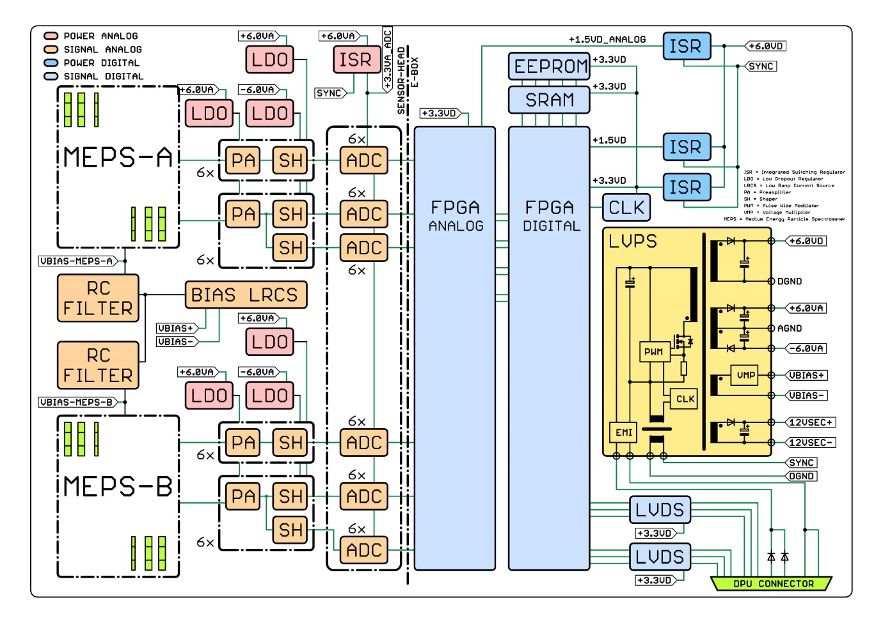
Figure 1-4: MEPS Block diagram

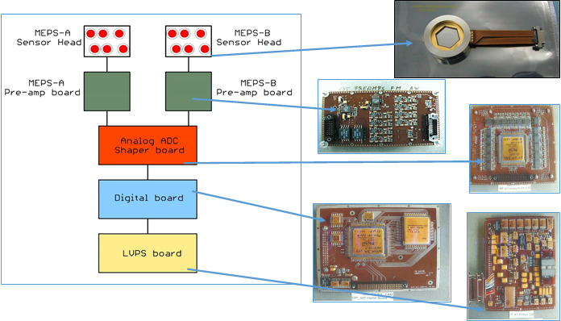
Figure 1-5: MEPS instrument function block diagram

Purpose and Scope
This is a preliminary document to provide an overview of the potential Long Lead Items (LLI) identified for the MEPS the procurement strategy is detailed within [RD-02] and is based on the information available at the start of phase B1.

Long lead items are defined as items with a procurement cycle greater than 12 months.

Documents
    - Applicable Documents
- XXXX <Instrument> PA and Safety Plan
- LGR-IS-KIE-LI-0002_iss1_rev0_MEPS_CIL MEPS Critical Items List
    - Reference Documents
- XXXX <Instrument> PA Requirements for Subcontractors
- XXXX <Instrument> Industrial Procurement Plan

requirements
The requirements for LLI are the same as for all other parts and are identified within [RD-01].
Schedule critical items are tracked and closely monitored throughout the project.

Long Lead ITEM Approach

Objective
The approach for Long Lead Items (LLI) is derived from the schedule requirements which aim at securing the AIV programme and the MEPS delivery. The LLI approach is the result of the analysis of the schedule requirements, the risk assessment, and the past experience in space projects.
This LLI is established in a preliminary form at the start of the phase B1 and will be maintained throughout the project lifecycle to include the outcomes from the equipment/unit selection. The purpose of this plan is to set a definition of the LLI for the MEPS, establish a list, and describe the approach for their tracking, identification, and the procurement rules.

LLI Definition
Within the MEPS project, all items which have a procurement lead time of more than 52 weeks/12 months are defined as Long lead Items (LLI). In general, LLI can be grouped into the following categories:
- Materials, mechanical parts and components
- EEE parts such as: hybrids, ASIC, FPGA, MMIC, micro-processors, memories
- Components requiring development and/or qualification
- Other components, if of procurement lead time greater than 52 weeks
- Components or parts with a risk of obsolescence
- ITAR Items.

Calculation of Long Lead Items for EEE Parts
A procurement cycle starts with the selection of the standard part which may have a standard procurement lead time greater than 52 weeks however simple, non-standard items, may also that have longer lead time, since the parts may need a new specification, qualification, evaluation, radiation verification testing which also need to be considered as LLI. Therefore the user has to calculate the need date backwards: incoming inspection, delivery of the parts, parts acceptance including radiation verification and qualification, manufacture, ordering, PAD approval, evaluation, specification preparation.

Long Lead Item | Lead Time | Comment
RTAX2000SL-CQ256E  FPGA  ACTEL | ≤50 weeks | EAR part and LLI Procurement Activities
5962R0422701VXC  SRAM  Aeroflex | ≤50 weeks | EAR part and LLI Procurement Activities
28LV010RPFS -25  EEPROM  Maxwell Technology | ≤50 weeks | EAR part and LLI Procurement Activities
MSK5059KRHG  Switching Regulator  MS Kennedy Corporation | ≤50 weeks | EAR part and LLI Procurement Activities
QT188LD10S-48.00MHz  48MHz, Crystal Oscillator  Q-Tech Corporation | ≤50 weeks | EAR part and LLI Procurement Activities
QT188LD10S-2.00MHz  2MHz, Crystal Oscillator  Q-Tech Corporation | ≤50 weeks | EAR part and LLI Procurement Activities
ADC128S102WGRQV  8-Channel, 12-bit, 1MSPS  National Semiconductors | ≤50 weeks | EAR part and LLI Procurement Activities
UT54LVDM055LV-UCC  LVDS Driver/Receiver  Aeroflex | ≤50 weeks | EAR part and LLI Procurement Activities
IS2-1009RH  2.5V shunt regulator diode  Intersil Corporation | ≤50 weeks | EAR part and LLI Procurement Activities
ISL78841ASEHVF  Pulse Width Modulator  Intersil Corporation | ≤50 weeks | EAR part and LLI Procurement Activities
RH1498MW  Op. Amp  Linear Technology | ≤50 weeks | EAR part and LLI Procurement Activities
RH1056AMW  Op. Amp  Linear Technology | ≤50 weeks | EAR part and LLI Procurement Activities
AD8005ART  Op. Amp  Linear Technology | ≤50 weeks | LLI Procurement Activities (screened for Solar Orbiter)
JANSR2N7626UB  P-Channel MOSFET  International Rectifier | ≤50 weeks | EAR part and LLI Procurement Activities
JANSR2N7616UB  N-Channel MOSFET  International Rectifier | ≤50 weeks | EAR part and LLI Procurement Activities
JANSR2N7485U3  N-Channel MOSFET  International Rectifier | ≤50 weeks | EAR part and LLI Procurement Activities
BF862  N-Channel JFET  NXP Semiconductors | ≤50 weeks | LLI Procurement Activities (screened for Solar Orbiter)
Table 3-2: Long Lead Items

DOCUMENT CHANGE DETAILS

ISSUE.Rev | Date of issue | RELEVANT INFORMATION/INSTRUCTIONS
1.0 | 31/07/2026 | ALL

DISTRIBUTION LIST

The following lists indicate the individuals and agencies in receipt of review copies of the present document:

Agency / Organization | Name & Title | Contact information
CAU | MEPS Kiel team
  Bjoern Schuster | schuster@physik.uni-kiel.de
  Cesar Martin | martin@physik.uni-kiel.de
  Lars Seimetz | seimetz@physik.uni-kiel.de
  Shrinivasrao Kulkarni | kulkarni@physik.uni-kiel.de
  Stephan Boettcher | boettcher@physik.uni-kiel.de
  Wimmer-Schweingruber | wimmer@physik.uni-kiel.de
  Christoph Terasa | terasa@physik.uni-kiel.de
  Ali Ravanbakhsh | ravanbakhsh@physik.uni-kiel.de
  Mahesh Yedla | yedla@physik.uni-kiel.de
  Robert Elftmann | elftmann@physik.uni-kiel.de
  Stefan Kolbe | kolbe@physik.uni-kiel.de
  Violetta Knierim | knierim@physik.uni-kiel.de
  Mike Richards | mlr@richards-consulting.eu
UCL | Project Office
  Richard Cole | r.cole@ucl.ac.uk
  Jonathan Rae | jonathan.rae@ucl.ac.uk
  Hubert Hu | d.hu@ucl.ac.uk
  Dhiren Kataria | d.kataria@ucl.ac.uk
  Bob Bentley | b.bentley@ucl.ac.uk

