MEPS Critical Items List

Prepared by: | Mahesh Yedla | Date: | 08/01/2019
Checked by: | Cesar Martin | Date: | 08/01/2019
Approved by: | Cesar Martin | Date: | 08/01/2019
Authorised by: |  | Date:

CONTENTS
1. Introduction 4
1.1 Overview 4
1.2 Purpose and Scope 8
1.3 Documents 9
2. Process 10
2.1 Critical Item Definition 11
2.1.1 Critical Item Categories 11
2.2 Critical Item Description 13
3. Critical Items List 14

TABLES

Table 1-1: Proposed MEPS instrument heritage of MEPS from EPT Solar Orbiter Technical Parameters 5
Table 2-1: Critical Item Definition 12
Table 2-2: Definition of Criticality Level 13
Table 2-3: Critical Item Description 13
Table 3-1 MEPS Critical Item List 16

FIGURES

Figure 1-1: MEPS single unit CAD-study with two sensor heads, each of which has two double-ended telescopes. One MEPS unit provides eight view cones in total, four for electrons and four for ions. 4
Figure 1-2: Boards on the electronics module 5
Figure 1-3: MEPS sensor head 6
Figure 1-4: MEPS Block diagram 7
Figure 1-5: MEPS instrument function block diagram 7
Figure 2-1 CAU, Kiel Critical Item Control Process 10
Figure 3-1 MEPS Engineering Product Tree 14

Introduction

Overview
The MEPS instrument is a particle instrument measuring the energy spectra and angular distributions of energetic electrons (30-600 keV) and ions (30-6000 keV/nuc). The full experiment consists of one unit which provides two double-ended telescope pairs (sensor heads) with four view cones per pair, two dedicated for electrons and two for ions. Utilizing any spin of the spacecraft, MEPS observations cover the full sky with a total of eight electron and eight ion view cones. As the L5 S/C is not a spinner, MEPS still provides crucial pitch-angle information to determine whether the event is scatter free. This is an important indicator for interpreting the timing information of the space weather event. Figure 1-1 shows the MEPS unit, with eight view cones.

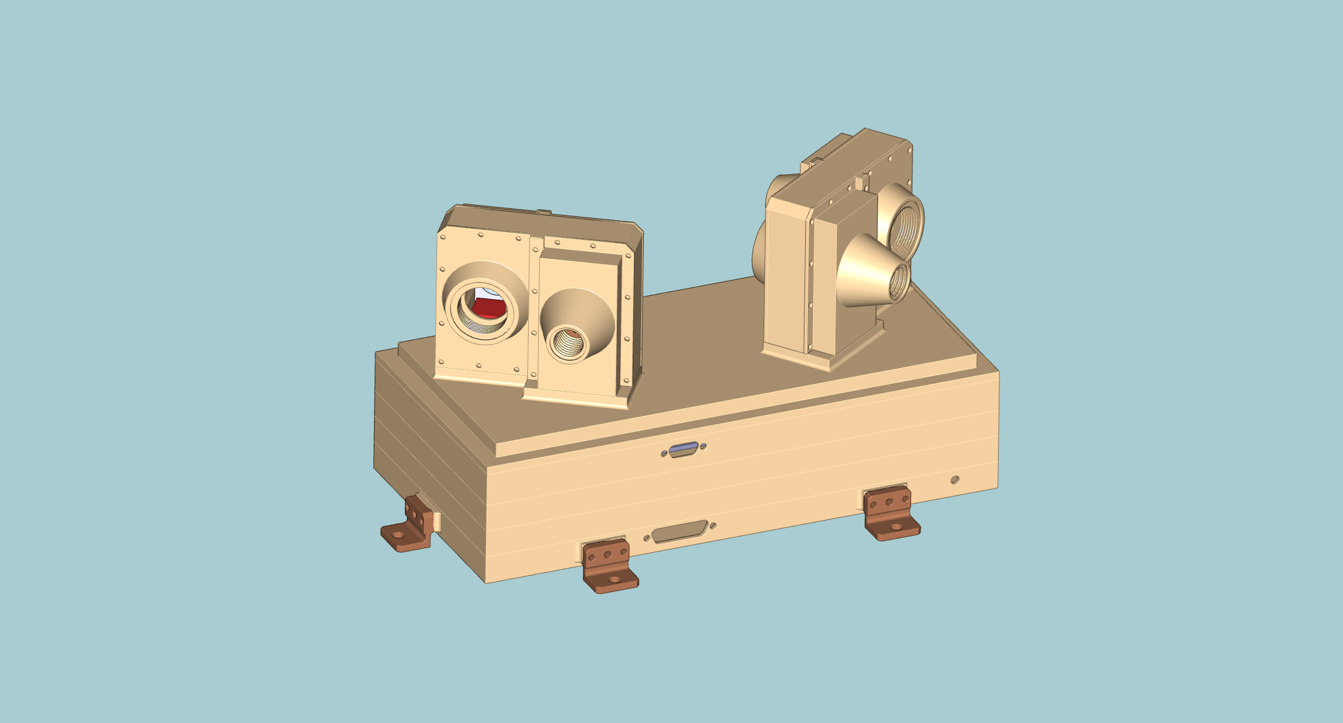
Figure 1-1: MEPS single unit CAD-study with two sensor heads, each of which has two double-ended telescopes. One MEPS unit provides eight view cones in total, four for electrons and four for ions.

Units: 1
Sensors: 2 per unit
FoVs: 4 double FoVs per unit. The FOVs for each sensor are separated by 70°
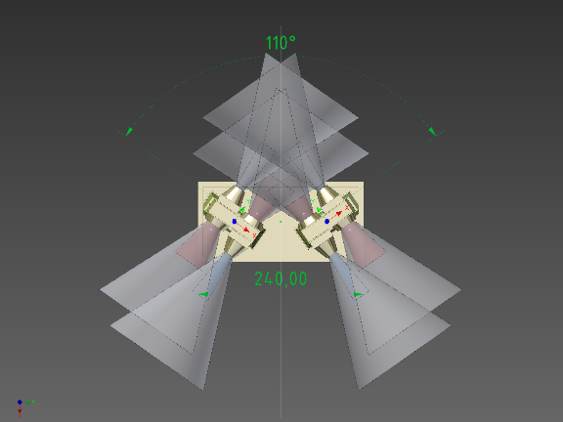

Angular resolution: 45° full angle
Energy range:
- 30keV/n-6MeV/n for the 20-300-300 um detector stack solution
Volume: 300x160x175 mm3 (including potential radiators and MLI)
Power: 5W for 1 unit
Mass: 2.4 kg for 1 unit
Data Products: Particle VDF
Cadence: 5(1) minutes
TRL: 6 (most parts 8-9)
Table 1-1: Proposed MEPS instrument heritage of MEPS from EPT Solar Orbiter Technical Parameters
One unit MEPS consists of mainly three subassemblies, a CAD screenshot is shown in Figure 1-2
- Electronics module containing the power, analog-digital and preamplifier boards.
- MEPS-A sensor
- MEPS-B sensor
CAD screenshots of MEPS unit as well as all subassemblies are shown in Figure 1-2 and Figure 1-3.

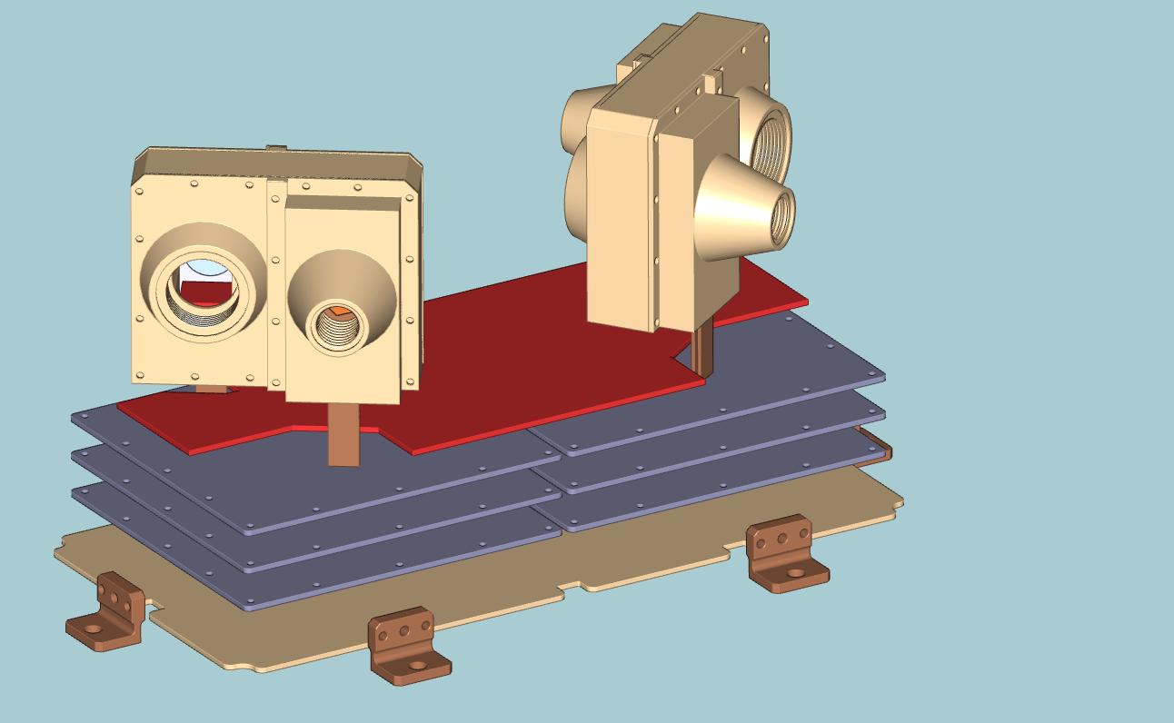
Figure 1-2: Boards on the electronics module

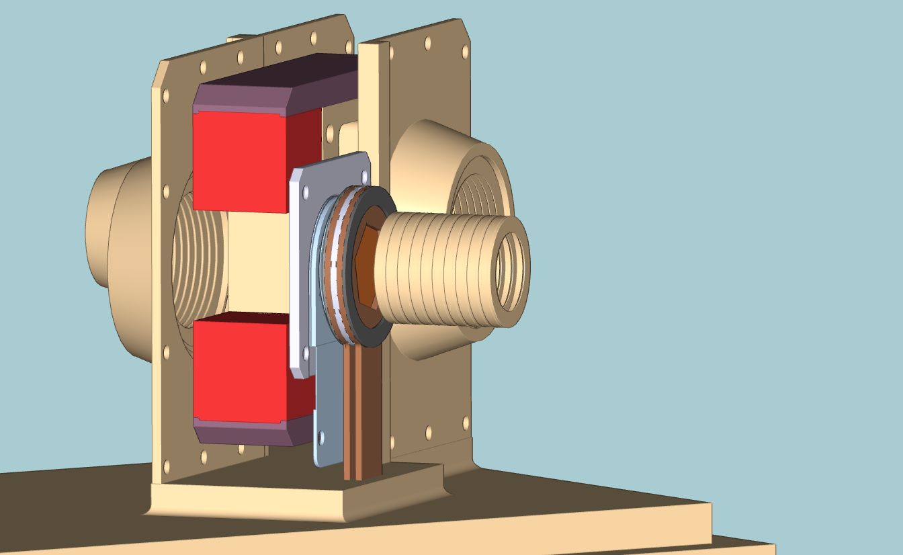
Figure 1-3: MEPS sensor head
All boxes are made of AL-6061 T6. The IF plate is bolted to the Lagrange S/C deck by means of four screws (TBC).

A block diagram of the MEPS electronics is shown in Figure 1-4. MEPS electronics has four boards:

- Preamplifier board
  - Charge Sensitive Preamplifiers for the detector signals
- Analog board
  - Shaping the signals from the preamps and convert to digital ADC values
  - The FPGA on this board detects the peak of the shaper signals
  - Builds the PHA data
  - Contains the housekeeping ADC
- Digital board
  - Builds the data products
  - Manage the communications with the DPU
- Low Voltage Power Supply (LVPS) board
  - Supply different voltages to the different boards.

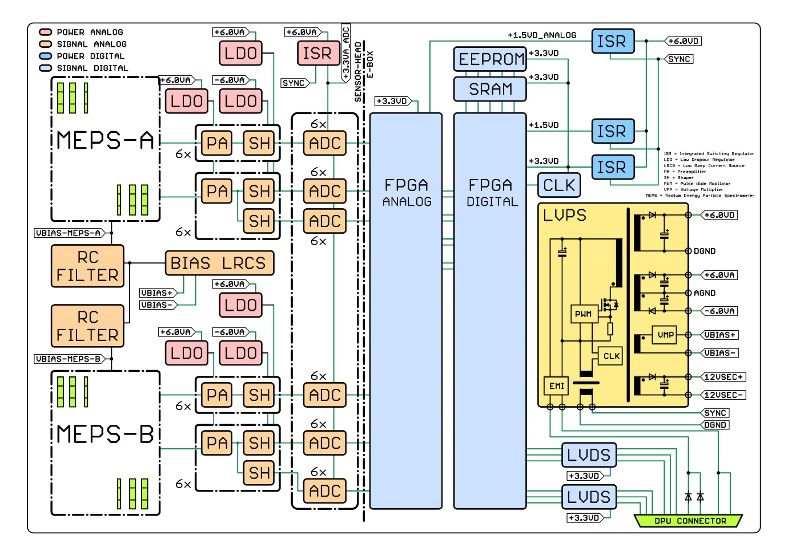
Figure 1-4: MEPS Block diagram

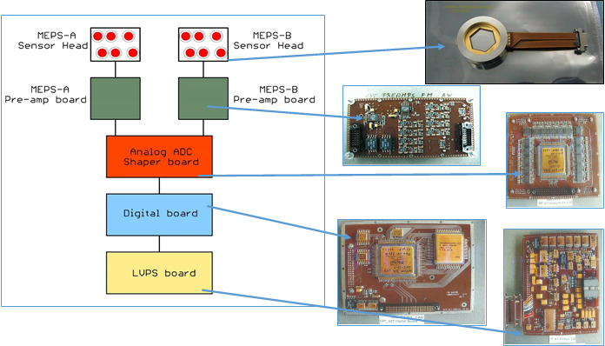
Figure 1-5: MEPS instrument function block diagram

Purpose and Scope
This is a preliminary document to provide an overview of the critical items identified for the MEPS phase A/B1 project and is based on the information available at the start of phase B1.
The critical item control process is applied to ensure that in-orbit / post-delivery failure risks are mitigated and controlled as appropriate. Critical items are identified, assessed, mitigated and controlled in a systematic, proactive and cost effective way all along the project design and manufacturing phases.
The critical items identification and classification is also used as an input to the risk management process while actions results issued from the risk management approach are used to consolidate CI close-out.

The structure of the document provided in the current issue is the following:
- Chapter 1 – provides an introduction to the mission
- Chapter 2 – provides an overview of the Critical Items process and definitions
- Chapter 3 – provides the preliminary Critical Items tables.

Documents
    - Applicable Documents
- ECSS-Q-ST-10-04C Critical Item Control
- ECSS-Q-ST-30C Dependability
- MSSL-LGR-PL-18006_TN11_MEPS_DDVP_Issue_2-DRAFT
- XXXX <Instrument> PA Requirements for Subcontractors
    - Reference Documents
- XXXX <Instrument> Product Assurance and Risk Management Plan

Process
Each area of responsibility within the MEPS Project is reviewed to detect critical items, taking into account lessons learnt from the previous programs design, build and test operations, as well as the MEPS specific design configuration.

At the stage of phase B1, the initial draft of the critical items list aims to provide the structure of the document that will be used along the course of the programme, and to identify any items that are already identified as critical. The declared critical items will be processed through an action plan during the course of the B/C/D programme, and will be subject to review on a periodic basis, including major project design reviews. The list is ‘Live’ and therefore can be updated by addition/deletion at any time. The list is under the responsibility of CAU, Kiel for approval by ESA. Any item that is deleted will not be suppressed from the CIL, but will remain and be barred, so that full traceability of the list evolution is maintained.

The critical item process control is fully defined in ECSS-Q-ST-10-04C. CAU, Kiel policy is illustrated hereunder in Figure 2-6 and is compliant to the ECSS.

Figure 2-6 CAU, Kiel Critical Item Control Process

Critical Item Definition

Critical Item Categories
A critical item is defined as an item which falls into one or more of the following categories as detailed in
Table 2-2 below.Table 2-2: Critical Item Definition .
Critical Item Code | Critical Item Description
GEN | General Critical Items:-  - Components, material and processes new or not qualified or not validated for intended application.  - Item with a known history of flight failures.
RAMS | Potential RAMS critical items:-  - Item not meeting the applicable failure tolerance requirement.  - Item constituting a residual single point failure (SPF).  - Fracture critical item (pressure vessel, structural item whose failure can result in catastrophic or critical consequences).  - Limited life and limited cycle item (item with useful life duration or operating cycles limitation; item prone to wear out, drift or degradation below minimum required performance in less than the storage and mission time).  - Materials or equipment with particular constraints for storage or transportation (Aging sensitive items.)  - Item not meeting applicable derating requirements.  - Item considered critical at the conclusion of the worst case analyses.  - Item submitted to double isolation requirement
EEE | Potential critical EEE components, materials and processes:-  - EEE Long lead items (adverse impact of item procurement on project schedule).  - EEE components subject to export licence constraints.  - EEE components containing dangerous elements.  - EEE components sensitive to radiation environment in space (SEU or latch up).  - EEE components sensitive to ON/OFF switching.  - EEE Components, material and processes new or not qualified or not validated for intended application.  - EEE Item with a known history of flight failures.  - EEE Item highly sensitive to manufacturing processes.  - EEE parts considered as long term storage sensitive.
SW | Potential critical software components:-  - Software items whose performances could be difficult to obtain.  - Software items not observable after integration in equipment.  - Software items not modifiable in the operational environment.  - Software items with strong intrinsic complexity.  - Software development tools with limited maintenance with respect to mission lifetime.
INT | Items critical for integration:-  - Material with long manufacturing or procurement duration.  - Items that cannot be checked and tested after integration.  - Item presenting risks to the personnel (including in the event of inopportune controls).  - Item requiring special handling procedures.  - Item highly sensitive to manufacturing processes.
MIS | Miscellaneous critical items:-  - Item difficult to control or implement.  - Material with particular constraints for storage.  - Item having posed as yet unsolved problems, at the time of a preceding utilisation.  - Material sensitive to transport conditions.  - Item issued from the lessons learned internal database, if applicable.
HAZ | Hazardous Items  - Hazardous substance  - Hazardous items of the categories catastrophic and critical.  - Hardware, software, firmware items or procedures which support a safety critical function and which do not comply to the applicable safety requirements or which cannot be verified as complying with those requirements.
CTM | Critical Technology and Materials:-  - Items/technologies with exceptional qualification circumstances and/or process sensitivity, not all unqualified PMP  - Items requiring precautions to avoid contamination of instrument, equipment or Spacecraft.  - ITAR products
LLI | Long Lead Items:-  - LLI’s that have excessive procurement cycles which may lead to schedule drivers for the project.
Table 2-2: Critical Item Definition

Critical Item Description
Critical‐item control is part of the product assurance programme of a project. Results from various PA analyses provide considerable inputs for critical item identification, e.g.
- RAMS: FMECA results, hazard analysis results.
- PMP: non-qualified parts materials and processes.
- EEE: non-qualified parts or new technology, lessons learned from previous programmes

Risk magnitude =  Criticality Level | Proposed actions
Very High | Unacceptable risk: implement new team process or change baseline – seek project management attention at appropriate high management level as defined in the risk management plan
High | Unacceptable risk
Medium | Unacceptable risk: aggressively manage, consider alternative team process or baseline – seek attention at appropriate management level as defined in the risk management plan.
Low | Acceptable risk: control, monitor – seek responsible work package management attention.
Very Low | Acceptable risk
Table 2-3: Definition of Criticality Level
The critical items are described in tabular format in Table 2-4 below with the following meaning of the headings used.

Heading | Description
No. | Unique item identifier.
Code | Classification of Critical Item as defined by Table 2-2: Critical Item Definition
Critical item | Identified critical item (e.g. unit, subsystem, equipment, component, material, process, and function).
Risks associated | Technical risk(s) associated with the critical item (refer to the associated entry in the Risk Register).
Reference doc. | Reference document in which the item is identified as critical.
Criticality level | The definition is taken from ECSS-M-ST-80C
Cause | Description of the cause which makes this item critical.
Control activities | Planned activities to reduce or control the risk and statement of verification of the control implementation (e.g. design and operational requirements, test, inspection and failure history).
Due date | Expected completion date of activities.
Status | Status of action: Open / Closed (with ref. to close-out docs.)
Table 2-4: Critical Item Description

Critical Items List
The following table lists the critical items in the MEPS as per the major elements of the engineering product tree as detailed in Figure 3-7.
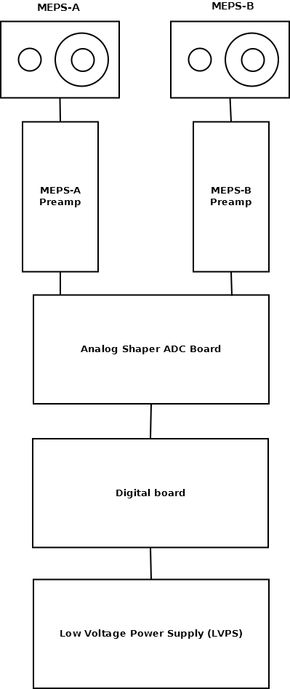
Figure 3-7 MEPS Engineering Product Tree

No. | Code | Critical Item | Risks associated | Reference Doc. | Criticality Level | Cause | Control Activities | Due Date | Status
1 | EEE | BF862  N-Channel JFET  NXP Semiconductors | LGR-R-11 [CPPA] |  | High | Long delivery times | Long Lead Item Procurement Activities | 01-01-2021 | Screened for Solar Orbiter
2 | EEE | JANSR2N7626UB  P-Channel MOSFET  International Rectifier | LGR-R-11 [CPPA] |  | High | Long delivery times | Long Lead Item Procurement Activities | 01-01-2021 | Open
3 | EEE | JANSR2N7616UB  N-Channel MOSFET  International Rectifier | LGR-R-11 [CPPA] |  | High | Long delivery times | Long Lead Item Procurement Activities | 01-01-2021 | Open
4 | EEE | JANSR2N7485U3  N-Channel MOSFET  International Rectifier | LGR-R-11 [CPPA] |  | High | Long delivery times | Long Lead Item Procurement Activities | 01-01-2021 | Open
5 | EEE | AD8005ART  Op. Amp  Linear Technology | LGR-R-11 [CPPA] |  | High | Long delivery times | Long Lead Item Procurement Activities | 01-01-2021 | Screened for Solar Orbiter
6 | EEE | RH1056AMW  Op. Amp  Linear Technology | LGR-R-11 [CPPA] |  | High | Long delivery times | Long Lead Item Procurement Activities | 01-01-2021 | Open
7 | EEE | RH1498MW  Op. Amp  Linear Technology | LGR-R-11 [CPPA] |  | High | Long delivery times | Long Lead Item Procurement Activities | 01-01-2021 | Open
8 | EEE | ADC128S102WGRQV  8-Channel, 12-bit, 1MSPS  National Semiconductors | LGR-R-11 [CPPA] |  | High | Long delivery times | Long Lead Item Procurement Activities | 01-01-2021 | Open
9 | EEE | RTAX2000SL-CQ256E  FPGA  ACTEL | LGR-R-11 [CPPA] |  | High | Long delivery times | Long Lead Item Procurement Activities | 01-01-2021 | Open
10 | EEE | 5962R0422701VXC  SRAM  Aeroflex | LGR-R-11 [CPPA] |  | High | Long delivery times | Long Lead Item Procurement Activities | 01-01-2021 | Open
11 | EEE | 28LV010RPFS -25  EEPROM  Maxwell Technology | LGR-R-11 [CPPA] |  | High | Long delivery times | Long Lead Item Procurement Activities | 01-01-2021 | Open
12 | EEE | MSK5059KRHG  Switching Regulator  MS Kennedy Corporation | LGR-R-11 [CPPA] |  | High | Long delivery times | Long Lead Item Procurement Activities | 01-01-2021 | Open
13 | EEE | QT188LD10S-48.00MHz  48MHz, Crystal Oscillator  Q-Tech Corporation | LGR-R-11 [CPPA] |  | High | Long delivery times | Long Lead Item Procurement Activities | 01-01-2021 | Open
14 | EEE | QT188LD10S-2.00MHz  2MHz, Crystal Oscillator  Q-Tech Corporation | LGR-R-11 [CPPA] |  | High | Long delivery times | Long Lead Item Procurement Activities | 01-01-2021 | Open
15 | EEE | HCC4024BK  7-Stage ripple carry binary counter/divider  ST Microelectronics | LGR-R-11 [CPPA] |  | High | Long delivery times | Long Lead Item Procurement Activities | 01-01-2021 | Open
16 | CTM | 20µm Silicon Detector  Micron Semiconductor Ltd | LGR-R-5 [Schedule] |  | High | Long delivery times | Long Lead Item Procurement Activities | 01-01-2020 | Open
17 | CTM | 300µm Silicon Detector  Micron Semiconductor Ltd | LGR-R-5 [Schedule] |  | High | Long delivery times | Long Lead Item Procurement Activities | 01-01-2020 | Open
Table 3-5 MEPS Critical Item List

DOCUMENT CHANGE DETAILS

ISSUE.Rev | Date of issue | RELEVANT INFORMATION/INSTRUCTIONS
1.0 | 08-01-2019 | All

DISTRIBUTION LIST

Agency / Organization | Name & Title | Contact information
CAU | MEPS Kiel team
  Bjoern Schuster | schuster@physik.uni-kiel.de
  Cesar Martin | martin@physik.uni-kiel.de
  Lars Seimetz | seimetz@physik.uni-kiel.de
  Shrinivasrao Kulkarni | kulkarni@physik.uni-kiel.de
  Stephan Boettcher | boettcher@physik.uni-kiel.de
  Wimmer-Schweingruber | wimmer@physik.uni-kiel.de
  Christoph Terasa | terasa@physik.uni-kiel.de
  Ali Ravanbakhsh | ravanbakhsh@physik.uni-kiel.de
  Mahesh Yedla | yedla@physik.uni-kiel.de
  Robert Elftmann | elftmann@physik.uni-kiel.de
  Stefan Kolbe | kolbe@physik.uni-kiel.de
  Violetta Knierim | knierim@physik.uni-kiel.de
  Mike Richards | mlr@richards-consulting.eu
UCL | Project Office
  Richard Cole | r.cole@ucl.ac.uk
  Jonathan Rae | jonathan.rae@ucl.ac.uk
  Hubert Hu | d.hu@ucl.ac.uk
  Dhiren Kataria | d.kataria@ucl.ac.uk
  Bob Bentley | b.bentley@ucl.ac.uk

