TITLE: MEPS Instrument Specification

Document Number: MSSL-LGR-MEPS-180xx Issue DRAFT A Date 09/01/2019

Distribution:

ESA
Mullard Space Science Laboratory | R Cole
 | D Kataria
 | J Rae
 | J Hu
 | R Bentley
Imperial College
IWF
CAU
PSI
Isaware
CAS
Airbus

Author: | César Martín | Date: | 09/01/2019
Manager/Project Office: |  | Date:
Total No of Pages 29
CHANGE RECORD

ISSUE | DATE | PAGES CHANGED | COMMENTS
DRAFT A | 09/01/19 |  | First draft, inherit from MEPS specification
CONTENTS

1 Introduction 6
1.1 Purpose and Objective of the MEPS Unit Specifications Document 6
1.2 LGR Requirements Levels Definition 6
2 Applicable and Reference documents 7
1.1.1 Applicable documents 7
1.1.2 Reference Documents 7
3 Definitions and Abbreviations 7
3.1 Definitions 7
3.2 Abbreviations 7
4 MEPS System Architecture Overview 9
4.1 MEPS Major Components 12
5 Brief re-cap of functional breakdown 13
6 Requirements 16
6.1 Mechanical Requirements 17
6.2 Thermal Requirements 18
6.3 Electrical Requirements 19
1.1.3 General 19
1.1.4 Pulse Acquisition 20
1.1.5 Scanning and Sequencing 21
1.1.6 Operational and non-operational modes 21
1.1.7 Commanding from the DPU 22
6.3.1 Telemetry Data 23
6.3.2 Thermal control 26
6.3.3 Command Packet Structure IS-MEPS-ER-0800 26
6.3.3.1 Introduction 26
6.3.3.2 Command Message Format 26
6.3.3.3 Error reporting, ACK, NACK 27
6.3.4 Telemetry Packet structure IS-MEPS-ER-0810 27
6.3.4.1 Storage in telemetry buffers 27
7 Science Requirements Compliance matrix 27

Introduction
This document is required to be Issue Draft at PM3, updated at any following key milestone (e.g. PDR) and Final at CDR. [The philosophy is subject to discuss.]

Purpose and Objective of the MEPS Unit Specifications Document
To define the technical requirements to meet the Scientific Requirements
To describe the top level architectural structure of MEPS
To define the technical requirements that must be met to meet the higher-level ones defined in the MEPS Instrument Requirements section of the in-situ Instrument Requirements Document [AD1].
The lists of requirements propagate to lower level requirements documents.
A compliance matrix relating IRD to technical requirements defined in this document.

LGR Requirements Levels Definition
MEPS employs a requirements hierarchy, each level propagates requirements to the level below and receives requirements from the levels above.

- Level0: LGR Requirements Documents
[usually it is EID-A, in LGR, it is the SC2INS ICD, [AD1] or [AD2] subject to the final selection of prime.]
- Level1: In-Situ Instruments Requirements Documents [IRD, AD-1]
- Level2: MEPS Instrument Requirements Documents
[each instrument’s ICD, AD-4, ]

- Level3: MEPS Subsystem Requirements Documents [this document]

At any level a requirement may be fulfilled, usually by a design report, or a series of further requirements propagated down to the next level. If a requirement from a higher level is not addressed or elaborated at this level it is implicitly propagated to the level below.
This is a level 3 document.

Applicable and Reference documents

Applicable documents

[AD-1] | ESA-SSA-LGR-RS-004 Issue 01, In-situ sensing Instruments Requirements Document
[AD-2] | TN6_ICD-ADSS-1000305352_SC2INS_ICD_DRAFT_1.0
[AD-3] | LGR-TAS-INST-ICD-0001 Instrument Interface Control Document v0.3
[AD-4] | MSSL-LGR-ICD-18004_ICD_MEPS_ISSUE_2

Reference Documents
[RD-1] | ESA-SSA-LGR-RS-001, Issue 01, Lagrange Missions (L1 and L5) Mission Requirements Document
[RD-2] | ESA-SSA-LGR-RS-002, Issue 01, Lagrange Missions (L1 and L5) System Requirements Document

Definitions and Abbreviations

Definitions
Item | Definition

Abbreviations

CME | Coronal Mass Ejection
DOCS | Deep-space Optical Communication System
DPU | Data Processing Unit
EDAC | Error Detection and Correction
EEE | Electrical, Electronic and Electro-mechanical
EMC | Electro-Magnetic Cleanliness
EOL | End of Life
EPT | Electron Proton Telescope
HV | High Voltage
IMF | Interplanetary Magnetic Field
LCL | Latch Current Limiter
LET | Linear Energy Transfer
LGR | Lagrange
MAG | Magnetometer
MCP | Microchannel Plate
MEPS | Medium Energy Particle Spectrometer
MICD | Mechanical Interface Drawing
MRAM | Magneto-Resistive Memory
NGRM | Next Generation Radiation Monitor
PLA | Plasma Analyser
RADEM | Radiation Monitor
RAM | Random Access Memory
RAMS | Reliability, Availability, Maintainability, Safety
RM | Radiation Monitor
SEE | Single Event Effects
SEP | Solar Energetic Particles
SIR | Stream Interaction Region
SIXS | Solar Intensity X-ray and particle Spectrometer
SO | Solar Orbiter
SRAM | Static Random Access Memory
SSA | Space Situational Awareness
IS | Solar Wind Analyser
TC | Telecommand
TID | Total Ionizing Dose
TM | Telemetry
TOF | Time of Flight
XFM | X-ray Flux Monitor

MEPS System Architecture Overview
The MEPS instrument is a particle instrument measuring the energy spectra and angular distributions of energetic electrons (30-600 keV) and ions (30-6000 keV/nuc). The full experiment consists of one units provides a double-ended telescope pairs (sensor heads) with four view cones per pair, two dedicated for electrons and two for ions. Utilizing any spin of the spacecraft, MEPS observations cover the full sky with a total of eight electron and eight ion view cones. As the L5 S/C is not a spinner, MEPS still provides crucial pitch-angle information to determine whether the event is scatter free. This is an important indicator for interpreting the timing information of the space weather event. Figure 4-1 shows a single MEPS unit, with eight view cones. The second unit would be identical.

Electronics
Module
MEPS-A
Sensor
MEPS-B
Sensor
Figure 4-1: MEPS single unit CAD-study with two sensor heads, each of which has two double-ended telescopes. One MEPS unit provides eight view cones in total, four for electrons and four for ions.

Units: 1
Sensors: 2 per unit
FoVs: 4 double FoVs per unit. The FOVs for each sensor are separated by 70°
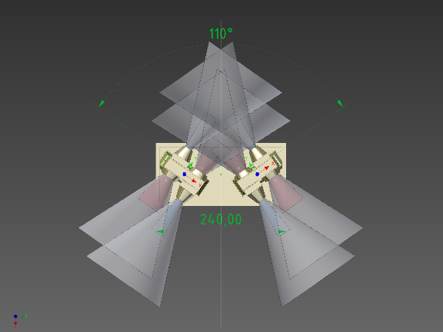

Angular resolution: 45° full angle
Energy range:
- 30keV/n-6MeV/n for the 20-300-300 um detector stack solution
Volume: 300x160x175 mm3 (including potential radiators and MLI)
Power: 5W for 1 unit
Mass: 2.4 kg for 1 unit
Data Products: Particle VDF
Cadence: 5(1) minutes
TRL: 6 (most parts 8-9)
Table 4-1: Proposed MEPS instrument heritage of MEPS from EPT Solar Orbiter Technical Parameters
The two ends of a telescope observe electrons and ions, respectively. Each telescope consists of a stack of three solid-state detectors (Figure 4-2). On one end, the outer detector is covered with a thin polyimide layer or parylene foil (TBC), stopping ions below a few hundred keV/nuc but letting electrons pass almost unaffected. This uppermost detector (300 μm thick Si) on this side is operated in anticoincidence with the second (middle) detector and thus observes the energy spectrum of stopping electrons. The other end of the telescope has a broom magnet (instead of a PI layer) that defects electrons below a few hundred keV (see Figure 4-3 for electron deflection measured with the Solar Orbiter EPT EM). This side of the telescope employs a 20 μm thick Si detector in front of the 300 μm Si detector in the middle, which thus form an ion telescope observing at energies from 30-6000 keV/nuc. Ions passing the thin first detector can be identified at high energies (MeV/nuc range) using the d E/dx vs. E technique, operable at Ekin ≥ 1 MeV/nuc for protons and alphas and ≥ 2 MeV/nuc for heavier species. Lower ion energies can nevertheless be resolved using the middle detector as an anticoincidence: Anything above 1.2 MeV energy deposit in the thin detector is heavier than protons, which in return means that the thin detector may be used as a Z ≥ 2 channel SSDs for deposited energies > 1.2 MeV (or 300 keV/nuc for He). The same logic applies for penetrating He, enabling a Z ≥ 6 channel for energies > 4.8 MeV; or 420 keV/nuc for C, 360 keV/nuc for N and 310 keV/nuc for O.
Figure 4-2: Working principle of an EPE double-ended telescope. The polyimide layer stops ions but lets electrons pass, whereas on the other side electrons are deflected by magnets and ions pass unaffected. The thin detector on the right side enables the separation of different ion species via the d E/dx vs. E-method (in the MeV/nuc energy range; for the separation at lower energies see text).
The permanent magnets of one sensor head (double-ended telescope pair) form a quadrupole, significantly reducing the far field. The far field is reduced even further by the other sensor head on the same unit, since its quadrupole forms an angle of 70° with respect to the first sensor head. The MEPS unit integrates the sensors and electronics in a single package. Right below the sensors in the electronic box are the preamp boards, followed by an analogue board and the back-end electronics (digital and LVPS-board[s]). Pre-flight ground energy calibration (1 % level) of all detector elements, on-axis active area calibration, selected off-axis directions active area calibration and dead-time calibration will be performed. Calibration quality will be monitored in-flight using measured data and cross-calibration with suprathermal electron/ion instruments.
Figure 4-3: Electron Proton Telescope on Solar Orbiter (EPT) EM measurements with a Bi- 207 source. The conversion electron lines at 482 keV and 554 keV are seen on the PI-side (Det 1) but vanish on the magnet-side (Det 2).

MEPS Major Components
MEPS comprises two electron/ion sensor heads with a single electronics box.
The major components are shown in Figure 4-4 and listed in Table 4-2 .

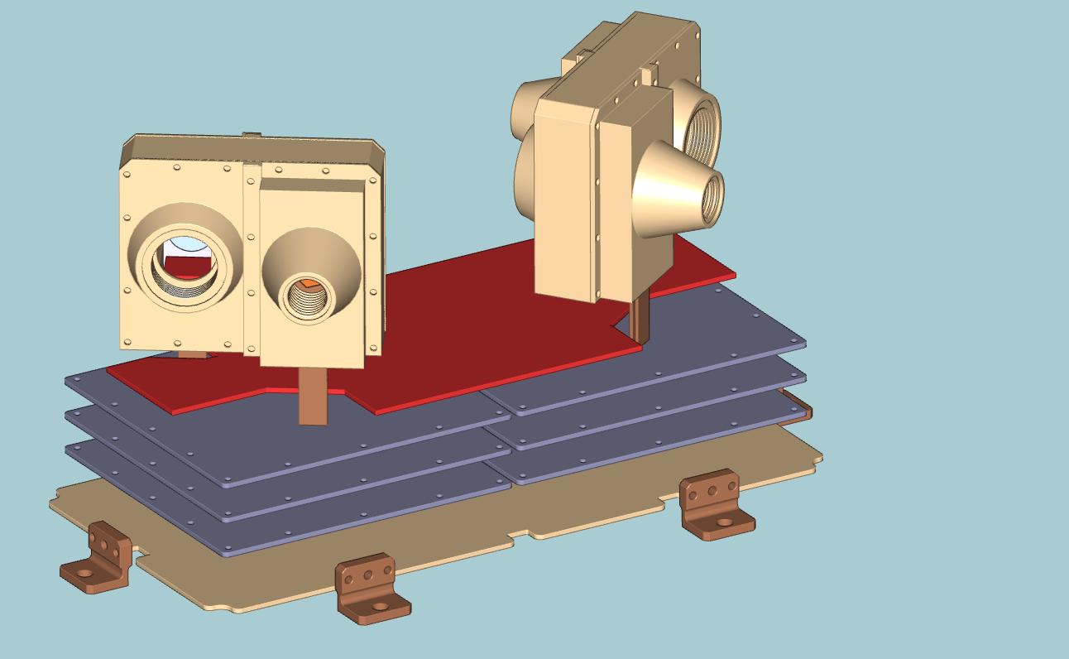
Preamp board
Analog board
Digital board
Power board
Figure 4-4: Boards on the electronics module

System | Major Components/  Sub-systems | Description and location
Mechanical Structure | MEPS-A sensor | Consists of 2 top electron-ion heads coupled to a single electronics box
Mechanical Structure | MEPS-B sensor
Mechanical Structure | Electronics module
Electronics Boards | Preamplifier Board | Charge sensitive preamplifiers
Electronics Boards | Analog Board | Shapers+ADCs+FPGA
Electronics Boards | Digital Board | Communication FPGA
Electronics Boards | Low Voltage Power supply | For detector Bias and PCB voltages supply
Table 4-2: MEPS Major Components

Brief re-cap of functional breakdown

A block diagram of the MEPS electronics is shown in Figure 5-5. MEPS electronics has four boards:

- Preamplifier board
  - Charge Sensitive Preamplifiers for the detector signals
- Analog board
  - Shaping the signals from the preamps and convert to digital ADC values
  - The FPGA on this board detects the peak of the shaper signals
  - Builds the PHA data
  - Contains the housekeeping ADC
- Digital board
  - Builds the data products
  - Manage the communications with the DPU
- Low Voltage Power Supply (LVPS) board
  - Supply different voltages to the different boards.

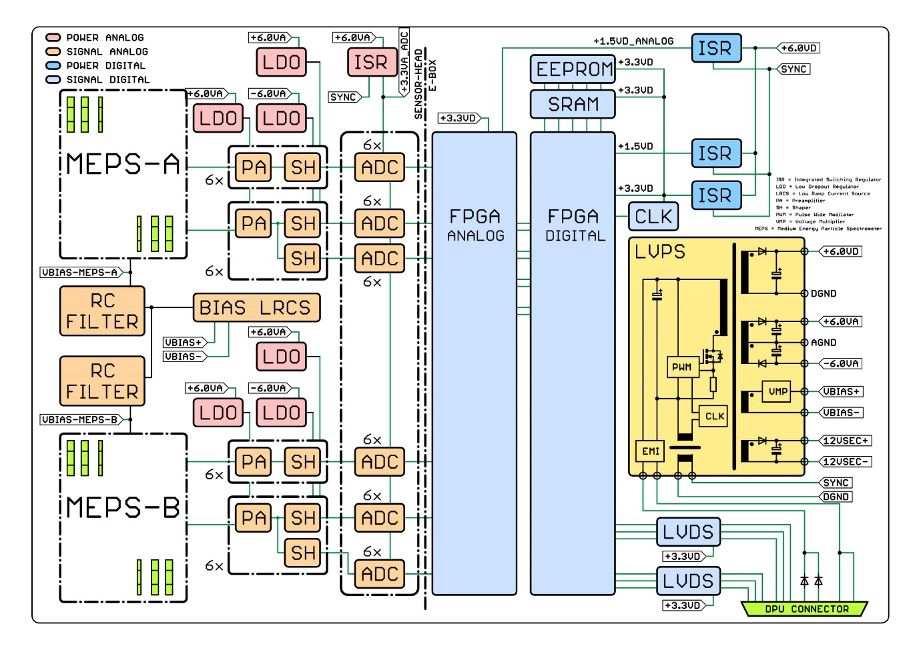
Figure 5-5: MEPS Block diagram
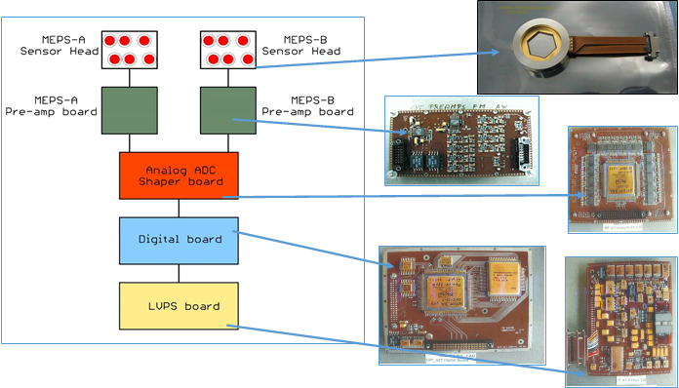
Figure 5-6: MEPS instrument function block diagram

Requirements
The requirements are sectioned into different discipline. Understand the level of detail and maturity of requirements for different discipline is very different. For example, this document shall be sufficient to cover all the mechanical, thermal and major electrical requirements. This document will serve as the base document for all the future verification activity. So expect many third party will check this document and the design/test of instrument against this document.
The verification method is specified in the table and it is standard ECSS catalogue and is consistent to those method used in the verification matrix.
Requirement reference number is self-explainable. Basic rule is
IS – XXX – YR - 0000
IS for in-situ
XXX for instrument name
YR for requirement section, mechanical requirement is MR, thermal requirement is TR, and electric requirement is ER,

The SC2INS ICD and other normative references’ requirements are implicitly included and are not listed here.

Each table consists of
- Requirement number: This is the requirement number that propagates to the documents below. If this column is blank, this document does not propagate or elaborate this requirement, it is include for reference, and the Upper Link Requirement is used by lower documents
- Requirement Name is included as a brief identifier
- Value is included to indicate if there is a numeric value, or a type associated with this requirement
- Verification method is indicated by :
A | By Analysis
R | By Review of Design
T | By Test
I | By Inspection
S | By Simulation (FPGA only)
- Description is a brief description and/or justification for the requirement
- Upper link indicates where the requirement has come from. “None” means that at the time of writing, the requirement has not been included at a higher level.

Mechanical Requirements

Requirement Number | Requirement Name | Value | Verification | Description | Upper Link
 | FOV (field of Views) | 4x45° | I | The MEPS instrument shall have 4 FOVs (Parker, Anti-Parker and 2 FOVs perpendicular to the Parker direction). | I-IRD-MEP-OBS-0080
 | Number of heads | 2 | I | The MEPS instrument shall have two sensors (each one forward and backward looking) consisting each of one electron and one proton telescope each with 45° full conical field of view. | I-IRD-MEP-OBS-0070
 | Mass | 3.5 kg | T | The instrument shall have a mass of less than 3.5 Kg for a single unit including margin, mounting bracket, electronics, harness and MLI/blankets. | I-IRD-MEP-INS-0010
 | Dimensions | 300 x 160 x 175 mm3. | R,I | The MEPS instrument shall have a dimension of less than 300 x 160 x 175 mm3. | I-IRD-MEP-INS-0040
IS-MEP-MR-0010 | Mechanical parts manufacturing tolerance and fit check | +/-0.2mm  (TBC) | R,I,T | All of the mechanical parts drawings, including the primary and secondary structures, shall be reviewed before manufacturing and inspected (fit check where applicable) after manufacturing.  (heritage: EPT-HET Solar Orbiter)
IS-MEP-MR-0020 | Purging path | Scheme | A,I | A purging path shall be implemented and the flow rate range will be defined.  (heritage: EPT-HET Solar Orbiter)
IS-MEP-MR-0030 | Aperture cover |  | A,I | MEPS collimators shall have aperture covers (Red tag items) for use in during AIT.  (heritage: EPT-HET Solar Orbiter)
IS-MEP-MR-0040 | Fastener sizing |  | A | The selection of the fasteners (screws, bolt and nuts etc.) for MEPS assembly shall be done based on preliminary analysis and updated where applicable after correlated FEM analysis.  (heritage: EPT-HET Solar Orbiter)
IS-MEP-MR-0050 | Electronic PCB interface with structure |  | A,T | In addition to all the other structural design requirements, the interfaces between the PCBs and structure shall be designed to minimize the fatigue stress on EEE components on PCBs.  (heritage: EPT-HET Solar Orbiter)

Thermal Requirements
The majority of thermal requirements are defined in the EIDA [NR1].
Requirement Number | Requirement Name | Value | Verification | Description | Upper Link
IS-MEP-TR-0010 | Detectors  Operating Temperature limit | >-40ºC,  < 20ºC | A,T | The MEPS detectors shall remain between -40 and +20 ºC while operating. Operational heaters and control system shall be provided to ensure this.  (heritage: EPT-HET Solar Orbiter)
IS-MEP-TR-0020 | Detectors  Non-Operating Temperature limit | >-50ºC,  < 70ºC | A,T | The MEPS detectors shall remain between -50 and +70 ºC while not operating  (heritage: EPT-HET Solar Orbiter)
IS-MEP-TR-0030 | Electronics Operating Temperature limit | >-40ºC,  < 60ºC | A,T | The electronics PCBs shall remain between -40ºC and +60ºC  (heritage: EPT-HET Solar Orbiter)
IS-MEP-TR-0040 | Electronics non- Operating Temperature limit | >-50ºC,  < 90ºC | A,T | The electronics PCBs shall remain between -50ºC and +90ºC.  (heritage: EPT-HET Solar Orbiter)
IS-MEP-TR-0050 | Operational heaters | Yes | A,T | MEPS is an external and thermally isolated unit from the S/C, operational heaters are needed in order to meet the unit thermal control requirements. The exact budget for these operational heaters will be determined after detailed thermal modelling and case by case.  (heritage: EPT-HET Solar Orbiter)
IS-MEP-TR-0060 | Survival heaters | Yes | A,T | MEPS is an external and thermally isolated unit from the S/C, survival heaters are needed in order to meet the unit thermal control requirements. The exact budget for the survival heaters will be determined after detailed thermal modelling for cold non-operational case.  (heritage: EPT-HET Solar Orbiter)

Electrical Requirements
Requirements that propagate down to the MEPS electronics documents

General
Requirement Number | Requirement Name | Value | Verification | Description | Upper Link
 | Power | 10W | T, R | The instrument shall have a power consumption of less than 10 W including margin.  Note: this is assuming a single unit and 5 W for the operational heaters. | I-IRD-MEP-INS-0020
IS-MEP-ER-0010 | Power | 28V unregulated  (TBC) | R | MEPS shall receive switched raw bus voltage from the DPU. | None
IS-MEP-ER-0020 | Communications | SpW  12Mbits/s | R | Communications to the DPU shall be by SpW at 12Mbits/sec (TBC) | None
IS-MEP-ER-0030 | Communication to the DPU | Protocol | R,T | All communications shall be formed of SPW packets (TBC) | None
IS-MEP-ER-0040 | Grounding | Scheme | R,T | All MEPS secondary returns shall be connected to structure at the chassis PCB (TBC) | None
IS-MEP-ER-0050 | Maximum detector voltages | +5V &  -70V | R | MEPS 20 µm detector shall be biased with +5V and the 300 µm detector shall be biased with -70V | None
IS-MEP-ER-0060 | Number of printed circuit board copper layers | ≤10 | R | Number of copper layers for the MEPS PCB’s shall be ≤ 10 (heritage: taken from EPT-HET Solar Orbiter) | None
IS-MEP-ER-0070 | Thickness of the printed circuit boards | ≤1.6mm | R | The thickness as manufactured of a rigid and rigid-flex Polyimide PCB’s shall be ≤1.6mm (heritage: taken from EPT-HET Solar Orbiter) | None
IS-MEP-ER-0080 | Low voltage power supply | Switched (1.5V x 2, 3.3V x 2), | R,T | MEPS LVPS secondary switched power lines shall be distributed to the Analog FPGA (V_CORE:1.5V, V-IO:3.3V) and for the Digital FPGA & SRAM(V_CORE:1.5V, V-IO:3.3V) (heritage: taken from EPT-HET Solar Orbiter) | None

Pulse Acquisition
Requirement Number | Requirement Name | Value | Verification | Description | Upper Link
IS-MEP-ER-0090 | Decay time preamps | >1ms | R,T | Decay time of preamp output signal shall be >1ms | None
IS-MEP-ER-0100 | Shaping time | 2µs | R,T | Shaping time of the Analog shapers shall be 2µs (TBC) | None
IS-MEP-ER-0110 | Maximum number of channels | 36 | S,A,T | MEPS shall acquire data from up to 36 pulse input channels (TBC) | None

Scanning and Sequencing

Requirement Number | Requirement Name | Value | Verification | Description | Upper Link

Operational and non-operational modes
Requirement Number | Requirement Name | Value | Verification | Description | Upper Link
IS-MEP-ER-120 | Power on | Yes | S | After power-on MEPS shall be in the Idle mode IS-MEP-ER-601.  There shall be no automatic configuration, i.e. all configuration has to be done via commanding.  Justification: Pre-defining autostart modes violates the simplicity and predictability of the system. | None
IS-MEP-ER-130 | Idle Mode | Yes | S,T | The unit shall be in Idle mode after power-on, accepting telecommands from GSE or DPU. | None
IS-MEP-ER-140 | Housekeeping Mode | Yes | S,T | The unit shall transition from any mode to Housekeeping mode by sending the appropriate telecommand(s) to the unit. In Housekeeping mode MEPS shall emit Housekeeping telemetry, but no Science telemetry. | None
IS-MEP-ER-150 | Nominal Operational Mode | Yes | S,T | The unit shall transition from any mode to Nominal Operational mode by sending the appropriate telecommand(s) to the unit. In Nominal Operational Mode MEPS shall emit Housekeeping telemetry, as well as Science telemetry.  Remark: This is the “main” mode of the unit, and is intended to be the target mode immediately after power-on. | None
IS-MEP-ER-160 | Auxiliary modes | Yes | S | MEPS shall transition to additional TBC auxiliary modes by telecommand. The design of MEPS offers capbilities to add more operational modes later through updating.  Remark: This requirement mirrors the yet unused capacities of the MEPS design. | None
Fig 7.3.4 MEPS operational states and modes.
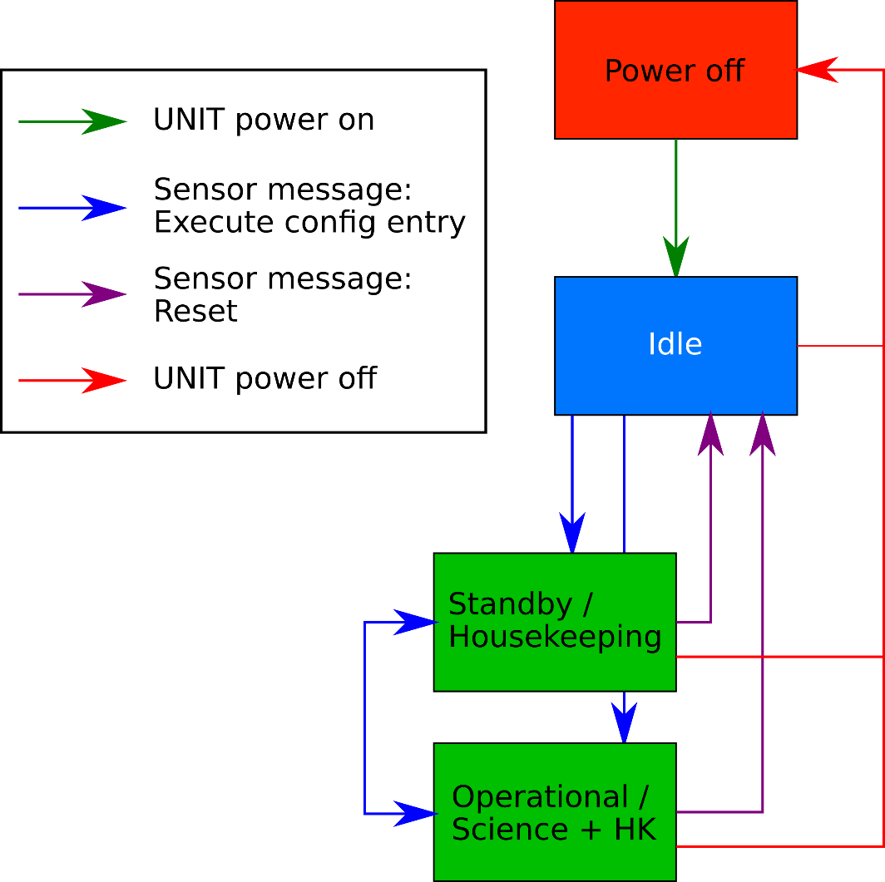

Commanding from the DPU
This section defines the formals telecommands necessary to command MEPS from ground through the DPU.
Requirement Number | Requirement Name | Value | Verification | Description | Upper Link
IS-MEP-ER-180 | MEPS command message | Yes | S,T | The DPU shall command MEPS via Spacewire using command messages in the format outlined in sec. 6.3.3.
IS-MEP-ER-190 | Send command messages | Unsigned 2byte int: Delay in ms  List of command messages | S,T | The DPU shall send the command messages contained in “List of command messages” to the MEPS unit with a delay of “Delay in ms” milliseconds between each command.  The purpose of this command is to allow commanding of the unit.  This telecommand thinly encapsulates MEPS command messages as per IS-MEP-ER-180 | None
IS-MEP-ER-200 | Send command messages (ALTERNATIVE) | Unsigned 2byte int: Delay in ms  N Bytes: data | S,T | The DPU shall send bytes in “List of command messages” to the MEPS unit with a delay of “Delay in ms” milliseconds before sending.  The purpose of this command is to allow commanding of the unit. The bytes in the payload are formatted command messages as per the MEPS command message format outlined in IS-MEP-ER-180 | None

Telemetry Data
Requirement Number | Requirement Name | Value | Verification | Description | Upper Link
 | Ground telemetry data rate | <1 kbps | R | The instrument shall generate a data rate to ground of less than 1 kbps. | I-IRD-MEP-INS-0030
IS-MEPS-ER-210 | Telemetry data format | Packets | S,T | Telemetry data from MEPS shall be sent as data payload of a sensor transfer frame (STF) packet as outlined in sec, 6.3.4  Remark: MEPS design has no concept of different telemetry data types, i.e. all telemetry data, be it housekeeping, science, etc, is just payload of a STF packet. | None
IS-MEP-ER-220 | Telemetry data time resolution | Yes | S,T | MEPS shall be able to emit telemetry with a configurable cadence of 1s, 5s, 10s, 30s, 60s, 300s, 600s, 3600s. The cadence shall be individually configurable for each telemetry data packet. | None
IS-MEP-ER-230 | Telemetry channels | Yes | S,T | Telemetry telemetered to the DPU shall be able to be differentiated by the lower byte of the packet APID, which serves the purpose of notifying the DPU of the intended “telemetry channel”.  The description and number of telemetry channels are TBC.  The DPU shall provide an individual (ring-)buffer for each telemetry channel to aggregate the sensor data, to reduce ground telemetry overhead. | None
IS-MEP-ER-240 | Telemetry channel telemetering policy | Yes | S,T,R | DPU shall be able to configure each telemetry channel telemetering policy individually.  DPU shall provide at least four different policies:  - Send each data packet received to telemetry immediately.  - Send data to S/C after a configurable amount of time, or when the telemetry buffer is full. When a new packet is received which does not fit into the buffer, the buffer needs to be sent first, and the packet added to the new empty buffer  - Store data in the buffer, and only send the data to S/C on demand. This is the intended way to handle burst mode or selective downlink data.  - Data is not telemetered to S/C, but can be consumed by DPU, or ignored and discarded. | None
IS-MEP-ER-250 | Housekeeping channel | Yes | S,T | One (or more) of the telemetry channels shall be a Housekeeping channel, which will contain packets intended for monitoring MEPS by DPU. The telemetry policy for this channel shall be IS-MEPS-ER704 policy #4  DPU shall have facilities to extract bytes and byte ranges from the data for monitoring.  DPU shall send the extracted bytes as MEPS housekeeping data to ground, for monitoring of MEPS by MOC. | None
IS-MEP-ER-260 | Science data channel | Yes | S, T | One (or more) telemetry channels shall be used for science data. Science data will be either sent with IS-MEP-ER-240 policy #2 or #3.
IS-MEP-ER-270 | Engineering/Maintenance channel | Yes | S, T | One (or more) telemetry channels shall be used for engineering/maintenance. The data policy of this channel is IS-MEP-ER-240 policy #1.  Remark: This channel can be used for debugging of unit operations. This is most useful in “interactive” environments during engineering windows or comissioning.
IS-MEP-ER-280 | Telemetry timetagging | Yes | S, T | DPU shall timetag science data packets at the moment of sending a telemetry buffer to S/C temelemetry, with its current real time clock time.  Remark: The exact time of all data within a telemetered buffer can be inferred from the configuration state of the unit, so only the exact timestamp of the last packet in a buffer is necessary to reproduce the timing of the contained packets, assuming no data is lost between MEPS and DPU.  Justification: MEPS has no internal real-time clock, but relies on DPU to correctly timetag CCSDS packets.

Thermal control
Requirement NumberIS-MEPS-ER-708 | Requirement Name | Value | Verification | Description | Upper Link
IS-MEP-ER-290 | Operational heater Control | Yes | S,T | MEPS shall be able to be configured to use one of its thermistors as a reference to control its operation heater(s). The controlling of the operational heater shall be internal to MEPS, and can be overridden using commanding. | None

Command Packet Structure IS-MEPS-ER-0800

Introduction
All commands to MEPS are formatted in the MEPS Command Message format. All operations of MEPS can be controlled using these command messages. The command message structure has heritage from Solar Orbiter EPD sensor units.

Command Message Format
MEPS Command Message:
Byte | Value | Description
0 to 2 | 0x3c3d | Sync Word
2 to 4 | variable | Upper 2 bits: Payload Size  Lower 14 bits: Address (recipient FPGA module in MEPS)  The Payload Size defines how many N bytes of the data payload of the command will be interpreted by MEPS FPGA:  - 0: N = 0 bytes  - 1: N = 2 bytes  - 2: N = 4 bytes  - 3: N = 8 bytes
4 to N+4 | variable | N Payload bytes
N+4 to N+6 | variable | 16-bit CRC (CRC-16/CITT) of the whole command packet
Useful generation of command messages requires intricate knowledge of the sensor design and operations, so in practice the MEPS team will prepare and provide a set of telecommands for operations of MEPS. The telecommand outlined in IS-MEP-ER-190 is a thin wrapper around the MEPS Command Message structure, essentially just encapsulating one or multiple command messages in one telecommand. This approach simplifies operations and design requirements for the DPU, while maintaining the full flexibility of the MEPS FPGA design.

Error reporting, ACK, NACK
MEPS by design will not emit ACK or NACK upon reception of telecommands, all well-formatted and valid (based on CRC check) command messages are accepted and executed, there can be no blocking state. It is up to the user to create meaningful command messages. It is therefore possible to command the unit into an unintended, but nevertheless valid state (garbage in, garbage out principle).
Error registers can be sent at regular intervals to infer the amount of well- and malformed packets received, but not on an individual basis.

Telemetry Packet structure IS-MEPS-ER-0810
All telemetry of MEPS is formatted in the MEPS Sensor Transfer Frame data format. The STF data format has heritage from Solar Orbiter EPD sensor units.
Byte | Value | Description
0 to 4 | 0xbebacafe | Sync word
4 to 6 | Variable | Packet size N + 4 (N bytes of data + 2 bytes of MEPS-APID + 2 bytes of CRC)
6 to 8 | Variable | 16 bit MEPS-APID:  - First byte: Sending module  - Second Byte: Intended Receiver/telemetry channel
6 to N+6 | Variable | N bytes of data
N+6 to N+8 | Variable | 16-bit CRC (CRC-16/CITT) of the whole telemetry packet

Storage in telemetry buffers
When buffering the telemetry packets of MEPS, DPU does not need to store the sync word, since the telemetry buffer of a MEPS telemetry channel should only contain packets from MEPS, the buffer starts with a valid packet, and the buffer should always contain full packets. It is therefore sufficient to store telemetry packets only from the 4th byte onwards, slightly reducing telemetry overhead.

Science Requirements Compliance matrix
This matrix identifies which technical requirements address which MEPS Science Requirements.
Science Requirement Number | Description | Lower Links | Compliant
I-IRD-MEPS-OBS-0010 | The MEPS instrument shall measure medium energy ions with kinetic energy from 30 kev/nuc up to 8 MeV/nuc. |  | Compliant
I-IRD-MEPS-OBS-0020 | The MEPS instrument shall measure medium energy electrons with kinetic energy in the range 30 keV to 0.6 MeV. |  | Compliant
I-IRD-MEPS-OBS-0030 | The MEPS instrument shall measure the following particles: electrons, protons, alpha particle, CNO group (goal: resolve He3 and He4, C, N and O, Si/Ne, Fe, Ni, plus single a measure for heavier ions).  Note: The goal requirement shall apply for energies larger than 1.5 MeV/nuc. |  | Compliant
I-IRD-MEPS-OBS-0040 | The MEPS instrument shall have a dynamic range sufficient to capture extreme flux during a solar event.  Note: The extreme flux is specified in the environmental specification document. |  | Compliant
I-IRD-MEPS-OBS-0050 | The MEPS instrument shall have 32 energy channels for the energy range of the ions |  | Compliant
I-IRD-MEPS-OBS-0060 | The MEPS instrument shall have 16 energy channels for the energy range of the electrons. |  | Compliant
I-IRD-MEPS-OBS-0070 | The MEPS instrument shall have two sensors (each one forward and backward looking) consisting each of one electron and one proton telescope each with 45° full conical field of view. |  | Compliant
I-IRD-MEPS-OBS-0080 | The MEPS instrument shall have 4 FOVs (Parker, Anti-Parker and 2 FOVs perpendicular to the Parker direction). |  | Compliant
I-IRD-MEPS-OBS-0090 | The MEPS instrument shall have a measurement cadence of 1 minute (30 s). |  | Compliant
I-IRD-MEPS-OBS-0100 | The nominal direction of the Parker spiral shall be assumed to be at 45° from the Sun-L5-Line. |  | Compliant
I-IRD-MEPS-OBS-0110 | The MEPS instrument shall provide measurements of particle spectra (flux) with a relative accuracy of ±5% for electrons and of ±15% for ions for each channel of the spectrum. |  | Compliant
I-IRD-MEPS-OBS-0120 | The MEPS shall provide measurements of particle spectra with ±50% (±40%) absolute accuracy.  Note: the requirements shall be met for the flux spectrum of a typical (to be agreed for each particle type) solar particle event. |  | Compliant

