TITLE: Instrument AIT and Calibration Plan – for MEPS

Document Number: MSSL-LGR-PL-180xx Issue A Date 09/01/19

Distribution:
ESA | S Kraft
Mullard Space Science Laboratory | R Cole
 | IJ Rae
 | D Kataria
 | D Hu
 | R Bentley
Imperial College | J. P. Eastwood
 | C. Carr
U of Kiel | R Wimmer
 | C Martin
IWF | W. Magnes
PSI | W. Hajdas
Isaware | J. Huovelin
 | S. Korpela
 | T. Luntama
CAS | J. Soucek
 | O. Santolik
Airbus | S Willis

Author: | Ali Ravanbakhsh | Date: | 09.01.2019
Manager/Project Office: |  | Date:
Total No of Pages 18
CHANGE RECORD

ISSUE | DATE | PAGES CHANGED | COMMENTS
A | 09/01/19 |  | First draft
CONTENTS

1 Introduction 4
2 Applicable and Reference documents 4
2.1.1 Applicable documents 4
2.1.2 Reference Documents 4
3 Definitions and Abbreviations 5
3.1 Definitions 5
3.2 Abbreviations 5
4 Instrument Description 7
5 Integration Plan 8
6 Qualification and acceptance test programme 8
7 AIT Plan 10
7.1 Overall AIT summary 10
7.2 MEPS sensors (A&B) assembly 11
7.3 MEPS Ebox assembly 12
7.4 MEPS test matrix 13
8 Calibration Plan 15
9 GSE description 15
10 AIT Management 16
10.1 General safety precautions 16
10.2 Deviations and Waivers 16
10.3 Test documentation 16
11 Activity Sheets 17
11.1 Example Activity 1 17
11.2 Example Activity 2 18

Introduction
This document contains the AIT and Calibration plan for the MEPS instrument in the In-situ suite for the LGR programme.

Applicable and Reference documents

Applicable documents
[AD-1] | ESA-SSA-LGR-RS-004 Issue 01, In-situ sensing Instruments Requirements Document
[AD-2] | ECSS-M-ST-10C, Project planning and implementation
[AD-3] | ECSS-M-ST-10-01C, Organization and Conduct of Reviews
[AD-4] | ESA-SSA-LGR-LI-0004 Issue 01, Lagrange Missions Instruments Phase A/B1 Study - Document Requirements List (ins-DRL) – named here DRL
[AD-5] | ECSS-M-ST-80C, Risk management
[AD-6] | ESA Cost Estimate template, ‘LGR-III Cost Estimate Template V1.xls’
[AD-7] | ESA-LGR-EST-ENV-SP-001, Issue 01, Lagrange Mission (L5) Environmental Specifications
[AD-8] | ECSS-Q-ST-20C Rev.1, Quality Assurance
[AD-9] | ECSS-M-ST-60C, Cost and schedule management, 31 July 2008
[AD-10] | ESA-SSA-LGR-LI-0004, Lagrange Missions Phase A/B1 Instrument Studies Document Requirements Definition (INS-DRD), Issue 01
[AD-11] | MSSL-LGR-MEPS-180xx, MEPS instrument requirements specification
[AD-12] | MSSL-LGR-PL-18006_TN11_MEPS_, DDVP, Instrument Suite Design Development and Verification Plan – for MEPS (TN11)
[AD-13] | MSSL-LGR-RP-18006, Instrument Design and Definition Report - MEPS

Reference Documents
[RD-1] | ESA-SSA-LGR-RS-001, Issue 01, Lagrange Missions (L1 and L5) Mission Requirements Document
[RD-2] | ESA-SSA-LGR-RS-002, Issue 01, Lagrange Missions (L1 and L5) System Requirements Document
[RD-3] | SWE-OHB-DD-0023_L5 Final Report_Issue 1.1, Final Report SWE-X Study, Enhanced Space Weather Monitoring System Study (Phase 0) L5
[RD-4] | SWE-OHB-DD-0011_L1 Final Report_Issue 1.1_Signed Final Report SWE-X Study, Enhanced Space Weather Monitoring System Study (Phase 0) L1
[RD-5] | AirbusDS-SWE-DD0011 L1 and L5 Final Report Issue 1, Review 2, Final Report SWE-X Study, Enhanced Space Weather Monitoring System Study (Phase 0) L1 + L5

Definitions and Abbreviations

Definitions
Item | Definition

Abbreviations

AIT | Assembly Integration and test
ADC | Analog Digital Converter
CAD | Computer Aided Design
DPU | Data Processing Unit
EGSE | Electronic Ground Support Equipment
EM | Electrical Model
EMC | Electro-Magnetic Cleanliness
EPT | Electron Proton Telescope
FEE | Front End Electronics
FFT | Full Functional Test
FM | Flight Model
FS | Flight Spare
HET | High Energy Telescope
KIP | Key Inspection Point
MEPS | Medium Energy Particle Spectrometer
MGSE | Mechanical Ground Support Equipment
MIP | Mandatory Inspection Point
NCR | Non-Conformance Report
LVPS | Low Voltage Power Supply
PFM | Proto-flight model
QM | Qualification Model
RFD | Request for Deviation
SFT | Short Functional Test
STM | Structure Thermal Model
TRL | Technology Readiness Level

Instrument Description
The MEPS instrument is a particle instrument measuring the energy spectra and angular distributions of energetic electrons (30-600 keV) and ions (30-6000 keV/nuc). The MEPS unit CAD model is shown in Figure ‎4-1. MEPS unit provides two double-ended telescope pairs (sensor heads) with four view cones per pair, two dedicated for electrons and two for ions. The following key elements are responsible for MEPS functional performance:
- Two sensor heads, each of which include two telescopes and each telescope consists of a stack of three solid-state detectors.
- FEE (Front End Electronics) or pre-amp boards between the sensor heads and the Analog board.
- Analog board including the ADCs.
- FPGA-based digital board for sensor control, interfaces, counters and electrical interfaces to the DPU.
- LVPS (Low Voltage Power Supply) board.

Figure ‎4-1: MEPS unit conceptual design CAD-model.

Also, the draft hardware and software breakdown is shown in Table ‎4-1, [AD-12].
Table ‎4-1: MEPS Hardware/software matrix

Integration Plan
During the MEPS development and based on the model philosophy explained in [AD-12], MEPS can be integrated with DPU.
The test procedures for the unit/DPU integration at each level and for each applicable model is TBD.

Qualification and acceptance test programme
The test program for MEPS unit is based on the final TBC model philosophy and the main objective is the verification of the subsystem design requirements as well as the whole MEPS assembly qualification. MEPS model philosophy summary can be found in the following table, [AD-12].

Prototype | STM | EM (x2) | QM | FM or PFM | FS
Sensor heads and electronics in representative structure and functional connections | Representative of mass, power and structure, structural and thermal interfaces | Representative model for electrical and data interfaces.  Used for engineering tests and limited EMC tests | Qualification model tested to qualification level | Flight or proto-flight model | Flight spare or refurbished QM
Table ‎6-2: MEPS model philosophy summary
The qualification test levels and test durations are applicable for the relevant tests of each of the following models:
- STM
- QM
- D-EM
The acceptance test levels and test durations are applicable to:
- FM
- FS
The qualification test levels and acceptance test durations are applicable to:
- PFM
The acceptance and qualification test margins are TBD by the Prime Contractor or according to ECSS.

AIT Plan

Overall AIT summary
MEPS sensor heads share a common Ebox. By doing so parts of the control logic, the power supply as well as the data interface can be used by both detectors. Both sensor heads are connected to this Ebox. Most sensor heads calibration occurs sequentially through fixed calibration setups. The telescopes are then integrated with the Ebox followed by unit-level testing and calibration. The MEPS unit is built up by integration of three main subassemblies as MEPS-A sensor, MEPS-B sensor and Ebox explained in previous sections. The AIV process is seen in Figure ‎7-2. After assembly the MEPS unit goes through a full functional test followed by environmental tests and planned calibration.
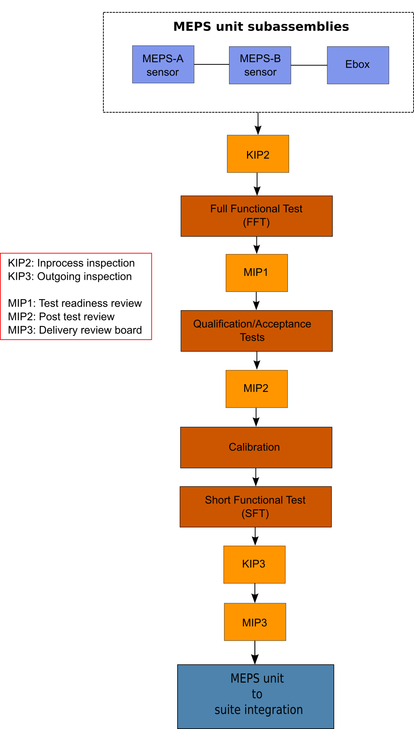
Figure ‎7-2: MEPS unit AIT flow

MEPS sensors (A&B) assembly
MESP sensor heads (A&B) components are fabricated and assembled in parallel for efficiency, however AIV activities follows a staggered schedule optimizing use of team and facility resources. Each of MEPS sensors consists of the solid state detectors (SSD), magnets, mechanical parts and front end electronics (FEE).
The SSDs and magnet system assembly are characterized before sensor assembly. At various stages of sensor assembly, the sensor is verified against requirements before instrument integration begins. Initial sensor testing uses radioactive sources for stimulus. The magnet systems will be tested and characterized prior to assembly. The far field will be re-measured after assembly of the unit. Before being integrated with Ebox assembly an electrical bench test is performed to verify functionality.

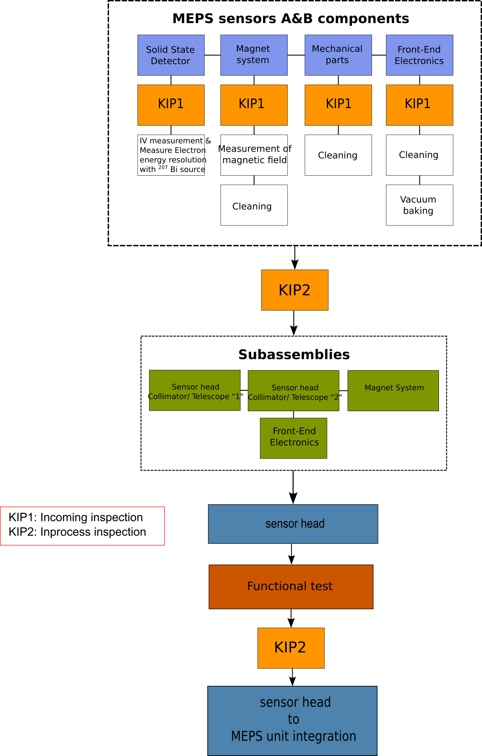
Figure ‎7-3: MEPS sensors (A&B) AIT Flow

MEPS Ebox assembly
MEPS sensors (A&B) share a common Ebox which includes the analog board, digital board, power board and two preamp boards for each of the two sensor heads. The electronics are assembled in to the Ebox as per the drawing package, and integrated with the sensor after some preliminary tests. The assembly steps of each electronic board are depicted in Fig. 7-3. Figure 7-4 shows Ebox assembly steps.

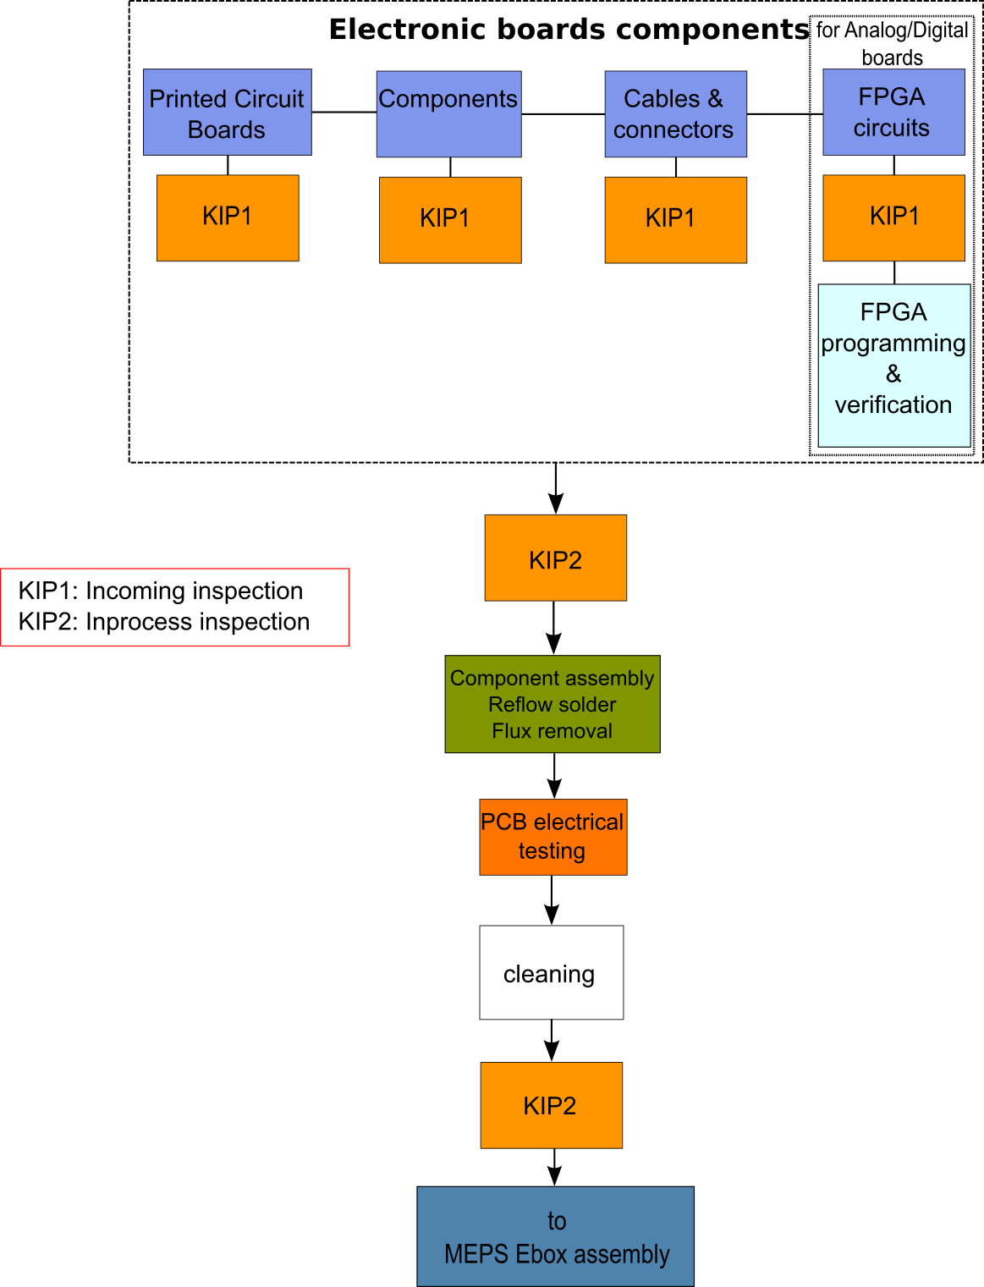
Figure ‎7-4: MEPS electronic boards AIT Flow

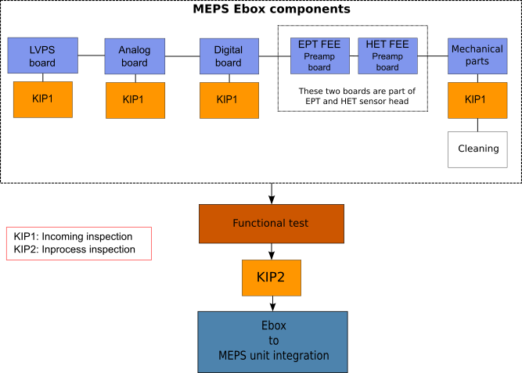
Figure ‎7-5: MEPS EBox AIT Flow

MEPS test matrix
Some qualification level tests will be carried out on earlier models, as indicated below. The final test and verification matrix will be agreed based on the decided model philosophy and project requirements and constraints.
Table ‎7-3: MEPS models testing program

Depending on the type of test, preferably the same test houses which have been used for EPD-Kiel units for Solar Orbiter will be used as below:
- CAU clean room for assembly
- CAU thermal vacuum chamber for thermal balance and thermal cycling tests and bake out
- Airbus DS Environmental Test laboratories in Portsmouth for vibration and EMC
- Airbus DS at Stevenage for DC magnetic tests
- ZARM FAB at Bremen for vibration (for development tests)
- Treo at Kiel for EMC (for development tests)
Otherwise, the other test facilities will be selected.

Calibration Plan
Most checkouts will be done with electronics pulsers and radioactive sources. Some models will be calibrated at facilities such as CAU, PTB, or HIMAC. Appropriate calibration procedures of different units will be used in relevant models.

GSE description
During the assembly of MEPS units, functional tests and verifications some test equipment are needed as flowing:
- Harness (appropriate power and data cables)
- Interface emulator or SpaceWire bricks to provide the DPU command and telemetry protocols and electrical interface
- Power supply
- Connector savers from flight connector stock will be used on the flight unit connectors to minimize mate/demate cycles
- General electrical tools such as oscilloscopes, voltage / current probes etc.
In the following figure the EGSE for EPT-HET instrument of Solar Orbiter is shown:
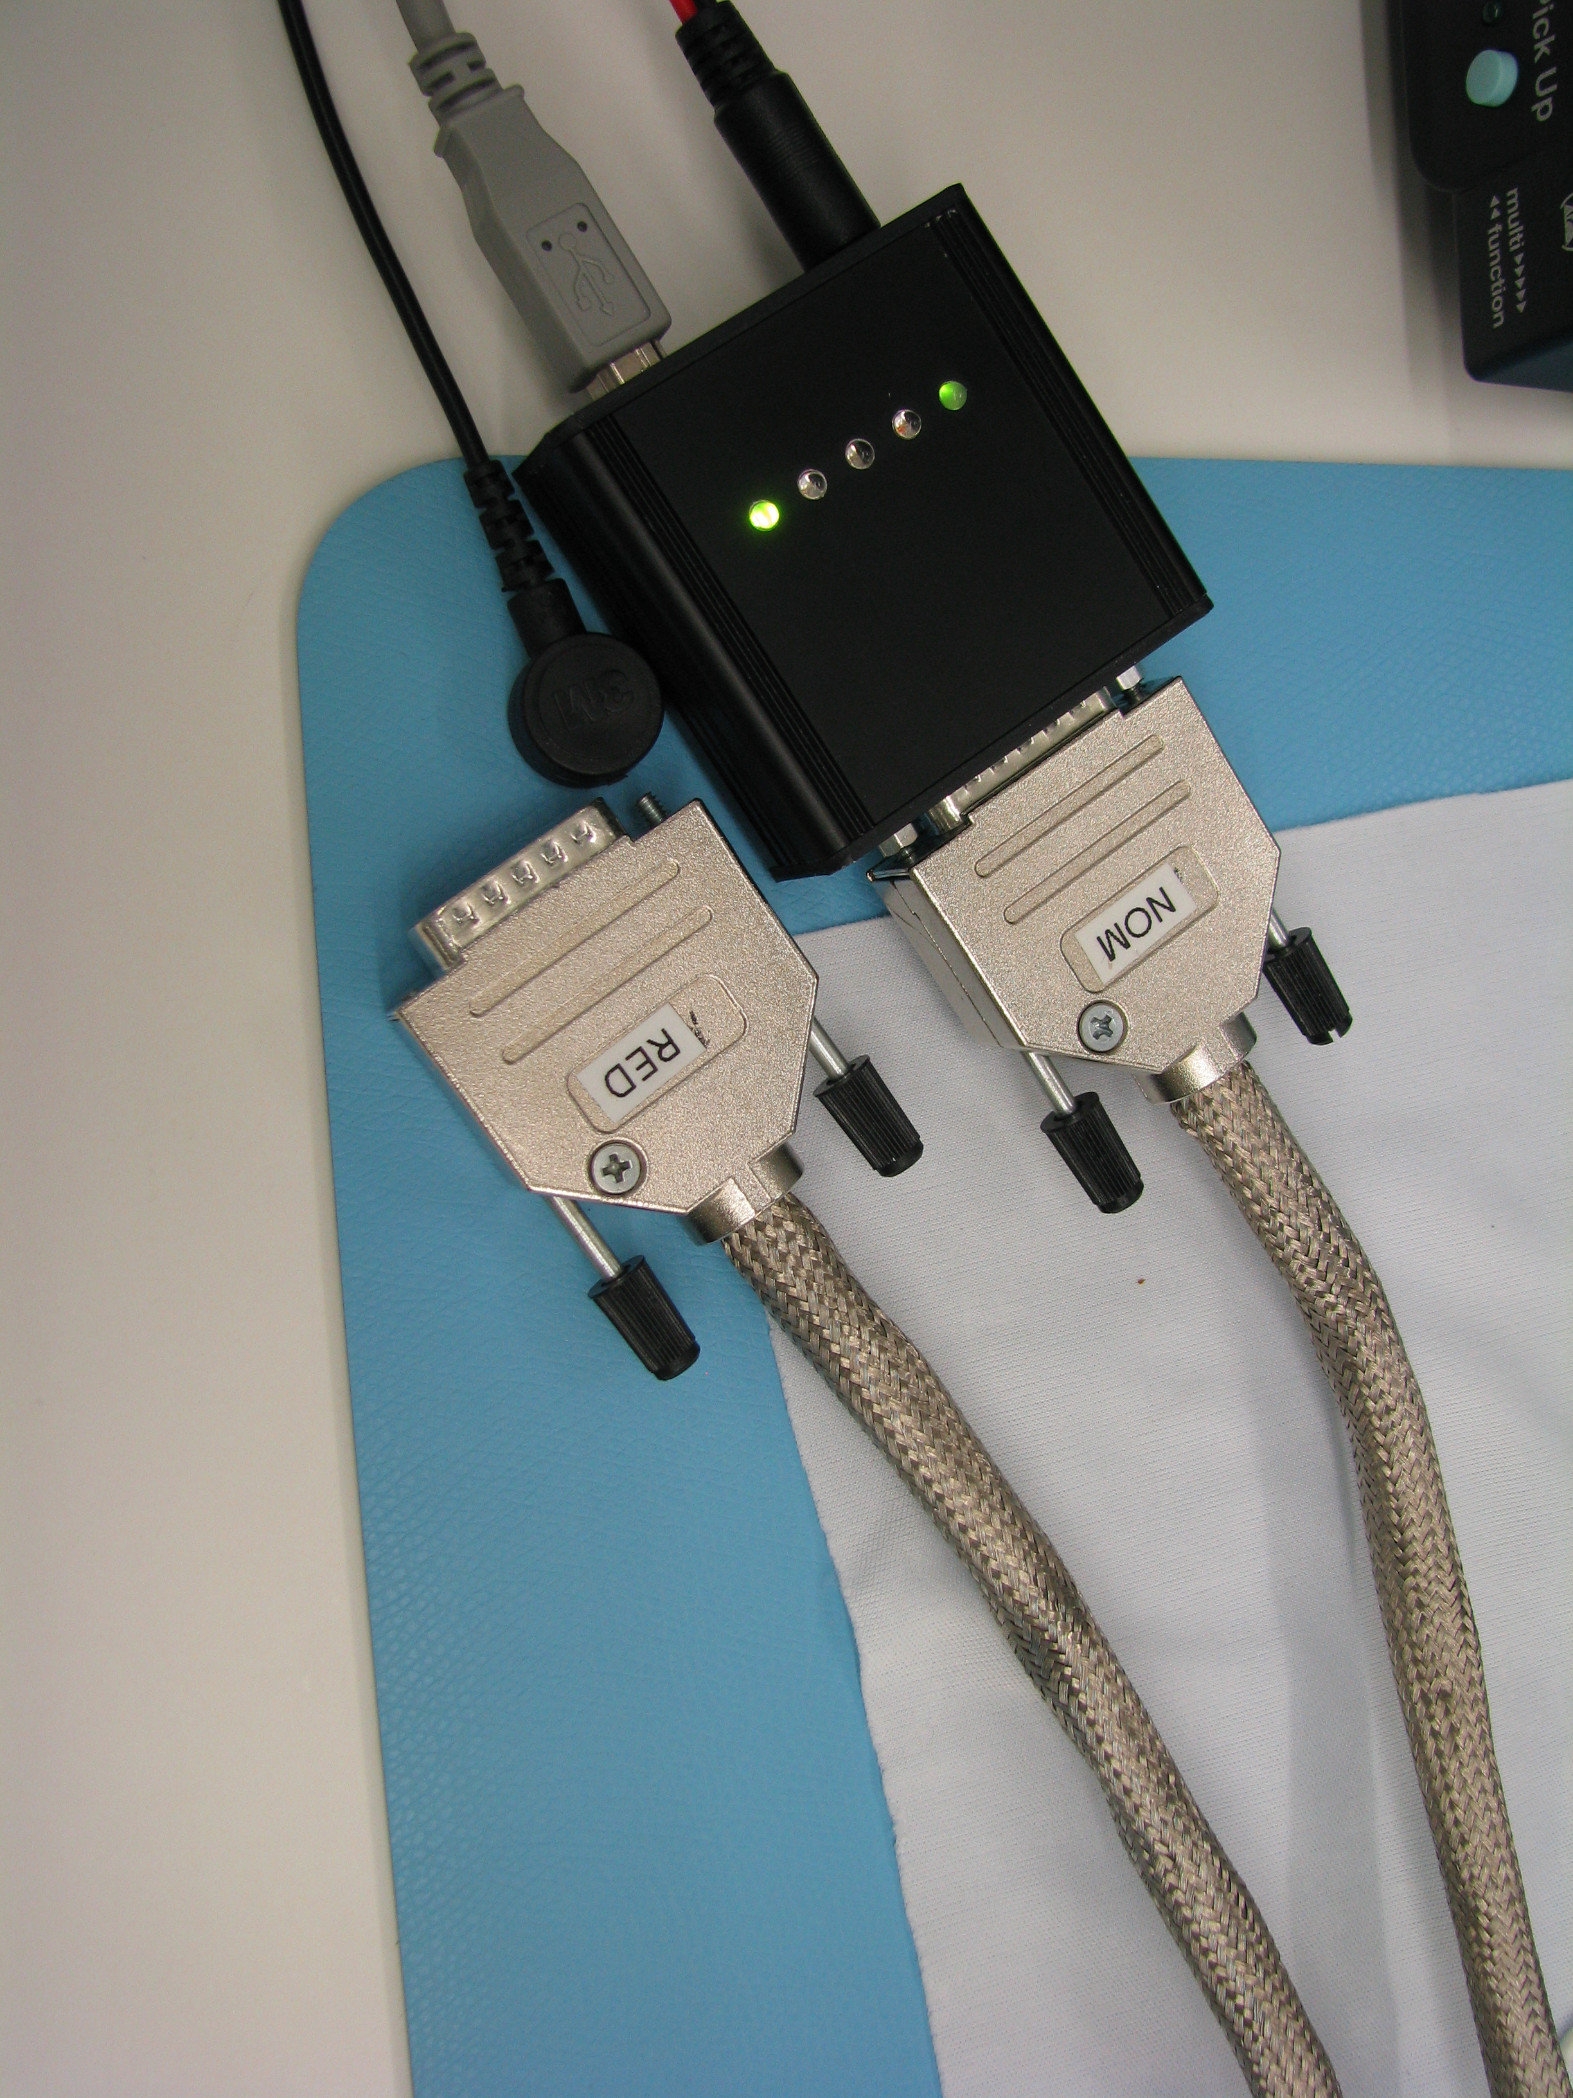
Figure ‎9-6: heritage: EGSE for EPT-HET on board Solar Orbiter

AIT Management

General safety precautions

The following minimum precautions shall be employed to avoid damage or degradation risk during AIV activities:

- Use of ground wrist straps, wear anti-static gloves or finger coats, anti-static clothes and shoes (if the ground is dissipative).
- All test means shall be conductive and connected to ground.
- Protected workstation with a conductive ground sheet.
- Use of conductive transport boxes.

Deviations and Waivers
Waivers or deviations will be filed with the LGR Project Office as appropriate. The MEPS waivers and deviations process are documented according to the in the LGR Product Assurance Plan TBC.

Test documentation
For each test at unit level, a completed test report will be presented after the test. It will include the final as-run test procedure approved by the PA (Product Assurance) responsible and the EPD EMI control engineer and will be accompanied by the test report from the test facility. Also, appropriate discussion will conclude the success/failure of the conducted test.
- The complete list of the test equipment and their calibration information will be included in in the final test report.
- Test anomalies will be reported in the final test report as part of the test documentation and in the form of NCR/RFD when applicable.
- Test deviations will be reported in the final test report as part of the test documentation and in the form of NCR/RFD when applicable.
All test data and reports shall be maintained and made available for inspection, and will be submitted to the LGR PO as well as ESA PO or made available for remote viewing.

Activity Sheets

Example Activity 1
Purpose
This step validates the xxxx

Instrument Requirements to be verified

- Requirement nnn
- Requirement mmm

Integration/Test Configuration and Set-up

ddd

Task# description
- ??
- ??

GSE, STE and Tools
- MGSE
- OGSE
Standard Laboratory Equipment
??
Remarks
???

Example Activity 2
Purpose
This step validates the xxxx

Instrument Requirements to be verified

- Requirement nnn
- Requirement mmm

Integration/Test Configuration and Set-up

ddd

Task# description
- ??
- ??

GSE, STE and Tools
- MGSE
- OGSE
Standard Laboratory Equipment
??
Remarks
???

