TITLE: Instrument Design and Definition Report - MEPS

Document Number: MSSL-LGR-RP-18006 Issue 3 DRAFT Date 04/01/2019

Distribution:
ESA | S Kraft | X
Mullard Space Science Laboratory | R Cole | X
 | IJ Rae | X
 | D Kataria | X
 | D Hu | X
 | R Bentley | X
Imperial College | J. P. Eastwood | X
 | C. Carr | X
IWF | W. Magnes | X
PSI | W. Hajdas | X
Isaware | J. Huovelin | X
 | S. Korpela | X
 | T. Luntama | X
CAS | J. Soucek | X
 | O. Santolik | X
Airbus | E. Monchieri | X

Author: | C Martin – U of Kiel | Date: | 04/01/2019
Manager/Project Office: |  | Date:
Total No of Pages 43
CHANGE RECORD

ISSUE | DATE | PAGES CHANGED | COMMENTS
A | 8/5/18 |  | Draft
B | 29/6/18 | 2.1.2  5.1.1  7.1  7.5  7.7  8.1  9.5 | Updates to address PCR RIDs  Added reference to measurement technique (RID PCR-102)  Clarified the programme to verify the 70keV threshold (RID PCR-93)  Replaced table 7-1 and text following (RID PCR-94)  Performance table added (RID PCR-95)  Clarified no software in MEPS (RID PCR-95)  Updated calibration plan (RID PCR-97)  Added caption for table 9-1 (RID PCR-77)  Added comment on ASIC use (RID PCR-96)
C | 22/08/2018 | 4.1  6.2 & 6.3  6.6 | The new experiments show that MEPS will fulfil the 30keV lower energy limit for detection. Added results.  Sections have been rearranged. Both make reference to Annex1&2 for the thermal & structural conceptual studies.  Parts from old section 6.2 have been moved to 6.6. Two new positions on the front part of the S/C have been added and assessed.
1 | 22/08/2018 |  | Formal version issued for PRR
2 | 02/11/2018 | Pg. 8  Pg. 30-41 | LGR PRR MSSL-33. Including detector radiation assessment  LGR PRR MSSL-35 Included MEPS Performance Modelling results
3 DRAFT | 04/01/2019 | Section 10 | Including analysis of PTB accelerator test data
CONTENTS

1 Introduction 6
2 Applicable and Reference documents 6
2.1.1 Applicable documents 6
2.1.2 Reference Documents 6
3 Definitions and Abbreviations 7
3.1 Definitions 7
3.2 Abbreviations 7
4 Design Requirements 8
5 Measurement principal 8
5.1 Design Trades 8
5.1.1 20 μm ion front detector performance 8
5.1.2 Potential degradation of detector functionality due to radiation 10
6 The case for a second MEPS unit 12
7 Design Baseline 16
7.1 Description of Total Solution 16
7.2 Structural design 19
7.3 Thermal Design 21
7.4 MEPS electronics description 21
7.5 Performance table 23
7.6 Instrument Accommodation 25
7.7 Software architecture 28
8 Calibration 29
8.1 On-ground calibration 29
9 Instrument operation concept 29
9.1 List of Modes 29
9.2 Burst mode 30
9.3 Other modes 30
9.4 FDIR 31
9.5 Instrument data products 31
10 MEPS performance modelling results 33
10.1 Analysis of PTB accelerator data 40

Introduction
This document gives the Instrument suite configuration, system analysis and definition report for the MEPS instrument in the LGR In-situ instrument suite.

Applicable and Reference documents

Applicable documents

[AD-1] | ESA-SSA-LGR-RS-004 Issue 01, In-situ sensing Instruments Requirements Document
[AD-2] | ECSS-M-ST-10C, Project planning and implementation
[AD-3] | ECSS-M-ST-10-01C, Organization and Conduct of Reviews
[AD-4] | ESA-SSA-LGR-LI-0004 Issue 01, Lagrange Missions Instruments Phase A/B1 Study - Document Requirements List (ins-DRL) – named here DRL
[AD-5] | ECSS-M-ST-80C, Risk management
[AD-6] | ESA Cost Estimate template, ‘LGR-III Cost Estimate Template V1.xls’
[AD-7] | ESA-LGR-EST-ENV-SP-001, Issue 01, Lagrange Mission (L5) Environmental Specifications
[AD-8] | ECSS-Q-ST-20C Rev.1, Quality Assurance
[AD-9] | ECSS-M-ST-60C, Cost and schedule management, 31 July 2008
[AD-10] | ESA-SSA-LGR-LI-0004, Lagrange Missions Phase A/B1 Instrument Studies Document Requirements Definition (INS-DRD), Issue 01

Reference Documents
[RD-1] | ESA-SSA-LGR-RS-001, Issue 01, Lagrange Missions (L1 and L5) Mission Requirements Document
[RD-2] | ESA-SSA-LGR-RS-002, Issue 01, Lagrange Missions (L1 and L5) System Requirements Document
[RD-3] | SWE-OHB-DD-0023_L5 Final Report_Issue 1.1, Final Report SWE-X Study, Enhanced Space Weather Monitoring System Study (Phase 0) L5
[RD-4] | SWE-OHB-DD-0011_L1 Final Report_Issue 1.1_Signed Final Report SWE-X Study, Enhanced Space Weather Monitoring System Study (Phase 0) L1
[RD-5] | AirbusDS-SWE-DD0011 L1 and L5 Final Report Issue 1, Review 2, Final Report SWE-X Study, Enhanced Space Weather Monitoring System Study (Phase 0) L1 + L5
[RD-6] | MSSL-LGR-RQ-18001, LGR-III Instrument Requirement Review
[RD-7] | "Space Sci Rev (2008) 136: 363–389. The Solar Electron and Proton Telescope  for the STEREO Mission. R. Muller-Mellin et al. In section 4.6 the Monte Carlo simulation explains the contamination issue and how is solved by subtraction techniques."

Definitions and Abbreviations

Definitions
Item | Definition

Abbreviations

CME | Coronal Mass Ejection
DOCS | Deep-space Optical Communication System
DPU | Data Processing Unit
EDAC | Error Detection and Correction
EEE | Electrical, Electronic and Electro-mechanical
EMC | Electro-Magnetic Cleanliness
EOL | End of Life
EPT | Electron Proton Telescope
HV | High Voltage
IMF | Interplanetary Magnetic Field
LCL | Latch Current Limiter
LET | Linear Energy Transfer
LGR | Lagrange
MAG | Magnetometer
MCP | Microchannel Plate
MEPS | Medium Energy Particle Spectrometer
MICD | Mechanical Interface Drawing
MRAM | Magneto-Resistive Memory
NGRM | Next Generation Radiation Monitor
PLA | Plasma Analyser
RADEM | Radiation Monitor
RAM | Random Access Memory
RAMS | Reliability, Availability, Maintainability, Safety
RM | Radiation Monitor
SEE | Single Event Effects
SEP | Solar Energetic Particles
SIR | Stream Interaction Region
SIXS | Solar Intensity X-ray and particle Spectrometer
SO | Solar Orbiter
SRAM | Static Random Access Memory
SSA | Space Situational Awareness
SWA | Solar Wind Analyser
TC | Telecommand
TID | Total Ionizing Dose
TM | Telemetry
TOF | Time of Flight
XFM | X-ray Flux Monitor

Design Requirements
The current set of requirements and response is stated in [RD-6].

Measurement principal

Design Trades

20 μm ion front detector performance
The electron energy coverage requirement (30-600keV) will be easily met as it was done with Solar Orbiter/EPT.
But the energy lower end for ion detection has two ranges:

- [1.5MeV/n, 6 MeV/n] → The detection and complete identification of these p+, ions is achieved by means of the ΔE-E technique. No problems expected.
- [30keV/n,1.5MeV/n] → These are stopping particles in the entrance 20μm thickness detector. These particles will be detected above threshold 30keV for protons (TBC, see later) and the identification will be based on groups of energy deposition in this detector. Complete elemental identification in this energy range cannot be met without a time of flight (TOF) instrument.
The Kiel team is verifying the 30keV detection threshold given by similar instruments (LET onboard STEREO).
New experiments in the lab have been performed to determine the detection threshold on an old STEREO/LET detector
- Sources in use 241Am, 133Ba, 207Bi
- The radioactive sources have allowed to perform a calibration in the low energy range
- The detector noise is around 10keV sigma for gamma detection using CANBERRA preamplifiers and spectroscopic amplifiers
- 31keV gamma peak from 133Ba is well resolved
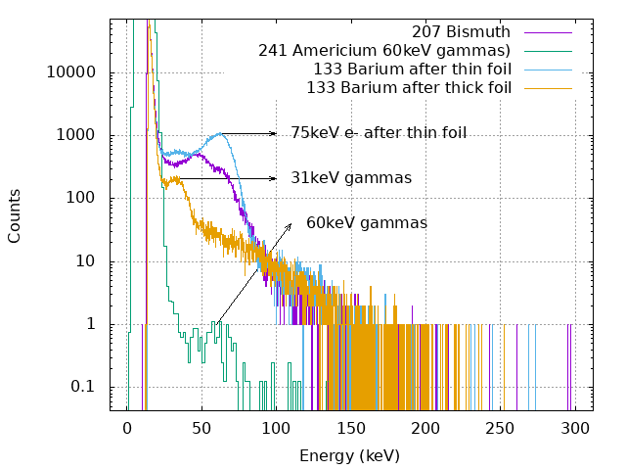
Figure 5-1: Gamma and conversion electrons calibrated spectra acquired with an old STEREO/LET 20μm thick detector

Following experiments include 241Am alpha experiment in vacuum for dead layer determination and a proton experiment at PTB in Sept-Oct 2018 with a new set of detectors more representative in size.
The MEPS team is planning to continue with the experiments in the lab and in accelerator facilities to provide a more precise value of the detection threshold of the 20μm detector. Conversations with the detector manufacturer in order to decrease the thickness of the dead layers (and thus, to reduce the threshold limit) have been initiated as well.

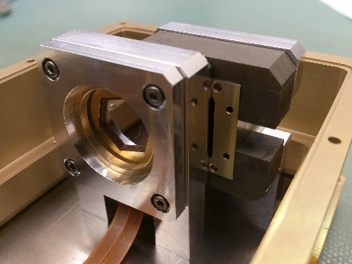
Figure 5-2: 20-300-300 μm demo model detector stack built for MEPS

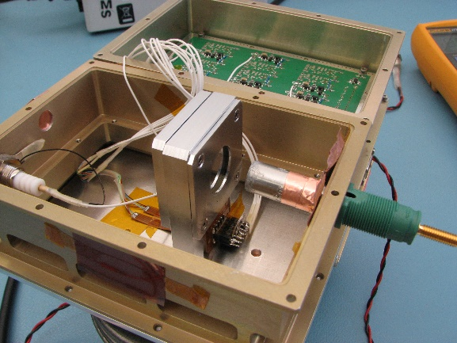
Figure 5-3: Alpha test with the demo detector stack

Potential degradation of detector functionality due to radiation
ESA has requested during PRR an assessment on potential degradation of the Silicon detector functionality due to the radiation environment.
It is well known that the PIPS Silicon detectors can withstand high levels of radiation without significant degradation of functionality. The main effect of the radiation damage is the increase of the detector leakage current leading to an increase in the detector noise level. Radiation damage is only one of the factors that can affect directly the detector performance. Other main factors are the degradation of the radiative surface properties (thermal control) leading to higher temperatures of the instrument and variations of the bias detector voltage due to derating of electronics components.
In any case, the PIPS technology has been extensively used in radiation detectors for space missions in a variety of environmental radiation conditions and their functionality has always exceeded the planned nominal and extended missions.
An assessment report on SOHO/EPHIN increasing leakage current during the mission duration can be found in http://cxc.harvard.edu/contrib/juda/memos/ephin/leakage_current/index.html
The following figure shows the EPHIN detector B leakage current for various temperatures as a function of time taken from month-long data blocks. The temperature is indicated by symbol color.
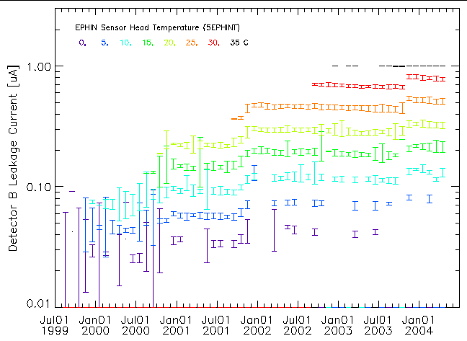

Figure 5-4: Detector B leakage current for various temperatures as a function of time taken from month-long data blocks. The temperature is indicated by symbol color.

As it can be seen the leakage current increases only slightly during the mission and much of the increase with time comes in discrete steps. The times of these steps coincide with times of major increases in the high-energy particle flux (solar storms). Also, it can be seen that the temperature effects on performance are much higher than any electronics or detector radiation degradation effects.
The usual method to compensate for increasing detector leakage current is to assure low temperatures on the detector compartment by means of a good thermal design and the use a detector BIAS voltage higher than the necessary for full depletion.

The case for a second MEPS unit
Early on during solar particle events, energetic particles flow along the IMF/Parker Spiral field, before becoming more isotropic due to in-transit scattering processes later on in the event at any given heliospheric distance. Hence, energetic particle instruments such as MEPS require look directions that are pointed along the general Parker spiral/IMF topology.
However, these are average or typical orientations, and in reality the real IMF can be significantly different to that of the average IMF. With the bulk solar wind, there are variations in the orientation of the solar wind, but these are small variations on a near-radial solar wind flow. However, Parker spiral angle is not as well ordered as bulk solar wind flow and IMF orientation are much more complex and variable.
We agree that we were to report on a single unit MEPS during the negotiation meeting. Following this negotiating meeting, we had several telecom and email exchanges whereby Kiel could discuss why and when two units may be needed for an operational SEP detection for LGR. This is why the U of Kiel team continues to push for study of both one and two units.
Each unit has two sensor heads on top of it. Each sensor head has two telescopes. Each telescope has a forward and backward looking detector stack, where one direction measures electrons and the opposite direction measures ions. In this configuration, two telescopes will look approximately along the Parker spiral angle to provide redundancy. More telescopes are required to ensure that MEPS (and any particle instrument) will see the particle event already at its onset and determine key characteristics of the event, such as onset time and location. Since the particles stream along the IMF this means that the IMF needs to fall approximately into the telescope opening. Because the particle pitch-angle distribution is not a perfect pencil beam, a certain width around the IMF can be allowed. Once the event continues, the SEPs isotropise due to scattering and then it would become sufficient to have a single look direction, but the key component of this detection is to determine onset time and location, and for that, as many look directions as possible is required.
Below some cases are shown where the IMF would not lie in the field-of-view of MEPS if there were only one unit. They were all taken from STEREO’s SEPT instrument which may serve as a demo model of MEPS (SEPT was also built at CAU Kiel). These configurations show that not all events are seen, or the event intensity is underestimated, or that the timing of the event is not correct if we have only one (forward-backward) look direction. These are all the basis for justification for a second MEPS unit to cover the entire range of IMF orientations for timing, intensity and onset of Solar Energetic Particle events.
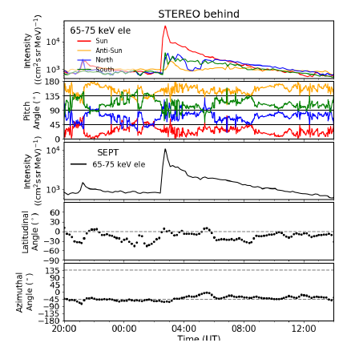
Figure 6-5: Event intensity only captured in one look direction
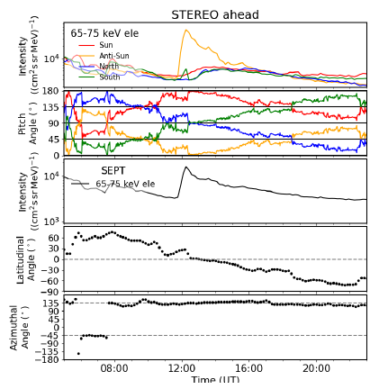
Figure 6-6: Event seen only in anti-sunward telecscope on account of non-standard Parker spiral angle
In summary, to capture any and all SEP onsets, a 4Pi view is required, which is not possible for a MEPS-like instrument. The Kiel group have not yet done a statistical study from STEREO SEPT data as to how often a one-unit MEPS would likely miss the onset, intensity and timing of an SEP onset, but this is the reason that we propose to continue to study both a one-unit and a two-unit MEPS instrument.
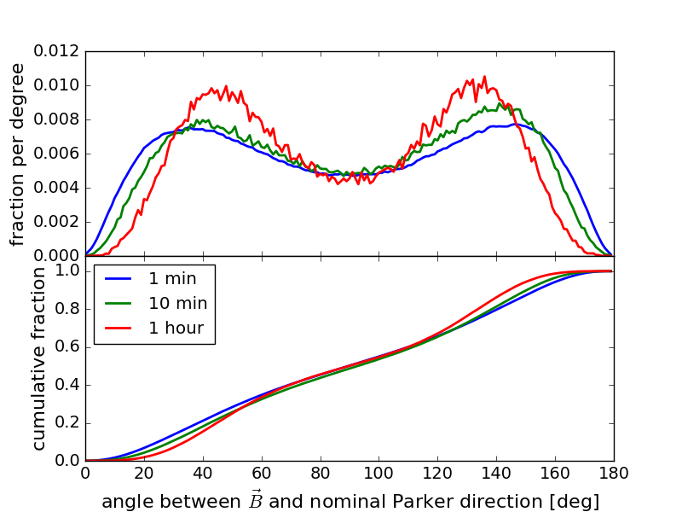
Figure 6-7: Magnetic field vector with respect to the nominal Parker field direction for 2007 - 2017 using STEREO MAG data. Data are shown for 1, 10 and 60 minute averages.
Figure 6-7 illustrates this quite clearly. We have taken 1, 10, and 60 minute averages of the STEREO-A MAG measurements of the IMF from 2007 – 2017 and plotted the angle of the measured IMF with respect to the nominal Parker direction (here assumed to be 45° from the Sun-STEREO line). The top panel shows a histogram of the angular distribution; the bottom panel shows the cumulative distribution. This, for a telescope opening of 45 degrees (and thus a half-angle of 22.5 degrees), we see that the IMF falls inside the telescope opening less than 20% of the time, depending on the IMF average used.
A more detailed description of the study is given in the ppt presentation attached, but the summary is given in the following table. Table 6-1 gives the fraction of time during which a 40° wide particle event would be seen in the individual forward-backward-looking MEPS telescopes:

Telescope | 1 min data | 10 min data | 60 min data
T1 | 50% | 46% | 40%
T2 | 23% | 18% | 11%
T3 | 50% | 46% | 40%
T4 | 22% | 17% | 10%
T1 or T2 (1 MEPS unit) | 67% | 61% | 49%
T3 or T4 (1 MEPS unit) | 67% | 60% | 48%
In any of the 4 MEPS telescopes, T1, T2, T3, or T4 | 86% | 77% | 60%
Table 6-1: The fraction of time during which a representative 40 degree wide particle event would be seen in different MEPS unit configurations.

Design Baseline

Description of Total Solution
The MEPS instrument is a particle instrument measuring the energy spectra and angular distributions of energetic electrons (30-600 keV) and ions (30-6000 keV/nuc). The full experiment consists of one unit which provides two double-ended telescope pairs (sensor heads) with four view cones per pair, two dedicated for electrons and two for ions. Utilizing any spin of the spacecraft, MEPS observations cover the full sky with a total of eight electron and eight ion view cones. As the L5 S/C is not a spinner, MEPS still provides crucial pitch-angle information to determine whether the event is scatter free. This is an important indicator for interpreting the timing information of the space weather event. Figure 7-8 shows the MEPS unit, with eight view cones.
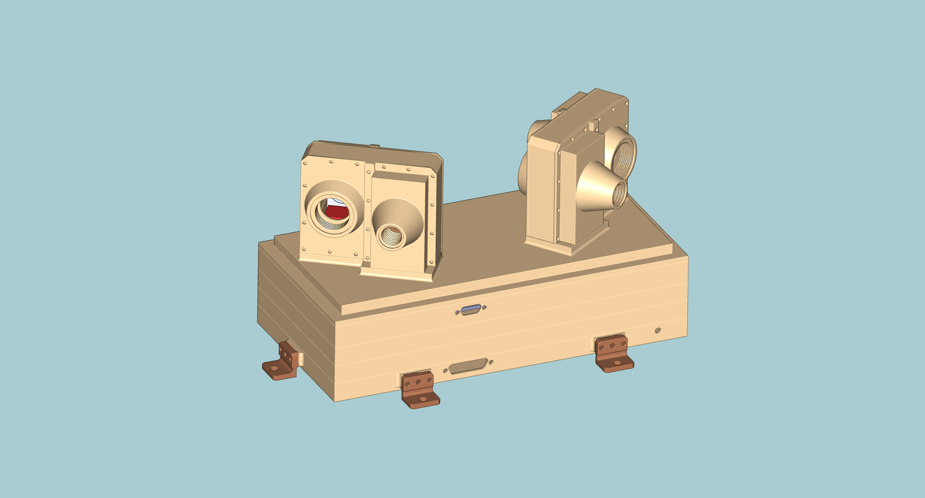
Electronics
Module
MEPS-A
Sensor
MEPS-B
Sensor
Figure 7-8: MEPS single unit CAD-study with two sensor heads, each of which has two double-ended telescopes. One MEPS unit provides eight view cones in total, four for electrons and four for ions.

Units: 1
Sensors: 2 per unit
FoVs: 4 double FoVs per unit. The FOVs for each sensor are separated by 70°
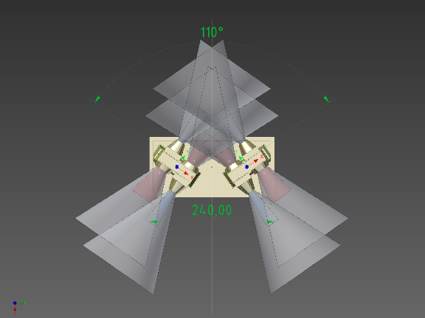

Angular resolution: 45° full angle
Energy range:
- 30keV/n-6MeV/n for the 20-300-300 um detector stack solution
Volume: 300x160x175 mm3 (including potential radiators and MLI)
Power: 5W for 1 unit
Mass: 2.4 kg for 1 unit
Data Products: Particle VDF
Cadence: 5(1) minutes
TRL: 6 (most parts 8-9)
Table 7-2: Proposed MEPS instrument heritage of MEPS from EPT Solar Orbiter Technical Parameters
The two ends of a telescope observe electrons and ions, respectively. Each telescope consists of a stack of three solid-state detectors (Figure 7-9). On one end, the outer detector is covered with a thin polyimide layer or parylene foil (TBC), stopping ions below a few hundred keV/nuc but letting electrons pass almost unaffected. This uppermost detector (300 μm thick Si) on this side is operated in anticoincidence with the second (middle) detector and thus observes the energy spectrum of stopping electrons. The other end of the telescope has a broom magnet (instead of a PI layer) that defects electrons below a few hundred keV (see Figure 7-10 for electron deflection measured with the Solar Orbiter EPT EM). This side of the telescope employs a 20 μm thick Si detector in front of the 300 μm Si detector in the middle, which thus form an ion telescope observing at energies from 30-6000 keV/nuc. Ions passing the thin first detector can be identified at high energies (MeV/nuc range) using the d E/dx vs. E technique, operable at Ekin ≥ 1 MeV/nuc for protons and alphas and ≥ 2 MeV/nuc for heavier species. Lower ion energies can nevertheless be resolved using the middle detector as an anticoincidence: Anything above 1.2 MeV energy deposit in the thin detector is heavier than protons, which in return means that the thin detector may be used as a Z ≥ 2 channel SSDs for deposited energies > 1.2 MeV (or 300 keV/nuc for He). The same logic applies for penetrating He, enabling a Z ≥ 6 channel for energies > 4.8 MeV; or 420 keV/nuc for C, 360 keV/nuc for N and 310 keV/nuc for O.
Figure 7-9: Working principle of an EPE double-ended telescope. The polyimide layer stops ions but lets electrons pass, whereas on the other side electrons are deflected by magnets and ions pass unaffected. The thin detector on the right side enables the separation of different ion species via the d E/dx vs. E-method (in the MeV/nuc energy range; for the separation at lower energies see text).
The permanent magnets of one sensor head (double-ended telescope pair) form a quadrupole, significantly reducing the far field. The far field is reduced even further by the other sensor head on the same unit, since its quadrupole forms an angle of 70° with respect to the first sensor head. The MEPS unit integrates the sensors and electronics in a single package. Right below the sensors in the electronic box are the preamp boards, followed by an analogue board and the back-end electronics (digital and LVPS-board[s]). Pre-flight ground energy calibration (1 % level) of all detector elements, on-axis active area calibration, selected off-axis directions active area calibration and dead-time calibration will be performed. Calibration quality will be monitored in-flight using measured data and cross-calibration with suprathermal electron/ion instruments.
Figure 7-10: Electron Proton Telescope on Solar Orbiter (EPT) EM measurements with a Bi- 207 source. The conversion electron lines at 482 keV and 554 keV are seen on the PI-side (Det 1) but vanish on the magnet-side (Det 2).

Structural design
One unit MEPS consists of mainly three subassemblies, a CAD screenshot is shown in Figure 7-11.
- Electronics module containing the power, analog-digital and preamplifier boards.
- MEPS-A sensor
- MEPS-B sensor
CAD screenshots of MEPS unit as well as all subassemblies are shown in Figure 7-11 and Figure 7-12.

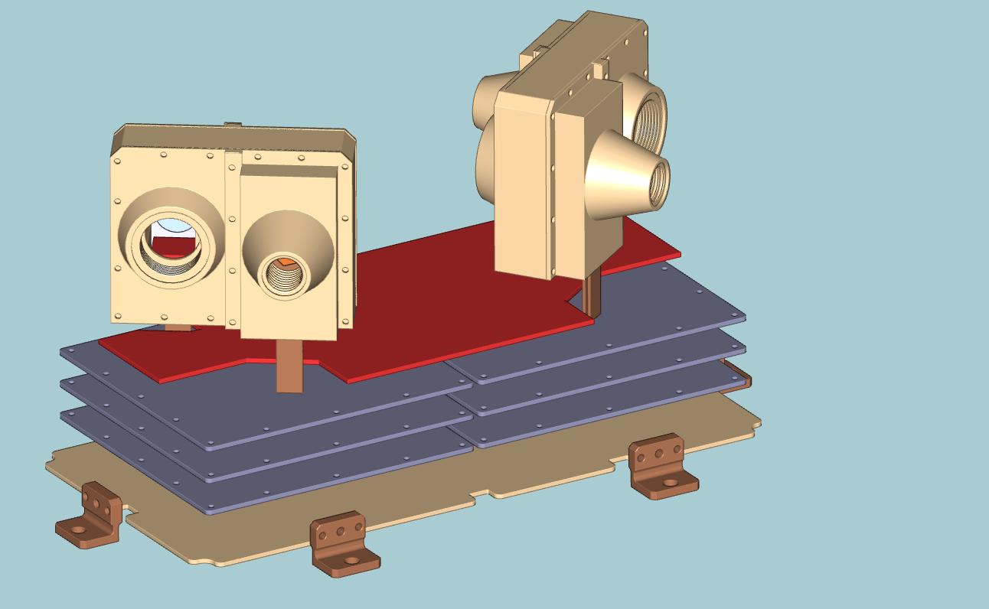
Preamp board
Analog board
Digital board
Power board
Figure 7-11: Boards on the electronics module

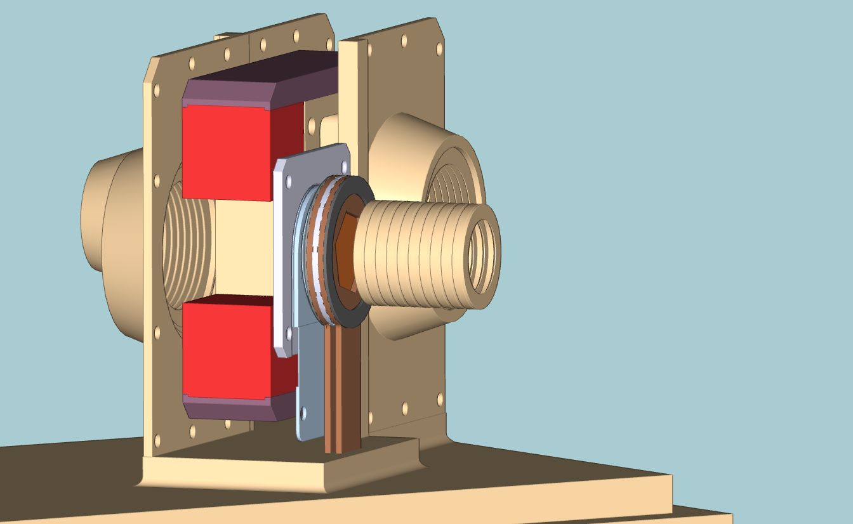
Detector stack
Electron collimator
Proton-Ion collimator
Magnet system
Figure 7-12: MEPS sensor head
All boxes are made of AL-6061 T6. The IF plate is bolted to the Lagrange S/C deck by means of four screws (TBC).

The MEPS conceptual structural design study can be found in Annex B.

Thermal Design
A passive thermal control design is foreseen for MEPS instrument. The unit passive thermal design is based on the assumption that the unit is thermally isolated from the S/C. This thermal design is done in EPT-HET (Electron, Proton Telescope- High Energy Telescope) in Solar Orbiter EPD (Energetic Particles Detector) In-situ payload.
For the passive thermal design, external radiators or radiative surfaces are considered for dissipating the internal power of the instrument to space. An independent power budgets for the operational and non-operational (survival) heaters are required. This power budget depends on the S/C and mission environmental conditions in different phases. In addition, based on the S/C thermal control design, for the unit survival heaters and their corresponding thermistors, a separate power/data line (survival connector) maybe needed in addition to the main connector between the unit and ICU. This separate connector between the unit and the S/C is controlled by the S/C thermal control subsystem.
The foreseen thermal hardware for the passive thermal design, consist of radiators with OSR (Optical Solar Reflector), SSM tapes (Second Surface Mirrors), MLI (Multi-layer Insulation), optical paintings, insulating material etc.
Note: If the “unit is thermally isolated from the S/C” assumption is not applicable, the unit thermal design concept may change. This can be limited to the passive thermal control design or may result to a change from passive to an active thermal control design.
Regarding the mechanical interface, the assumption is having a bracket as an interface between the unit and the S/C. The main points need to be considered for the mechanical interface (i.e. unit-S/C mounting bracket) are as following:
- Required mechanical fixation pattern defined by the mechanical design of the unit, i.e. enough number of the mechanical joints.
- Grounding location on the bracket.
- Preliminary information for the harness routing and purge pipe routing (if applicable) in the unit vicinity.
- Design characteristics such as structural stiffness and first resonance frequency.

The conceptual thermal design study can be found in Annex A.

MEPS electronics description
A block diagram of the MEPS electronics is shown in Figure 7-13. MEPS electronics has four boards:

- Preamplifier board
  - Charge Sensitive Preamplifiers for the detector signals
- Analog board
  - Shaping the signals from the preamps and convert to digital ADC values
  - The FPGA on this board detects the peak of the shaper signals
  - Builds the PHA data
  - Contains the housekeeping ADC
- Digital board
  - Builds the data products
  - Manage the communications with the DPU
- Low Voltage Power Supply (LVPS) board
  - Supply different voltages to the different boards.

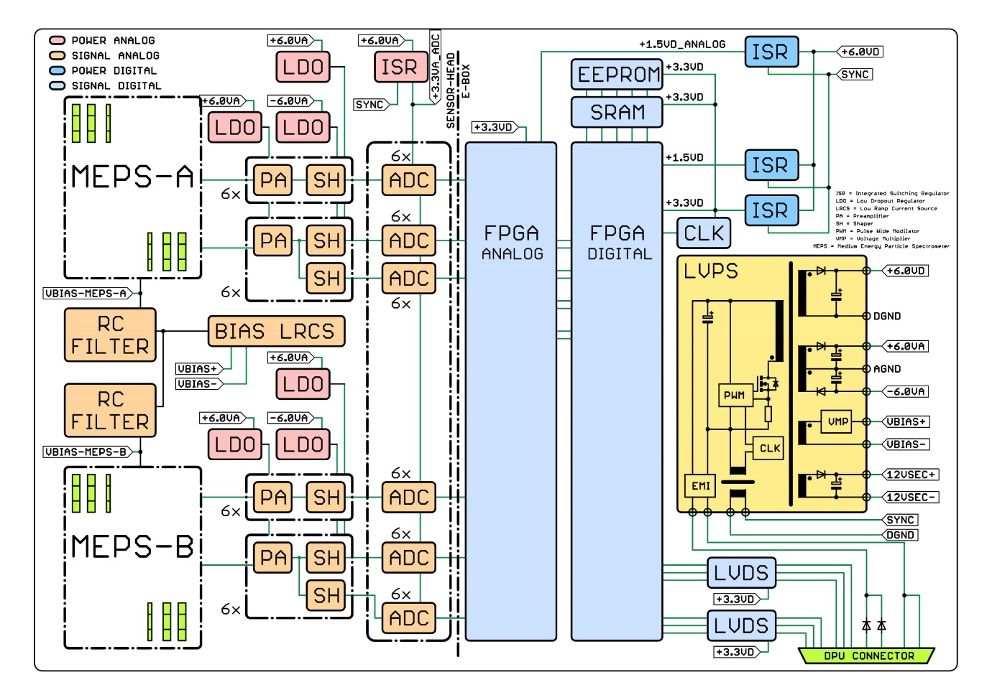
Figure 7-13: MEPS Block diagram
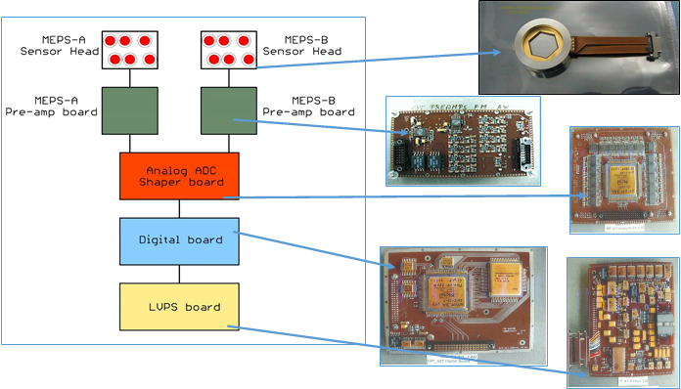
Figure 7-14: MEPS instrument function block diagram

Performance table
MEPS unit has the following performance presented in the table below
Parameter | Method | Performance
Energy measurement | Energy loss, full stopping range | **30keV/n-6MeV/n for protons-ions  30keV-1MeV for electrons
Measured particles | ΔE-E method | electrons, alpha particle, CNO group (goal: resolve He3 and He4, C, N and O, Si/Ne, Fe, Ni, plus single a measure for heavier ions).  Good resolution of ions from 1.5MeV/n
Energy channels for the energy range of the ions. | Electronics based | MEPS will have either 32 or 64 energy channels for ions, depending upon instrumental configuration.
Energy channels for the energy range of the electrons. | Electronics based | MEPS baseline configuration is to have 16 electron channels for the energy range of the electrons.
FoV | 45° Full angle | MEPS covers this requirement by using multiple sensor heads each having a 45° full opening angle to obtain critical pitch angle information.
Pointing directions | Parker spiral | The MEPS instrument shall be centred at the ecliptic plane and look along the Parker spiral.  (Goal: Two oppositely directed sensors, along and opposite to the Parker spiral and centred in the ecliptic plane). Two additional double FoVs will cover the almost perpendicular to the parker-anti-parker direction.
Front-end electronics | Kiel Direna concept | Amplification chain: Charge sensitive preamplifiers+ shapers+ADCs + FPGA based processing solution
Measurement cadence | Required 5 minutes (1 min). | Currently the MEPS instrument (based upon the Solar Orbiter EPT instrument) can operate at a cadence of 15 seconds to obtain 3D VDFs and produces a telemetry rate of 13kbps. Using appropriate scaling, there is no issue in MEPS providing both the requirement and goal measurement cadence.
Data products | Energy spectra | Spectra, PHA, counters, Housekeeping, high-time resolution data
** 30keV detection threshold under investigation (see study case)
Table 7-3: Performance Table

Instrument Accommodation
The MEPS unit has two sensor heads on top of it. Each sensor head has 2 telescopes. Each telescope has a forward and backward looking detector stack, where one direction measures electrons and the opposite direction measures ions. Thus, this configuration provides a total of 8 FoVs per unit (Figure 7-15). Each FoV covers a full opening angle of 45°. The viewing directions of the two sensors form an angle 70° to cover the pitch angle distribution.
The current geometrical factor of the MEPS unit is 0.1 cm² sr for the electron telescope and 0.09 cm² sr for the proton-ion telescope.
Figure 7-15: MEPS FoV configuration.
The spacecraft coordinate system is showed in Figure 7-16.
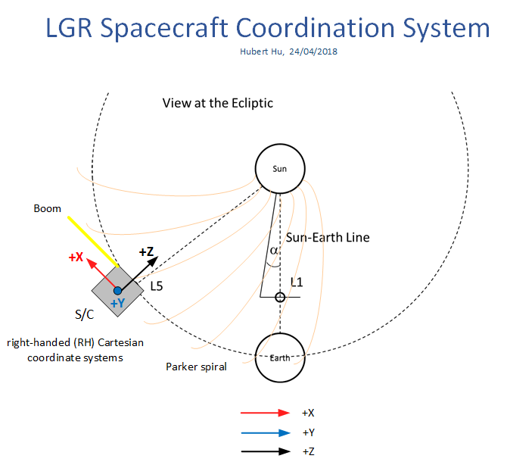
Figure 7-16: S/C coordinate system

The MEPS unit is mounted (using brackets) external to the spacecraft in any of the two positions shown in Figure 7-17. Ideally, 2 MEPS on these two positions would be needed to increase the probability to see the onset of a solar event from a 50% to a 86% for a 1 min time resolution.
Figure 7-17: Two possible S/C positions to accommodate a MEPS unit.
Other less optimal positions on the front part are shown in Figure 7-18 (for the Airbus based S/C):

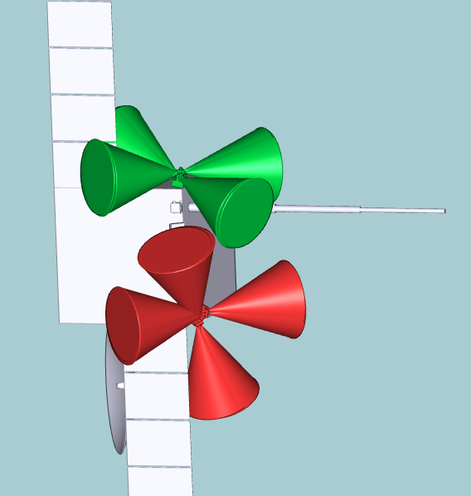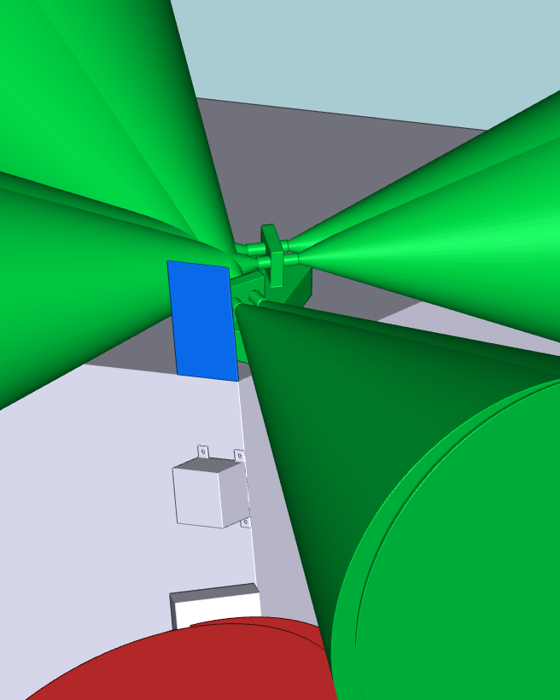
Figure 7-18: Left: Other two front S/C positions to accommodate the MEPS unit. Please note that this CAD corresponds to the Airbus proposed S/C. Right: Example of local sun-shield for the “green” position. This sun-shield avoids the illumination of a great part of the MEPS instrument during normal operation.

In these two front positions, the unit is exposed to direct solar illumination in steady state. The unit thermal control systems will need to cope with this excess of heat by means of radiators and MLI or the installation of a local sun-shield. The main drawback of these positions is the direct sun illumination on some of the instrument collimators. The direct solar illumination on the instrument will have a performance impact. If the instrument collimator and/or detector receives solar illumination, the leakage current induced in the detector will increase and the signals will become noisy and unusable. Thus, the unit collimators cannot receive direct illumination during nominal operation. The unit shall be switched off during manoeuvres.
In the configuration shown in Figure 7-18, the installation of a small local sunshield to avoid light entering in the proton-ion collimator seems to be possible. See Figure 7-18 screenshot on the right side.
The collimators in the red configuration are more difficult to protect due to the special orientation and the presence of the solar panel.

The MEPS pointing requirements are not very strict since the FoV is fairly broad. One field of view pair (electron/ion) on the MEPS unit shall point approximately parallel-antiparallel to the Parker spiral (45° in the ecliptic plane). The other two double ended FoVs shall point in different directions (approximately 60 – 70° away from the Parker angle) to cover the pitch angle distribution. The exact pointing directions shall be agreed during accommodation studies. Thus, the MEPS will provide 4 independent FoVs to provide a minimum pitch-angle coverage. The STEREO SEPT team have found that the four STEREO/SEPT FOVs are insufficient.

Since the STEREO SEPT team have found that the four STEREO/SEPT FOVs are insufficient, The MEPS team has proposed two units instead of one (accommodated on the above mentioned S/C positions) providing almost 6 independent FoV and provide a good coverage on pitch angle distribution and a reasonable detection of the event onsets (see trade off studies).
Due to the nature of measurements and intrinsic angular resolution, MEPS does not have strict alignment or pointing stability requirements. Nor do the MEPS sensors have strict pointing requirements relative to each other. Alignment/pointing accuracy of <2° (knowledge 1° (on ground)) is sufficient for all MEPS sensors relative to each other. Alignment with this accuracy is expected to be possible by mechanical design.
MEPS alignment/pointing accuracy w.r.t. S/C reference frame shall be better than 2° with knowledge on ground better than 1°.
The UFoV (Unobstracted FoV) shall be 90% of the FoV as a minimum for MEPS, meaning that up to 10% of the solid angle could be obstructed for each of the 8 FoVs of the unit (TBC)
MEPS is susceptible to straylight. Especial care shall be put on the instrument accommodation and placement of yokes, solar arrays and other S/C structures to avoid reflected light to instrument openings. The induced leakage current due to straylight on the MEPS detectors shall not exceed 0.1nA (TBC)

Software architecture
N/A. MEPS does not operate with software but with firmware

Calibration

On-ground calibration
Most checkouts will be done with radioactive sources. The electrical model will be calibrated at CAU with available radioactive sources and our ion and electron source. For the electrical and flight unit calibration, we will also use the PTB accelerator facility in Braunschweig Germany for proton-alpha beam experiments.In-flight calibration
During instrument commissioning, ambient particle intensities will be used to check the MEPS performance. If available, observations from other particle instruments (e.g. STEREO/SEPT, ACE/ULEIS, STEREO/SIT, SO/EPD) near LGR will be used to cross-calibrate the MEPS instrument response.
MEPS does not require special spacecraft manoeuvres or operations during flight calibration.

Instrument operation concept

List of Modes
The instrument modes are shown in Figure 9-19.
Power off: Sensor unit is not powered. Power on will transition sensor unit to Unconfigured mode.
Unconfigured: Sensor unit is powered, but not configured. Sensor unit accepts command messages, but does not autonomously create any telemetry. Sensor unit can safely be powered off anytime. Sensor unit can be transitioned to Standby or Operational by commanding with a sensor message.
Standby / Housekeeping: Sensor unit is configured to process and telemeter housekeeping data. Sensor unit accepts command messages, Detector frontend is disabled, so no science data is taken, processed or telemetered. Sensor unit can safely be powered off anytime. Sensor unit can be transitioned to Operational or Unconfigured by commanding with a sensor message.
Operational / Science + HK: Sensor unit is configured to process and telemeter housekeeping data. Sensor unit accepts command messages. In addition, detector frontend is enabled, particle events are accepted and processed. Generates science telemetry. Sensor unit can safely be powered off any time. Sensor unit can be transitioned to Standby or Unconfigured by commanding with a sensor message.

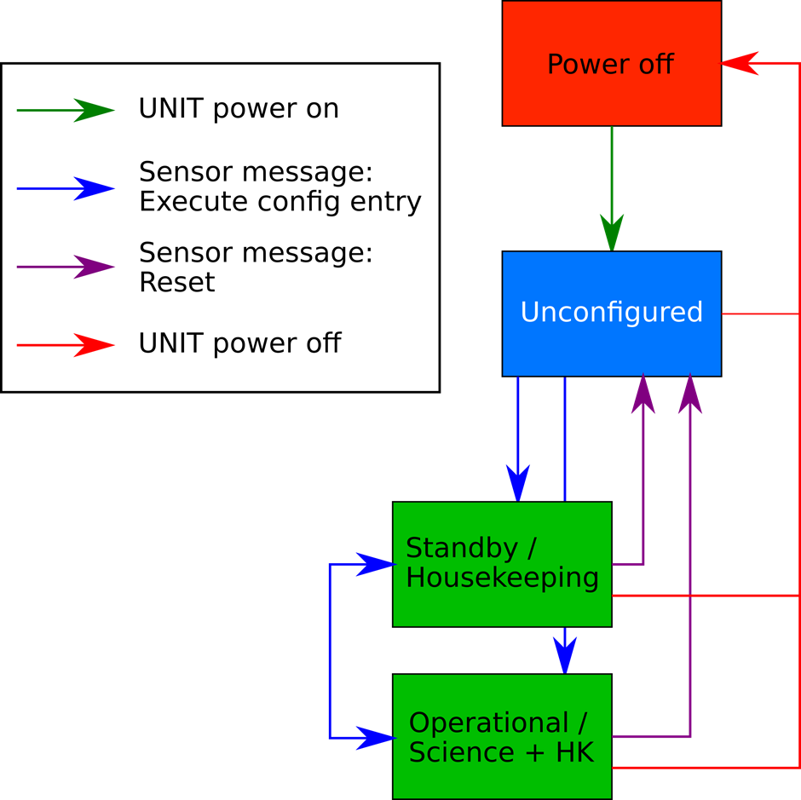

Figure 9-19: MEPS operation modes

Burst mode
In operational mode, sensor units generate burst science data packets as well, and send them to to the DPU. DPU can directly send the data to telemetry, store it for on-demand access, or discard it. Hence “burst mode” can be activated on DPU side by enabling the buffering and/or sending of the received burst data packets. If a buffer is used, it will be possible to request “old” burst data by requesting parts of the previously buffered burst data.
As an alternative it is possible to accommodate a dedicated burst mode in the sensor unit configuration tables, during which the sensor units will generate different science data telemetry. The transition to burst mode can then be commanded exactly like a transition to standby or operational mode, outlined above.

Other modes
In theory any further amount of (operational) modes are possible, depending on the EEPROM configuration, so the proposed Operational and Standby modes are the minimal set of modes, arbitrarily more can to be configured and used.

FDIR
Refer to DPU FDIR

Instrument data products
The science data products are completely configurable during flight. The sensor frontend (“the detector”) will produce PHA records, which are analyzed and stored into a histogram by a configurable trigger engine. A 2D histogram for Solar Orbiter EPT (similar to MEPS) is shown in Figure 9-20.
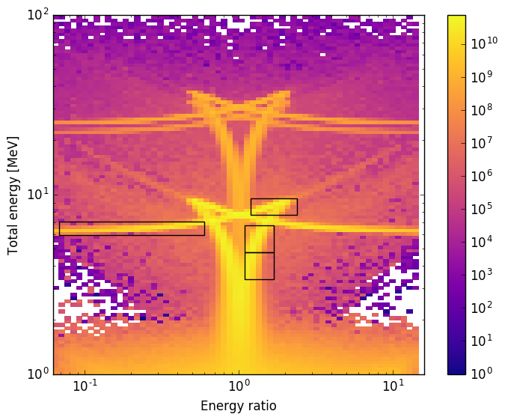
Figure 9-20: 2D histogram for EPT Solar Orbiter
The data product engine can compute configurable “windows” (shown as black box in the image) from this histogram to create the actual data product telemetry. Each box corresponds to one data item (a number) which is the sum of all the histogram counts inside this box.
The data items can be sent as 24 bit integer, as 8 bit base2-logarithmic numbers or 16 bit float. As an additional mode the data items can be run-length-encoded with a differential encoding scheme, and optionally compressed. This can reduce telemetry by a huge amount in case of stable/constant measurement environment.
As an additional data product the sensor can send a subsample of the measured single events as PHA records.
All of this functionality is implemented in the FPGA, and can be controlled by messaging, to change the configuration. No software is involved. It is very unlikely that the FPGAs can be converted to an ASIC as this would a programmatic risk, since the FPGA also handles all interface control and freezing this early in an ASIC would require a very early verification.
Since this processing is configurable, an estimation of data rate is not possible at this point. The data products can be tailored to the required scientific aims, and the data rate can be tailored to the data rate requirements on the instrument, for example by changing cadences or energy binning, etc.
The ADC to energy calibration of the sensor will be already implemented as part of the configuration, and is used to create the histogram.
If the data product scheme outlined above is used, the task of the DPU would be to gather and package the received data items, but no further processing of the raw science data itself will be necessary. This option mandates no dedicated knowledge of sensor configuration or design by the DPU. We assume that the sensor science data packets will be buffered and packaged into larger packets by the DPU, to minimize overhead due to packet headers, and offer the ability to coordinate telemetry windows/allotment.
It is an option to send the histogram as a whole to the DPU, and leave the data product generation (windowing, compression, etc.) to the DPU itself. This likely reduces the possible cadence of data products, since a whole histogram (or multiple histogram) is more data than the windowed data products. It will be the task of the DPU to generate the final data pakets. This option needs sufficient insight into the sensor configuration and histogram generation algorithms to be implemented in DPU software.
Another option is to stream the PHA data to the DPU, via a high-throughput data link from the sensor units. Calibration, histogramming and data product generation will be done by DPU (or even only on ground?). This mandates intricate knowledge of the sensor configuration, design and operation.
A possible data product configuration including telemetry allocation (for 2 MEPS units) could look like this:
Table 9-4: Possible data product configuration for 2 MEPS units

MEPS performance modelling results

The MEPS unit is being designed and verified using a FLUKA model to describe the detection elements of the instrument. The current geometrical representation of the model is shown in Figure 10-21.
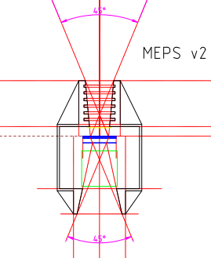
Figure 10-21 MEPS FLUKA simulation model

The current FLUKA model describes the complete geometry of one sensor head and has been used to perform the following studies:
- Simulation of detector response (energy deposition) with dead layers and noise addition
- Simulated response with different spectral indexes and abundances
- Preliminary quantification of p+ and e- contamination
- Simulation of different collimator shapes
- Confirmation of Geometrical factors
- Confirmation of He3 and He4 separation
- Preliminary simulation of magnet strength

We plan to describe the results of our performance modeling according to the timeline shown in Table 7-1 in TN06. The results corresponding to the different sections in this table will be populated by the end of November 2018. This is in line with the action LGR PRR MSSL-35 to update TN04 by PM3.
The following Figure 10-22 shows the energy loss matrix corresponding to the energy deposited in the central segment of the front 20um detector versus the energy deposited in the central segment of the second 300um. Ions from protons to iron has been generated with a flat energy spectrum (0-12 MeV/nuc) in vertical incidence.
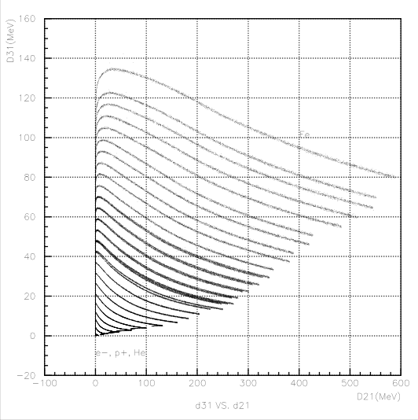
Figure 10-22 MEPS D31 vs D21 energy loss matrix for heavy ion generation (FLUKA model)
Figure 10-23 shows the same energy loss matrix D31 vs D21 for protons and alpha particles electrons (almost all rejected by the magnet system)
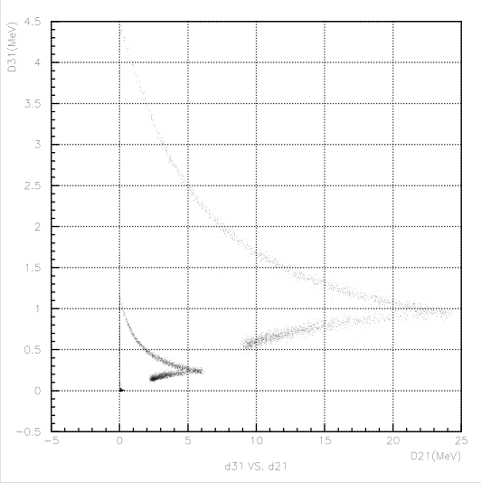
Figure 10-23 MEPS D31 vs D21 energy loss matrix for p+, He4 and electron generation (FLUKA model)

The following two Figure 10-24 and Figure 10-25 show the geometrical factor for proton detection in two different energy intervals: from 0 to 1.2 MeV (stopping protons in the first 20um detector) and from 1.2 MeV up to 6.5 MeV (stopping in the second 300um detector). The protons have been generated according to a flat energy spectrum in a isotropic distribution over the central segment detector.
The derived geometrical factor (≈ 0.09 cm2∙sr) confirms the calculated factor obtained by the mathematical expression from J.D. Sullivan (Nuclear Instruments and methods 95 (1971) 5-11)
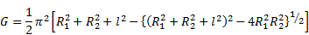
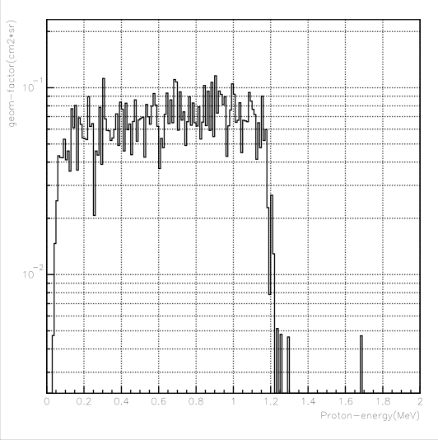
Figure 10-24 FLUKA simulation: p+ geometrical factor for protons stopping in the first 20um detector

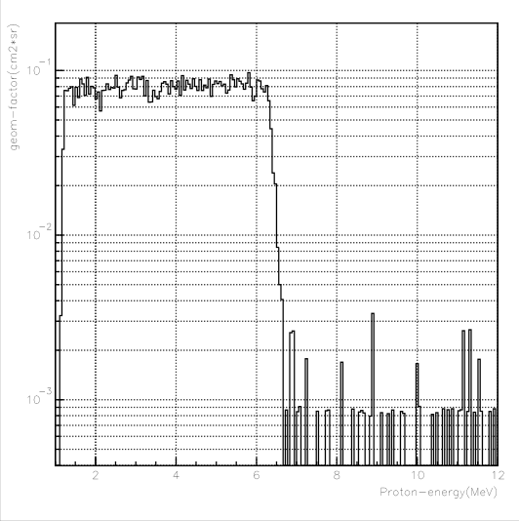
Figure 10-25 FLUKA simulation: p+ geometrical factor for protons stopping in the second 300um detector

Figure 10-26 and Figure 10-27 shows the geometrical factor for stopping electrons detected in the electron telescope first 300um detector (≈ 0.09 cm2∙sr)
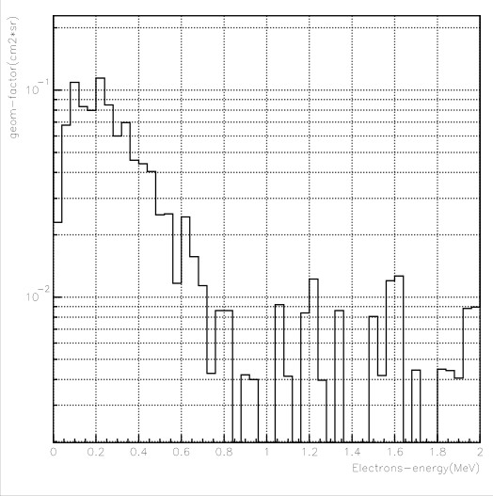
Figure 10-26 FLUKA simulation: e- geometrical factor for electrons stopping in the first 300um detector. Electron telescope
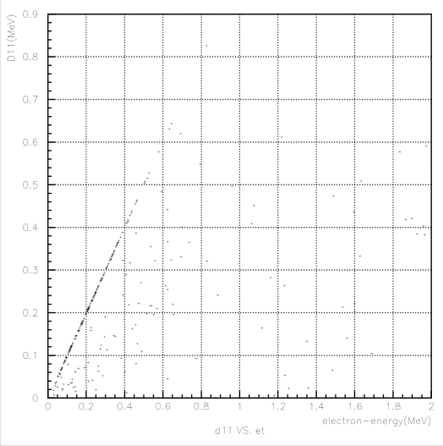
Figure 10-27 FLUKA simulation: 2D representation of the e- geometrical factor for electrons stopping in the first 300um detector. Electron telescope

Figure 10-28 and Figure 10-29 show the rejection of low energy protons by the 5um paelene foil on the electron telescope. All protons with energies below 400 keV are absorbed in the foil and will not reach the front detector.

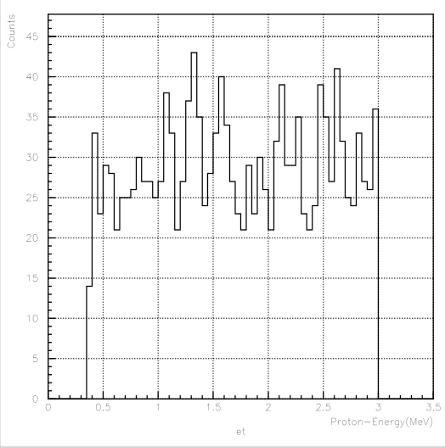
Figure 10-28 FLUKA simulation: P+ < 400keV rejection with parelene foil

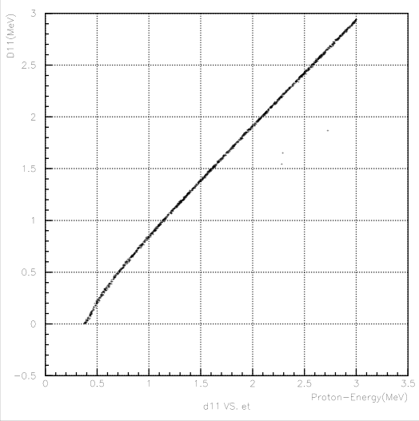
Figure 10-29 FLUKA simulation: 2D representation of P+ < 400keV rejection with parelene foil

Figure 10-30 and Figure 10-31 show the rejection of low energy electrons by the magnet system. The compensated magnet system create a magnetic field of 500mT in the center able to deviate all electrons with energies below 500keV from the front ion detector (20um detector)
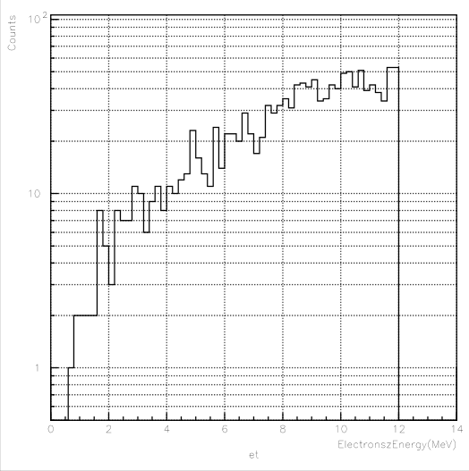
Figure 10-30 FLUKA simulation: e- < 500keV rejection with magnet system on the ion telescope

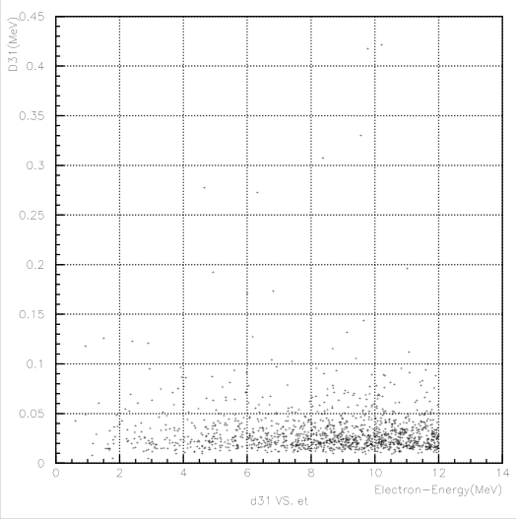
Figure 10-31 FLUKA simulation: 2D representation of the e- < 500keV rejection with magnet system.

Figure 10-32 shows the separation of He3 and He4 isotopes under isotropic distribution after adding electronics noise (5keV and 10keV) to the 300um and 20um detectors respectively) to the detector contribution.

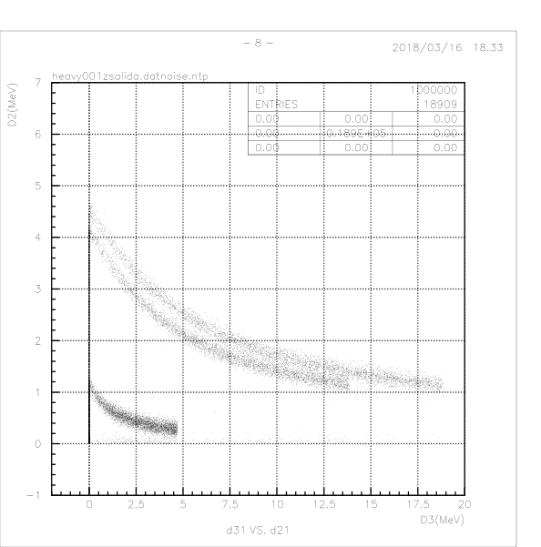
Figure 10-32 FLUKA simulation: He3-He4 separation on the MEPS ion telescope.

Analysis of PTB accelerator data
A MEPS Demo model has been built according to the predevelopment plan to check the functionality of the front 20um detector as part of the detector stack with thicknesses 20+300+300 um. The 20um detector is an old LET/STEREO detector purchased to Micron Semiconductor and the two 300um are CANBERRA detectors built for the EPT/Solar Orbiter sensor. The analog readout system can be considered representative of the MEPS preamplification stage and analog board concept for MEPS.
Figure 10-33 and Figure 10-34 show the detectors configuration of the MEPS demo model
Figure 10-33 MEPS demo model detector stack placement.
Figure 10-34 MEPS demo detector stack configuration.

This Demo models has been tested under a proton and alpha particles beam at The Physikalisch-Technische Bundesanstalt (PTB) facility in Braunschweig.
The experimental setup is shown in Figure 10-35
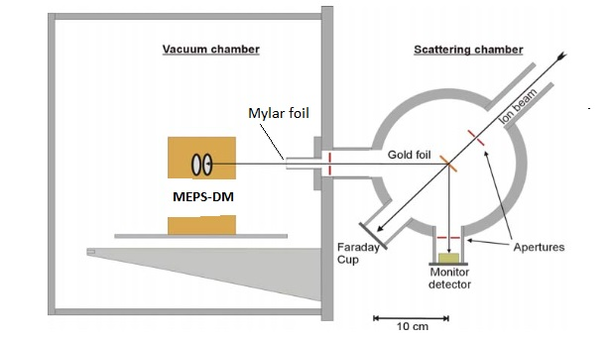
Figure 10-35 Experimental setup at PTB.

The characteristics of the acquisitions is registered in Table 10-5 and Table 10-6.

Sl.No. | Proton Energy (from accelerator) | Duration of test (min) | detector channel threshold (mV)
Sl.No. | Proton Energy (from accelerator) | Duration of test (min) | 20 um det (A1, A2, A3) | 300 um det (B1, B2) | 300 um det (C1, C2)
1 | 215 keV | 3(?) | 5.0/3.8, 20, 10 | 5 , 5 | 5, 5
2 | 260 keV | 3 | 5.0, 20, 10 | 5 , 5 | 5, 5
3 | 300 keV | 8 | 5.0, 20, 10 | 5 , 5 | 5, 5
4 | 400 keV | 6 | 5.0, 20, 10 | 5 , 5 | 5, 5
5 | 600 keV | 5 | 5.0, 20, 10 | 5 , 5 | 5, 5
6 | 800 keV | 6 | 5.0, 20, 10 | 5 , 5 | 5, 5
7 | 1 MeV | 7 | 5.0, 20, 10 | 5 , 5 | 5, 5
8 | 1.2 MeV | 9 | 5.0, 20, 10 | 5 , 5 | 5, 5
9 | 1.3 MeV | 8 | 5.0, 20, 10 | 5 , 5 | 5, 5
10 | 1.4 MeV | 5 | 5.0, 20, 10 | 5 , 5 | 5, 5
11 | 1.5 MeV | 11 | 5.0, 20, 10 | 5 , 5 | 5, 5
13 | 2 MeV | 21 | 5.0, 20, 10 | 5 , 5 | 5, 5
14 | 3 MeV | 8 | 5.0, 20, 10 | 5 , 5 | 5, 5
15 | 6.5 MeV | 26 | 5.0, 20, 10 | 5 , 5 | 5, 5
16 | 10 MeV | 26 | 5.0, 20, 10 | 5 , 5 | 5, 5
Table 10-5: Proton beam details

Sl.No. | Alpha Energy (from accelerator) | Duration of test (min) | detector channel threshold (mV)
Sl.No. | Alpha Energy (from accelerator) | Duration of test (min) | 20 um det (A1, A2, A3) | 300 um det (B1, B2) | 300 um det (C1, C2)
1 | 800 keV | 6 | 5.0, 20, 10 | 5 , 5 | 5, 5
2 | 900 keV | 9 | 5.0, 20, 10 | 5 , 5 | 5, 5
3 | 1 MeV | 9 | 5.0, 20, 10 | 5 , 5 | 5, 5
4 | 2 MeV | 10 | 5.0, 20, 10 | 5 , 5 | 5, 5
5 | 3 MeV | 6 | 5.0, 20, 10 | 5 , 5 | 5, 5
6 | 4.5 MeV | 10 | 5.0, 20, 10 | 5 , 5 | 5, 5
7 | 5 MeV | 9 | 5.0, 20, 10 | 5 , 5 | 5, 5
8 | 6 MeV | 8 | 5.0, 20, 10 | 5 , 5 | 5, 5
9 | 10 MeV | 22 | 5.0, 20, 10 | 5 , 5 | 5, 5
10 | 20 MeV | 26 | 5.0, 20, 10 | 5 , 5 | 5, 5
Table 10-6: Alpha beam details

The energy calibration for all detectors has been done with the help of a FLUKA Monte Carlo Simulation calculating the energy loss of the primary beam in the gold and milar foils and the energy deposition in each detector.
Figure 10-36 and Figure 10-37 show the energy loss matrix D31 vs D21 (central segment of the front 20um detector and the central segment of the middle 300um detector) for protons and alphas.
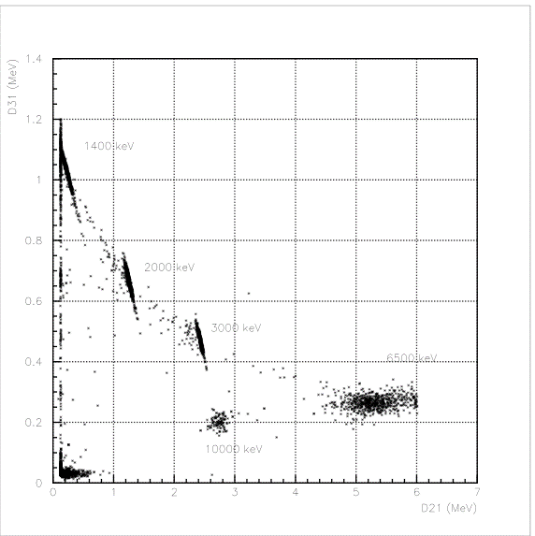
Figure 10-36 Proton D31 vs D21 energy loss matrix.

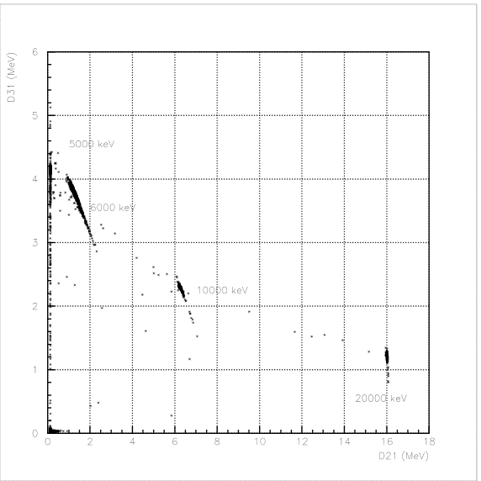
Figure 10-37 Alphas D31 vs D21 energy loss matrix.

