## Data Management Interface and Design Requirements

### General

A MEPS unit can be commanded by either

* LVDS signals through a UART operating at 115,200 baud
* SpaceWire (SpW) at 12Mbps

In case of SpW communication, the unit accepts spacewire packets with a hardwired address and protocol id as command messages. The bytes following address and pid are parsed as commands (see Sec. 5.6.2).

The unit transmits STF packets (see Sec. 5.6.3) encapsulated in SpW packets with a hardwired address and protocol id prepended to the bytes of the STF packet.

The address and protocol id currently hardwired in the code are

* **0xfe 0xfc** for command messages
* **0xfe 0xfd** for STF packets

These are TBC, and can be changed.

### Instrument Command and Control

All operations of MEPS can be controlled via formatted command messages. A command message consists of

* 16-bit sync word
* 2-bit size tag
* 14-bit address
* 0-bit/16-bit/32-bit/64-bit data word
* 16-bit CRC (CRC-16/CITT)

The address identifies the recipient of the message, and the size controls how many bits of the data payload are interpreted. Only as many data words as specified by the size tag are to be transmitted:

* 0: zero bits
* 1: 16 bits
* 2: 32 bits
* 3: 64 bits

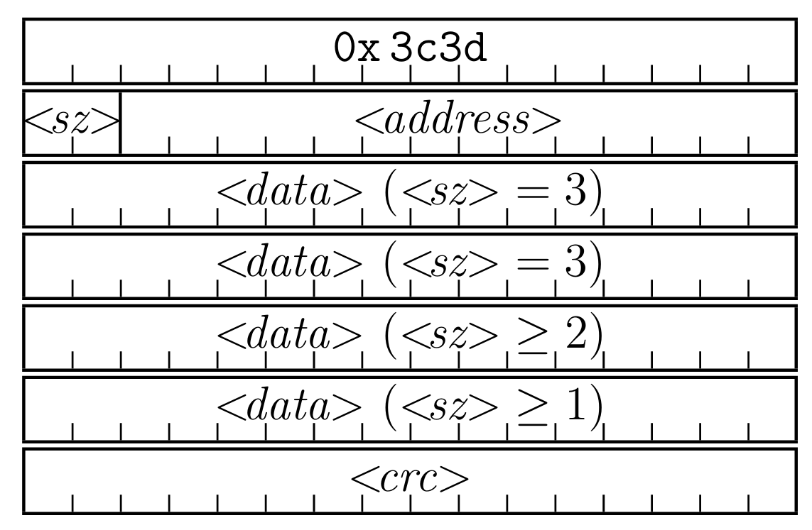  
Illustration 1: MEPS sensor command message format

### Instrument Telemetry

MEPS TM will be emitted in form of a Sensor Transfer Frame (STF) format previously used for the EPD sensors on Solar Orbiter. A STF packet consists of

* 32-bit sync-word (0xbebacafe)
* 16-bit payload size (n bytes of data + 4)
* 16-bit APID (encodes the STF sender and intended receiver)
* n*8-bit of data payload
* 16-bit CRC (CRC-16/CITT)

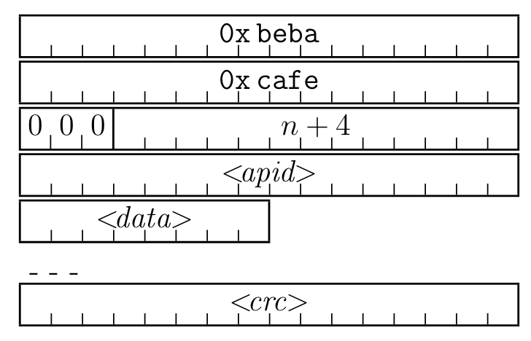  
Illustration 2: MEPS STF packet format

TM from MEPS includes scientific data products, consisting of histograms of measured particle events (spectra) and Pulse-Height-Analysis (PHA) data. In addition to that, housekeeping and auxilliary data (counters) will be telemetered.

A science data product consists of count rates of specific particles in an energy channel, particle spectra. These spectra can be sent in compressed or uncompressed fashion. The compression takes into account the poissonian statistics of the measurement process, and reduces the telemetry requirement of particle spectra.

A PHA record consists of “raw” event data. Only a statistical subsample of all events analyzed will be telemetered as PHA data. The main purpose of PHA data is diagnostics, to ensure nominal operation and check the particle spectra generation.

Housekeeping (HK) data contains voltages, currents and temperatures of various parts of the sensor, and are critical to monitor the operation of the unit. In addition the status of the configuration is telemetered.

Auxilliary data contains several internal counters. This data is useful for further diagnostics.

MEPS does not require the DPU to perform any analysis of the scientific data. It will be advantageous for the DPU to store scientific data sent by MEPS into internal buffers to allow better control of the telemetry. The DPU can monitor some parts of the HK or auxiliary TM to control and check the nominal operations of MEPS.

A TBC allotment of MEPS telemetry is shown in the following table:

### Time and Synchronisation

No instrument require SYNC signal to synchronize the power supply switching and electronics readout.

But understand DPU shall circulate a time sync TC to every instrument every TBD min.

### Inter-Instruments Communication

Not required by any instrument so far

### Electrical Interfaces and Redundancy

[HH: Reserved for system to fill in the details]

For BUS topology, there is a redundant bus.

For STAR topology, the base line is a single data bus to each instrument and no redundancy.

### Bus Interface

[HH: Reserved for system to fill in the details]

Either SpaceWire or CANBUS. Detail will be provided once the architecture is defined.



## Instrument Operations

[HH: this is a very important section. Please define it in as much detail as you can and also follows the predefinition of modes listed in the introduction words.]

**[Christoph]**

### Instrument Modes

* **Nominal mode:** In this mode MEPS generates science, HK and auxilliary telemetry. MEPS can optionally generate burts science data in this mode.*
* **Calibration & Commissioning mode**: TBC whether this moe exists. This mode is similar to **Nominal** mode, MEPS will generate science, HK and auxilliary telemetry. The configuration of the unit will be adapted to focus on diagnostical output. This can lead to some non-critical telemetry to be omitted compared to **Nominal** mode.
* **IDLE mode**: When powered up, MEPS will enter this mode. MEPS will accept command messages as outlined in Sec. 5.6.2, but not generate TM. Part sof the sensor which are non-critical for survival or communication will be idle. It is TBC whether parts of the sensor can be powered down in this mode
* **Housekeeping mode**: TBC whether this mode exists. This mode will generate HK and auxilliary data, but will not generate science data.
* **Burst mode**: TBC whether this mode exists. Like **Nominal** mode, but science data product generation will be reconfigured to generate spectra at higher time and/or energy resolutions.

*MEPS can be configured to emit burst science data products in nominal mode. In that case it is up to the DPU how to handle the burst data. Depending on DPU configuration the burst data can be telemered, buffered (for request/telemetry at a later time) or discarded.

### Instruments Operations Support

MEPS can be commanded via command messages as outlined in Sec. 5.6.2. The MEPS team will outline a set of TBC telecommands to allow commanding of MEPS in a general fashion.

### Flight Operations

A large part of the configuration of MEPS is flight-configurable. Specfically the cadence and amount of telemetry can be controlled in a very general fashion by reconfiguring the configuration tables of the unit. The scientific data generation of spectra can be fully reconfigured as well. This adds the possibility to re-configure MEPS during flight in case of anomalies or for measurement campaigns, by using telecommanding as per Sec. 5.8.2.