Instrument location, alignment and pointing

The MEPS unit has two sensor heads on top of it. Each sensor head has 2 telescopes. Each telescope has a forward and backward looking detector stack, where one direction measures electrons and the opposite direction measures ions. Thus, this configuration provides a total of 8 FoVs per unit (see figure 1). Each FoV covers a full opening angle of 45°. The viewing directions of the two sensors form an angle 70° to cover the pitch angle distribution.

The current geometrical factor of the MEPS unit is 0.1 cm2 sr for the electron telescope and 0.09 cm2 sr for the proton-ion telescope.

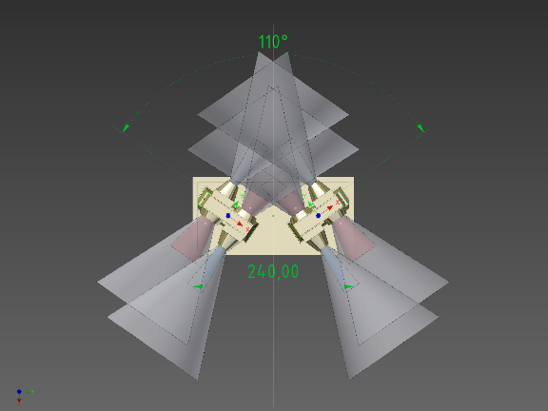

**Fig 1. MEPS FoV configuration.**

The spacecraft coordinate system is showed in figure 2.

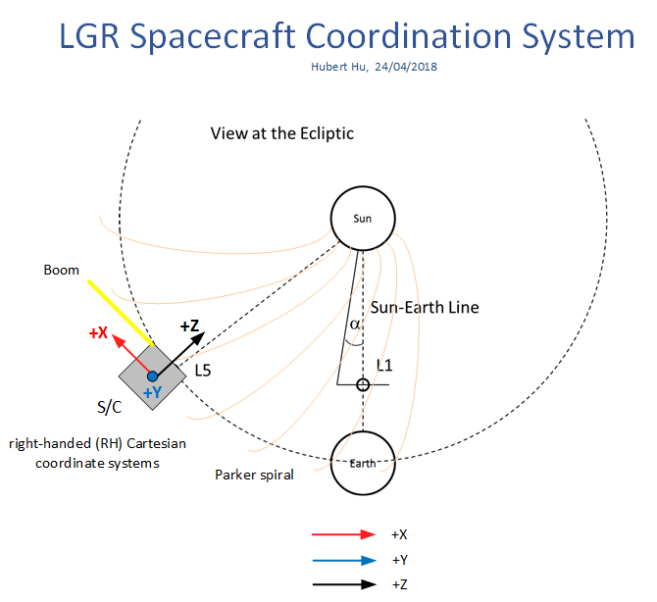

**Fig 2. S/C coordinate system**

The accommodation of the MEPS unit on the S/C is not easy, but preliminary studies showed that the following two configurations are feasible (see fig 3):

* Position 1 (orange figure): vertex of S/C planes –X, +Y, -Z
* Position 2 (green figure): vertex of S/C planes –X, -Y, -Z



**Fig 3. Two possible S/C positions to accommodate the MEPS unit**

The main forward-backward FoV (T1 and/or T3) is pointing in the direction of the nominal Parker spiral (45°). On the upper position (orange), the FoVs are nearly coplanar to the orbital plane and on the lower position (green), the FoVs are nearly perpendicular to the orbit.

Since the STEREO SEPT team have found that the four STEREO/SEPT FOVs are insufficient, The MEPS team has proposed two units instead of one (accommodated on the above mentioned S/C positions) providing almost 6 independent FoV and provide a good coverage on pitch angle distribution and a reasonable detection of the event onsets (see trade off studies).

Due to the nature of measurements and intrinsic angular resolution, MEPS does not have strict alignment or pointing stability requirements. Nor do the MEPS sensors have strict pointing requirements relative to each other. Alignment/pointing accuracy of <2° (knowledge 1° (on ground)) is sufficient for all MEPS sensors relative to each other. Alignment with this accuracy is expected to be possible by mechanical design.

MEPS alignment/pointing accuracy w.r.t. S/C reference frame shall be better than 2° with knowledge on ground better than 1°.

The UFoV (Unobstracted FoV) shall be 90% of the FoV as a minimum for MEPS, meaning that up to 10% of the solid angle could be obstructed for each of the 8 FoVs of the unit (TBC)

MEPS is susceptible to straylight. Especial care shall be put on the instrument accommodation and placement of yokes, solar arrays and other S/C structures to avoid reflected light to instrument openings. The induced leakage current due to straylight on the MEPS detectors shall not exceed 0.1nA (TBC)