MEPS tradeoffs

# 20 μm ion front detector performance

The electron energy coverage requirement (30-600keV) will be easily met as it was done with Solar Orbiter/EPT.

But the energy lower end for ion detection has two ranges:

* + **[1.5MeV/n, 6 MeV/n]** 🡪 The detection and complete identification of these p+, ions is achieved by means of the ΔE-E technique. No problem.
  + **[30keV/n,1.5MeV/n]** 🡪 These are stopping particles in the entrance 20μm thickness detector. These particles will be detected above threshold ~70keV for protons (TBC, see later) and the identification will be based on groups of energy deposition in this detector. 30keV cannot be met without a time of flight (TOF) instrument.

The lower energy limit for detection is mainly given by the front detector noise and the detector dead layers. Currently the MEPS team is verifying these quantities vs datasheet in old 20μm STEREO LET single detectors as well as in a custom 3 detector stack 20-300-300 μm. The preliminary noise levels are in the range 30-50 keV. Deadlayer threshold for protons is 70keV according to datasheet (higher for heavy ions). Simulations provide slightly lower values. Accurate alpha particle experiment to verify these values is ongoing in Kiel.

In view of these preliminary studies and results it is realistic to say that the MEPS lower end energy detection threshold would lie around 100 keV for protons.

The MEPS team is planning to continue with the experiments in the lab and in accelerator facilities to provide a more precise value of the detection threshold of the 20μm detector. Conversations with the detector manufacturer in order to decrease the thickness of the dead layers (and thus, to reduce the threshold limit) have been initiated as well.

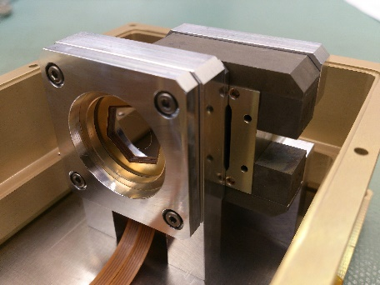

**Fig 1. 20-300-300 μm demo model detector stack built for MEPS**

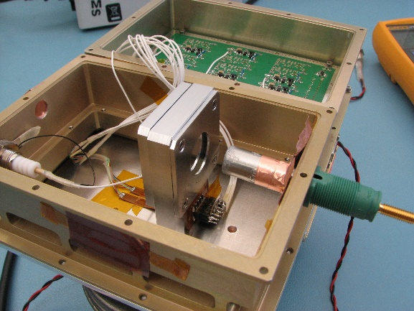

**Fig 2. Alpha test with the demo detector stack**

# Second MEPS unit (email from Jonathan Rae and R. Wimmer presentation)

Early on during solar particle events, energetic particles flow along the IMF/Parker Spiral field, before becoming more isotropic due to in-transit scattering processes later on in the event at any given heliospheric distance. Hence, energetic particle instruments such as MEPS require look directions that are pointed along the general Parker spiral/IMF topology.

However, these are average or typical orientations, and in reality the real IMF can be significantly different to that of the average IMF. With the bulk solar wind, there are variations in the orientation of the solar wind, but these are small variations on a near-radial solar wind flow. However, Parker spiral angle is not as well ordered as bulk solar wind flow and IMF orientation are much more complex and variable.

We agree that we were to report on a single unit MEPS during the negotiation meeting. Following this negotiating meeting, we had several telecom and email exchanges whereby Kiel could discuss why and when 2 units may be needed for an operational SEP detection for LGR. This is why MEPS continues to push for study of both 1 and 2 units.

Each unit has two sensor heads on top of it. Each sensor head has 2 telescopes. Each telescope has a forward and backward looking detector stack, where one direction measures electrons and the opposite direction measures ions. In this configuration, two telescopes will look approximately along the Parker spiral angle to provide redundancy. More telescopes are required to ensure that MEPS (and any particle instrument) will see the particle event already at its onset and determine key characteristics of the event, such as onset time and location. Since the particles stream along the IMF this means that the IMF needs to fall approximately into the telescope opening. Because the particle pitch-angle distribution is not a perfect pencil beam, a certain width around the IMF can be allowed. Once the event continues, the SEPs isotropize due to scattering and then it would become sufficient to have a single look direction, but the key component of this detection is to determine onset time and location, and for that, as many look directions as possible is required.

Below some cases are shown where the IMF would not lie in the field-of-view of MEPS if there were only one unit. They were all taken from STEREO’s SEPT instrument which may serve as a demo model of MEPS (SEPT was also built at CAU Kiel). These configurations show that not all events are seen, or the event intensity is underestimated, or that the timing of the event is not correct if we have only one (forward-backward) look direction . These are all the basis for justification for a second MEPS unit to cover the entire range of IMF orientations for timing, intensity and onset of Solar Energetic Particle events.

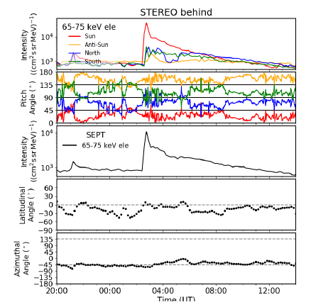

**Fig 3. event intensity only captured in one look direction**

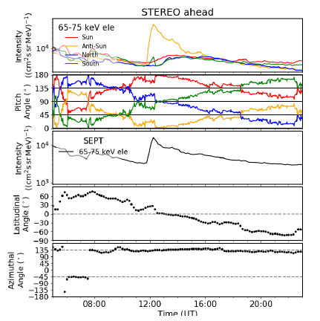

**Fig 4. Event seen only in anti-sunward telecscope on account of non-standard Parker spiral angle**

In summary, to capture any and all SEP onsets, a 4Pi view is required, which is not possible for a MEPS-like instrument. The Kiel group have not yet done a statistical study from STEREO SEPT data as to how often a 1 unit MEPS would likely miss the onset, intensity and timing of an SEP onset, but this is the reason that we propose to continue to study both a 1 unit and a 2 unit MEPS instrument.

Figure 5 illustrates this quite clearly. We have taken 1, 10, and 60 minute averages of the STEREO-A MAG measurements of the IMF from 2007 – 2017 and plotted the angle of the measured IMF with respect to the nominal Parker direction (here assumed to be 45° from the Sun-STEREO line). The top panel shows a histogram of the angular distribution; the bottom panel shows the cumulative distribution. This, for a telescope opening of 45 degrees (and thus a half-angle of 22.5 degrees), we see that the IMF falls inside the telescope opening less than 20% of the time, depending on the IMF average used.

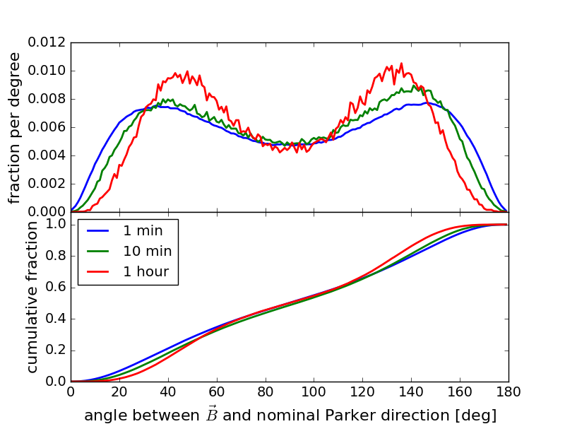  
**Fig 5: Magnetic field vector with respect to the nominal Parker field direction for 2007 - 2017 using STEREO MAG data. Data are shown for 1, 10 and 60 minute averages.**

A more detailed description of the study is given in the ppt presentation attached, but the summary is given in the following table. Table 1 gives the fraction of time during which a 40° wide particle event would be seen in the individual forward-backward-looking MEPS telescopes:

|  |  |  |  |
| --- | --- | --- | --- |
| **Telescope** | **1 min data** | **10 min data** | **60 min data** |
| T1 | 50% | 46% | 40% |
| T2 | 23% | 18% | 11% |
| T3 | 50% | 46% | 40% |
| T4 | 22% | 17% | 10% |
| T1 or T2 (1 MEPS unit) | 67% | 61% | 49% |
| T3 or T4 (1 MEPS unit) | 67% | 60% | 48% |
| In any of the 4 MEPS telescopes, T1, T2, T3, or T4 | 86% | 77% | 60% |

**Table 1. The fraction of time during which a representative 40 degree wide particle event would be seen in different MEPS unit configurations.**