**17TITLE: LGR In-Situ instrument ICD - MEPS**

**Document Number: MSSL-LGR-ICD-18004 Issue E Date 22/08/18**

**Distribution:**

|  |  |  |
| --- | --- | --- |
| ESA | S Kraft | X |
|  |  |  |
| Mullard Space Science Laboratory | R Cole | X |
|  | IJ Rae | X |
|  | D Kataria | X |
|  | D Hu | X |
|  | R Bentley | X |
|  |  |  |
| Imperial College | J. P. Eastwood | X |
|  | C. Carr | X |
|  |  |  |
| IWF | W. Magnes | X |
|  |  |  |
| PSI | W. Hajdas | X |
|  |  |  |
| Isaware | J. Huovelin | X |
|  | S. Korpela | X |
|  | T. Luntama | X |
|  |  |  |
| CAS | J. Soucek | X |
|  | O. Santolik | X |
|  |  |  |
| Airbus | E. Monchieri | X |

|  |  |  |  |
| --- | --- | --- | --- |
| Author: | César Martín | Date: | 22.08.2018 |
| U of Kiel Project Office: | César Martín | Date: | 22.08.2018 |
| UCL System Engineer |  | Date: |  |

Total No of Pages 37**CHANGE RECORD**

|  |  |  |  |
| --- | --- | --- | --- |
| ISSUE | DATE | PAGES CHANGED | COMMENTS |
| draft A | 20/04/2018 |  | Initial version |
| draft B | 08/05/2018 |  | Added materials provided by MEPS |
| draft C | 30/05/2018 |  | Added responses to PCR RIDs |
| draft D | 25/06/2018 | 2 | Adding information to change record |
|  |  | 5.4.2 | Answer to LGR-III PCR-15. Thermal limits |
|  |  | 5.8.1 | Answer to LGR-III PCR-27. Mode transition type |
|  |  | 4.1 | Answer to LGR-III PCR-53. Reference to picture corrected |
|  |  | 5.8.1 | Answer to LGR-III PCR-54. Instrument modes |
|  |  | 5.3.3 | LGR-III PCR-55. Unit dimensions added |
|  |  | 5.3.12 | LGR-III PCR-56. Generated disturbances added. |
| Draft E | 22/08/2018 | 5.7.1 | Cleanliness requirements added |
|  |  | 5.7.3 | Instrument purging and contamination requirements added |
|  |  | 5.7.6 | Red tag items added |
|  |  | 5.4.2 | Requirements added. Possibility of operational heater power added. |
|  |  | 5.2 | Instrument location, alignment and pointing added. Assessment of two new positions on the front of S/C. Discussion about possible sun-shield installation. |
|  |  |  |  |
|  |  |  |  |
|  |  |  |  |
|  |  |  |  |
|  |  |  |  |

CONTENTS

1 Introduction 6

2 Applicable and Reference documents 6

2.1.1 Applicable documents 6

2.1.2 Reference Documents 6

3 Definitions and Abbreviations 7

3.1 Definitions 7

3.2 Abbreviations 7

4 INSTRUMENT DESCRIPTION 8

4.1 Measurement Principles 8

4.2 Functional Description 11

4.3 Hardware Description 11

4.4 Software Description 12

5 INSTRUMENT DESIGN AND INTERFACE REQUIREMENTS 12

5.1 Definition of Coordinate System for Instrument and Sub-Units 12

5.1.1 Instrument/Unit Physical Reference Frame 12

5.1.2 Instrument/Unit Alignment Reference Frame 12

5.1.3 Instrument Line of Sight Reference Frame 12

5.2 Instrument Location, Alignment and Pointing 12

5.2.1 Instrument field of view 12

5.2.2 Instrument Location 13

5.2.3 Pointing and Co-alignment Requirements 16

5.3 Mechanical Interfaces and Design Requirements 17

5.3.1 Mechanical Interface 19

5.3.2 Mass and Mass Tolerances 19

5.3.3 Centre of Mass 19

5.3.4 Moments of Inertia 19

5.3.5 Unit Dimensions 19

5.3.6 Instrument Mounting 19

5.3.7 Feedthroughs 20

5.3.8 Doors 20

5.3.9 Boom 20

5.3.10 Baffles 20

5.3.11 Venting 20

5.3.12 Instrument Generated Disturbances 20

5.4 Thermal Interfaces and Design Requirements 20

5.4.1 Definitions 20

5.4.2 Thermal Control 22

5.4.3 Thermal Interface Design 23

5.4.4 Thermal Hardware Interfaces 24

5.5 Electrical Interfaces and Design Requirements 24

5.5.1 Instrument Power 24

5.5.2 Data Handling Electrical Interfaces 27

5.5.3 Harness and Interface Connectors 27

5.5.4 Instrument Grounding Scheme 27

5.6 Data Management Interface and Design Requirements 27

5.6.1 General 27

5.6.2 Instrument Command and Control 28

5.6.3 Instrument Telemetry 29

5.6.4 Time and Synchronisation 31

5.6.5 Inter-Instruments Communication 31

5.6.6 Electrical Interfaces and Redundancy 31

5.6.7 Bus Interface 31

5.7 Instrument Handling 31

5.7.1 Cleanliness 31

5.7.2 Physical Handling Requirements 32

5.7.3 Instrument Purging and Contamination Requirements 32

5.7.4 AIV Contamination Budget (S/C) 32

5.7.5 Cleanliness and Contamination Control Plan (S/C) 33

5.7.6 Red tag items 33

5.8 Instrument Operations 34

5.8.1 Instrument Modes 34

5.8.2 Instruments Operations Support 35

5.8.3 Flight Operations 35

5.9 Environment 35

5.9.1 Ground Environment 35

5.9.1.1 Contamination 35

5.9.1.2 Ground Handling, Transportation and Storage 35

5.9.1.3 Verification and Testing 35

5.9.2 Electromagnetic Design and Interfaces 35

5.9.2.1 General Concept 35

5.9.2.2 General EMC/RFC Requirements 35

5.9.2.3 Magnetic Cleanliness 35

6 INSTRUMENT ASSEMBLY, INTEGRATION AND VERIFICATION 36

6.1 Verification Concept and Methods (at S/C) 36

6.2 Particular S/C level Testing 37

6.3 System Level AIT aspects 37

# Introduction

This instrument ICD for MEPS is defined as an engineer solution in response to the requirements set out in [AD-1].

# Applicable and Reference documents

### Applicable documents

|  |  |
| --- | --- |
| [AD-1] | ESA-SSA-LGR-RS-004 Issue 01, In-situ sensing Instruments Requirements Document |
| [AD-2] | ECSS-M-ST-10C, Project planning and implementation |
| [AD-3] | ECSS-M-ST-10-01C, Organization and Conduct of Reviews |
| [AD-4] | ESA-SSA-LGR-LI-0004 Issue 01, Lagrange Missions Instruments Phase A/B1 Study - Document Requirements List (ins-DRL) – named here DRL |
| [AD-5] | ECSS-M-ST-80C, Risk management |
| [AD-6] | ESA Cost Estimate template, ‘LGR-III Cost Estimate Template V1.xls’ |
| [AD-7] | ESA-LGR-EST-ENV-SP-001, Issue 01, Lagrange Mission (L5) Environmental Specifications |
| [AD-8] | ECSS-Q-ST-20C Rev.1, Quality Assurance |
| [AD-9] | ECSS-M-ST-60C, Cost and schedule management, 31 July 2008 |
| [AD-10] | ESA-SSA-LGR-LI-0004, Lagrange Missions Phase A/B1 Instrument Studies Document Requirements Definition (INS-DRD), Issue 01 |

### Reference Documents

|  |  |
| --- | --- |
| [RD-1] | ESA-SSA-LGR-RS-001, Issue 01, Lagrange Missions (L1 and L5) Mission Requirements Document |
| [RD-2] | ESA-SSA-LGR-RS-002, Issue 01, Lagrange Missions (L1 and L5) System Requirements Document |
| [RD-3] | SWE-OHB-DD-0023_L5 Final Report_Issue 1.1, Final Report SWE-X Study, Enhanced Space Weather Monitoring System Study (Phase 0) L5 |
| [RD-4] | SWE-OHB-DD-0011_L1 Final Report_Issue 1.1_Signed Final Report SWE-X Study, Enhanced Space Weather Monitoring System Study (Phase 0) L1 |
| [RD-5] | AirbusDS-SWE-DD0011 L1 and L5 Final Report Issue 1, Review 2, Final Report SWE-X Study, Enhanced Space Weather Monitoring System Study (Phase 0) L1 + L5 |

# Definitions and Abbreviations

## Definitions

|  |  |
| --- | --- |
| Item | Definition |
| TBD |  |

## Abbreviations

|  |  |
| --- | --- |
| CME | Coronal Mass Ejection |
| DOCS | Deep-space Optical Communication System |
| DPU | Data Processing Unit |
| EDAC | Error Detection and Correction |
| EEE | Electrical, Electronic and Electro-mechanical |
| EMC | Electro-Magnetic Cleanliness |
| EOL | End of Life |
| EPT | Electron Proton Telescope |
| HV | High Voltage |
| IMF | Interplanetary Magnetic Field |
| LCL | Latch Current Limiter |
| LET | Linear Energy Transfer |
| LGR | Lagrange |
| MAG | Magnetometer |
| MCP | Microchannel Plate |
| MEPS | Medium Energy Particle Spectrometer |
| MICD | Mechanical Interface Drawing |
| MRAM | Magneto-Resistive Memory |
| NGRM | Next Generation Radiation Monitor |
| PLA | Plasma Analyser |
| RADEM | Radiation Monitor |
| RAM | Random Access Memory |
| RAMS | Reliability, Availability, Maintainability, Safety |
| RM | Radiation Monitor |
| SEE | Single Event Effects |
| SEP | Solar Energetic Particles |
| SIR | Stream Interaction Region |
| SIXS | Solar Intensity X-ray and particle Spectrometer |
| SO | Solar Orbiter |
| SRAM | Static Random Access Memory |
| SSA | Space Situational Awareness |
| SWA | Solar Wind Analyser |
| TC | Telecommand |
| TID | Total Ionizing Dose |
| TM | Telemetry |
| TOF | Time of Flight |
| XFM | X-ray Flux Monitor |

# INSTRUMENT DESCRIPTION

## Measurement Principles

The MEPS instrument is a particle instrument measuring the energy spectra and angular distributions of energetic electrons (30-600 keV) and ions (30-6000 keV/nuc). The experiment consists of two units (Figure 4‑1) each of which provides two double-ended telescope pairs (sensor heads) with four view cones per pair, two dedicated for electrons and two for ions. Utilizing any spin of the spacecraft, MEPS observations cover the full sky with a total of eight electron and eight ion view cones. As the L5 S/C is not a spinner, MEPS still provides crucial pitch-angle information to determine whether the event is scatter free. This is an important indicator for interpreting the timing information of the space weather event.

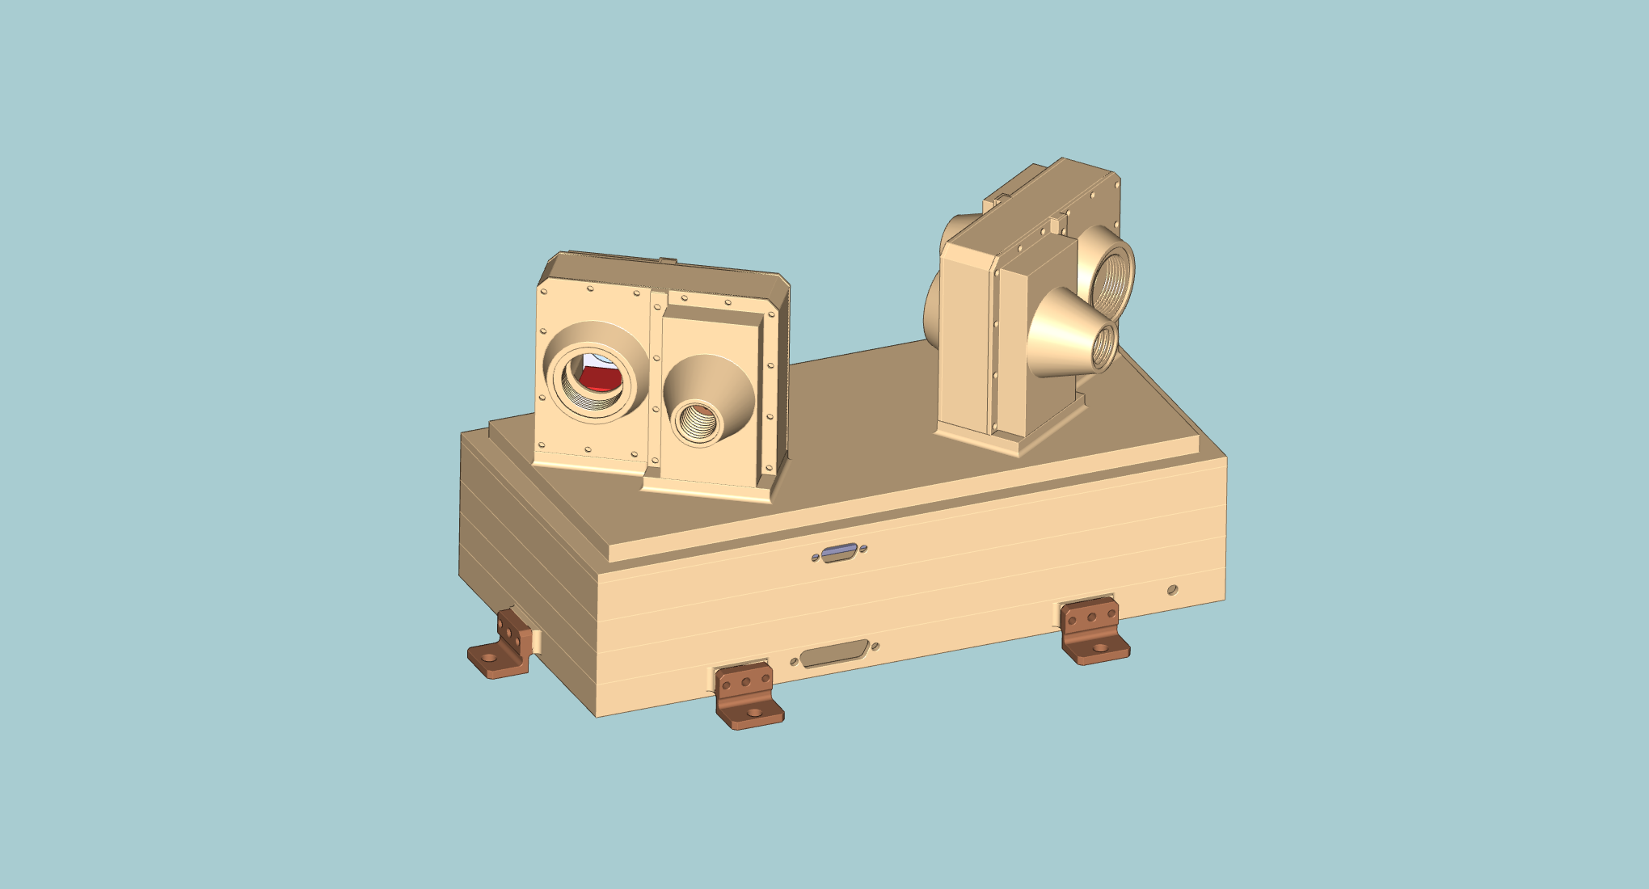

MEPS-A

Sensor

Electronics

Module

MEPS-B

Sensor

Figure 4‑1 MEPS unit CAD-study with two sensor heads, each of which has two double-ended telescopes. One MEPS unit provides eight view cones in total, four for electrons and four for ions.

The two ends of a telescope observe electrons and ions, respectively. Each telescope consists of a stack of three solid-state detectors (Figure 4‑2). On one end, the outer detector is covered with a thin polyimide layer, stopping ions below a few hundred keV/nuc but letting electrons pass almost unaffected. This uppermost detector (500 μm thick Si) on this side is operated in anticoincidence with the second (middle) detector and thus observes the energy spectrum of stopping electrons. The other end of the telescope has a broom magnet (instead of a PI layer) that defects electrons below a few hundred. This side of the telescope employs a 20 μm thick Si detector in front of the 300 μm Si detector in the middle, which thus form an ion telescope observing at energies from 100-6000 keV/nuc. Ions passing the thin first detector can be identified at high energies (MeV/nuc range) using the d E/dx vs. E technique, operable at Ekin ≥ 1 MeV/nuc for protons and alphas and ≥ 2 MeV/nuc for heavier species. Lower ion energies can nevertheless be resolved using the middle detector as an anticoincidence: Anything above 1.2 MeV energy deposit in the thin detector is heavier than protons, which in return means that the thin detector may be used as a Z ≥ 2 channel SSDs for deposited energies > 1.2 MeV (or 300 keV/nuc for He). The same logic applies for penetrating He, enabling a Z ≥ 6 channel for energies > 4.8 MeV; or 420 keV/nuc for C, 360 keV/nuc for N and 310 keV/nuc for O.



Figure 4‑2 Working principle of an EPE double-ended telescope. The polyimide layer stops ions but lets electrons pass, whereas on the other side electrons are deflected by magnets and ions pass unaffected. The thin detector on the right side enables the separation of different ion species via the d E/dx vs. E-method (in the MeV/nuc energy range; for the separation at lower energies see text).

The permanent magnets of one sensor head (double-ended telescope pair) form a quadrupole, significantly reducing the far field. The far field is reduced even further by the other sensor head on the same unit, since its quadrupole forms an angle of 70° with respect to the first sensor head. One MEPS unit integrates the sensors and electronics in a single package. Right below the sensors in the electronic box are the preamp boards, followed by an analogue board and the back-end electronics (digital and LVPS-board[s]). Pre-flight ground energy calibration (1 % level) of all detector elements, on-axis active area calibration, selected off-axis directions active area calibration and dead-time calibration will be performed. Calibration quality will be monitored in-flight using measured data and cross-calibration with suprathermal electron/ion instruments.

## Functional Description

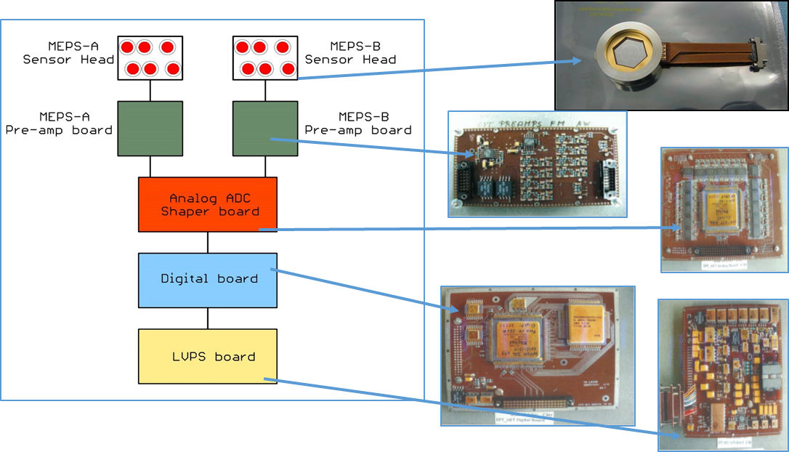

Figure 4‑3 MEPS function description

## Hardware Description

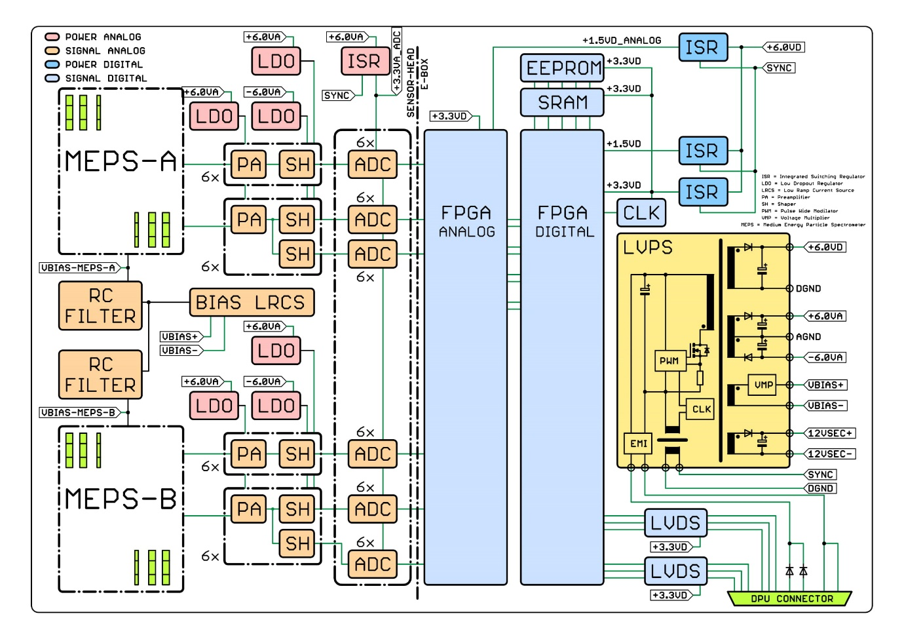

Figure 4‑4 MEPS instrument block diagram

## Software Description

N/A

# INSTRUMENT DESIGN AND INTERFACE REQUIREMENTS

## Definition of Coordinate System for Instrument and Sub-Units

TBD

### Instrument/Unit Physical Reference Frame

TBD

### Instrument/Unit Alignment Reference Frame

TBI

### Instrument Line of Sight Reference Frame

TBI

## Instrument Location, Alignment and Pointing

### Instrument field of view

The MEPS unit has two sensor heads on top of it. Each sensor head has 2 telescopes. Each telescope has a forward and backward looking detector stack, where one direction measures electrons and the opposite direction measures ions. Thus, this configuration provides a total of 8 FoVs per unit (see Figure 5‑1). Each FoV covers a full opening angle of 45°. The viewing directions of the two sensors form an angle 70° to cover the pitch angle distribution.

The current geometrical factor of the MEPS unit is 0.1 cm2 sr for the electron telescope and 0.09 cm2 sr for the proton-ion telescope.

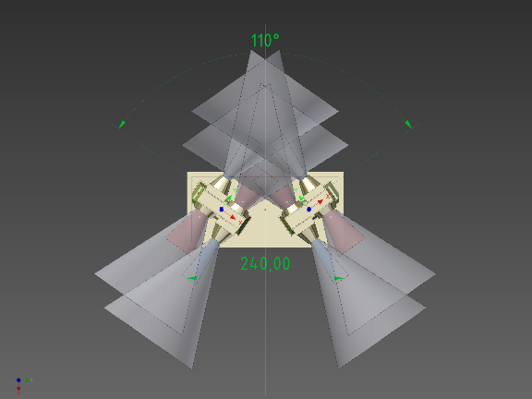

Figure 5‑1 MEPS FoV configuration.

The spacecraft coordinate system is showed in Figure 5‑2.

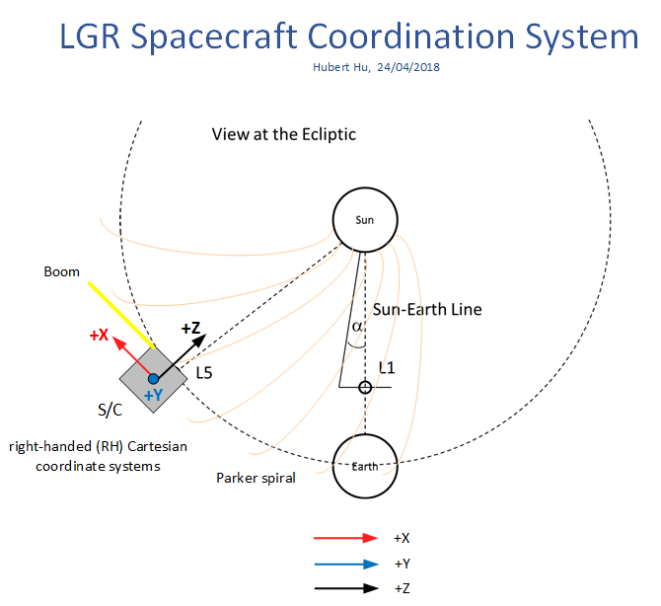

Figure 5‑2 S/C coordinate system

### Instrument Location

The accommodation of the MEPS unit on the S/C is not easy, but preliminary studies showed that the following two configurations are feasible (see Figure 5‑3):

* Position 1 (orange figure): vertex of S/C planes –X, +Y, -Z
* Position 2 (green figure): vertex of S/C planes –X, -Y, -Z



Figure 5‑3 Two possible S/C positions to accommodate the MEPS unit on the OHB S/C model

The main forward-backward FoV (T1 and/or T3) is pointing in the direction of the nominal Parker spiral (45°). On the upper position (orange), the FoVs are nearly coplanar to the orbital plane and on the lower position (green), the FoVs are nearly perpendicular to the orbit.

Since the STEREO SEPT team have found that the four STEREO/SEPT FOVs are insufficient, The MEPS team has proposed two units instead of one (accommodated on the above mentioned S/C positions) providing almost 6 independent FoV and provide a good coverage on pitch angle distribution and a reasonable detection of the event onsets (see trade off studies).

From the functional (and thermal) point of view, the two positions shown in Figure 5-3 are optimal regarding these three aspects:

* Totally unobstructed fields of view.
* The units are easier to protect from direct sunlight with a global or local S/C sun-shield
* Even when the DC magnetic field requirements from MAG are expected to be fulfilled in almost any accommodation position, these positions offered the maximum distance between MAG and MEPS

After the PCR meeting, ESA does not recommend MEPS to be mounted at the back corner of S/C.

Other less optimal positions on the front part are shown in Fig 5-4:

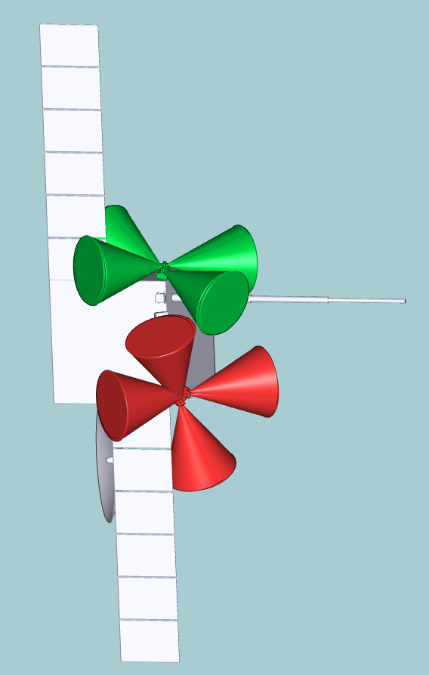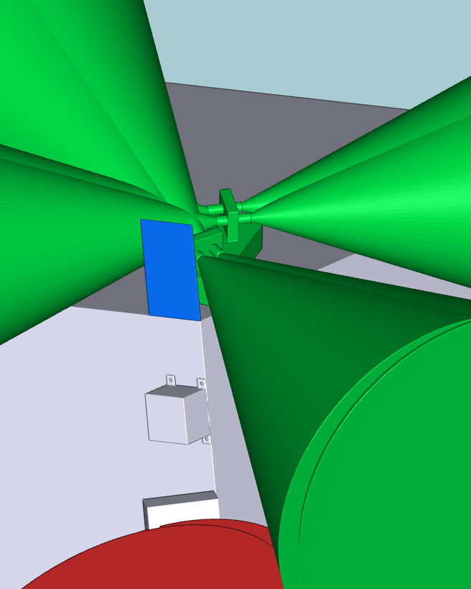

Figure 5‑4

Left:Other two front S/C positions to accommodate the MEPS unit. Please note that this CAD corresponds to the Airbus proposed S/C

Right: Example of local sun-shield for the “green” position. This sun-shield avoids the illumination of a great part of the MEPS instrument during normal operation.

In these two front positions, the unit is exposed to direct solar illumination in steady state. The unit thermal control systems will need to cope with this excess of heat by means of radiators and MLI or the installation of a local sun-shield. The main drawback of these positions is the direct sun illumination on some of the instrument collimators. The direct solar illumination on the instrument will have  a performance impact. If the instrument collimator and/or detector receives solar illumination, the leakage current induced in the detector will increase and the signals will become noisy and unusable. Thus, the unit collimators cannot receive direct illumination during nominal operation. The unit shall be switched off during manoeuvres.

The most susceptible collimators to the sun light are those for the proton-ion telescopes because the detectors are facing open space. The electron telescopes make use of a thin foil to filter the entrance of protons. This foil can also avoid or minimize sun light reaching the detectors. Since the sensor design is such that an electron-telescope is always co-aligned parallel to an ion-telescope, there are scarce possibilities to have an accommodation where only one of the co-aligned telescopes receives light, but not the other.

In the configuration shown in figure 5-4, the installation of a small local sunshield to avoid light entering in the proton-ion collimator seems to be possible. See figure 5-4 right screenshot.

The collimators in the red configuration are more difficult to protect due to the special orientation and the presence of the solar panel.

It is important to note that in the “green” configuration, the unit is mounted by means of a dedicated bracket on the +Y panel while in the “red” configuration the unit is on the +X panel. The position on the +Y panel allows the installation of a distance local sun shield to cover the collimators and most of the unit. This is not possible for the unit on the +X panel due to the collision of the main Parker FoV with any potential distance local sun shield. The solutions for the “red” case are thus not easy to find due to this fact as well as the position of the solar panel and the high gain antenna.

|  |  |
| --- | --- |
| **Req - ID** | **Description** |
| MEPS-ICDSC-2001 | The MEPS shall be mounted outside of the S/C. |
| MEPS-ICDSC-2002 | The MEPS shall be located away from straylight. The induced leakage current due to straylight on the MEPS detectors shall not exceed 0.1nA (TBC) |
| MEPS-ICDSC-2003 | Direct sunlight shall not illuminate the apertures of the MEPS collimators to avoid extra-noise in the detectors. The preferred option is to keep the MEPS instruments in shadow to make the thermal design easier and to avoid detector noise due to optical photons reaching the semiconductor detectors. |

### Pointing and Co-alignment Requirements

Due to the nature of measurements and intrinsic angular resolution, MEPS does not have strict alignment or pointing stability requirements. Nor do the MEPS sensors have strict pointing requirements relative to each other. Alignment/pointing accuracy of <2° (knowledge 1° (on ground)) is sufficient for all MEPS sensors relative to each other. Alignment with this accuracy is expected to be possible by mechanical design.

MEPS alignment/pointing accuracy w.r.t. S/C reference frame shall be better than 2° with knowledge on ground better than 1°.

The UFoV (Unobstracted FoV) shall be 90% of the FoV as a minimum for MEPS, meaning that up to 10% of the solid angle could be obstructed for each of the 8 FoVs of the unit (TBC)

MEPS is susceptible to straylight. Especial care shall be put on the instrument accommodation and placement of yokes, solar arrays and other S/C structures to avoid reflected light to instrument openings. The induced leakage current due to straylight on the MEPS detectors shall not exceed 0.1nA (TBC)

|  |  |
| --- | --- |
| **Req - ID** | **Description** |
| MEPS-ICD-2101 | The two modules on MEPS unit shall form a 70° (TBD) angle. |
| MEPS-ICD-2102 | MEPS alignment accuracy w.r.t. S/C reference frame shall be better than ±2° with knowledge on ground better than ±1°. |

|  |  |
| --- | --- |
| **Req - ID** | **Description** |
| MEPS-ICDSC-2201 | One of the MEPS FoVs shall point in the direction of the nominal Parker spiral (45°). |
| MEPS-ICDSC-2202 | The pointing accuracy shall be < ±2°. |
| MEPS-ICDSC-2203 | MEPS shall have a pointing knowledge better than ±1°. |

|  |  |
| --- | --- |
| **Req - ID** | **Description** |
| MEPS-ICDSC-2301 | Intrinsic FoV per sensor  45° cone full opening angle |
| MEPS-ICDSC-2302 | Unobstructed FoV per sensor  90% of the intrinsic FoV. Case by case assessment is needed in case of FoV obstruction (nominal Parker direction is the most important FoV and should be unobstructed, ion telescopes should not be unobstructed due to the already small geometrical factor) |
| MEPS-ICDSC-2303 | One MEPS unit contains 2 sensors. Each sensor has two double FoVs.  Every sensor’s unobstructed FoV shall be met by the S/C. |

## Mechanical Interfaces and Design Requirements

The latest mechanical design is shown in Figure 5‑5. More detail can be found in the CAD module provided in step format.

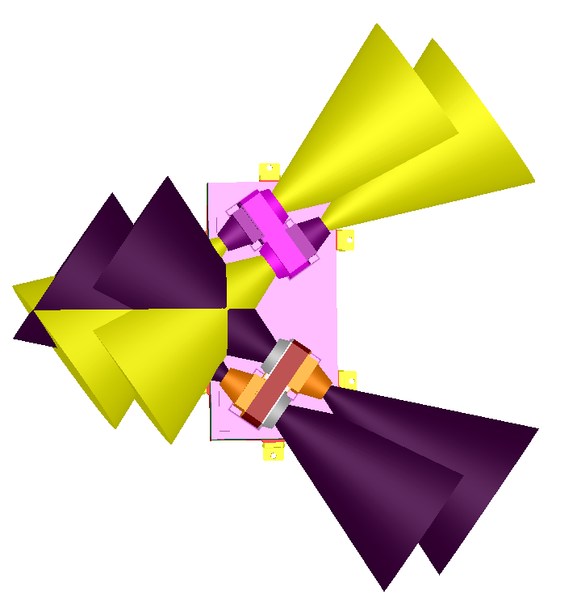

Figure 5‑5 MEPS mechanics CAD module top view

The mass breakdown of the instrument is shown in the Table 5‑1



Table 5‑1 MEPS instrument mass breakdown analysis

Note: This table is for one unit.

### Mechanical Interface

TBD

### Mass and Mass Tolerances

TBD

### Centre of Mass

TBD

### Moments of Inertia

TBD

### Unit Dimensions

The current unit dimensions are 300x160x175 mm3. These dimensions are based on the current CAD model adding 2 cm margin on each side for future incorporation of MLI and radiators.

### Instrument Mounting

TBD

### Feedthroughs

TBD

### Doors

None

### Boom

None

### Baffles

None

### Venting

TBD

### Instrument Generated Disturbances

The compensated magnet system which will be used in MEPS is inherited from the compensated magnet system which is used in Solar Orbiter EPT-HET1&2 and STEP. All these units passed the stringent DC Magnetic field requirements as well as extensive H-field characterization.

The following magnetic requirements are examples from Solar Orbiter project which Kiel units are compliant with them:

Maximum permitted magnetic dipole = 10 mAm^2

Maximum permitted dynamic DC magnetic field measured at 1m = 18 nT

Maximum permitted periodic transient measured at 1m = 110 pT

## Thermal Interfaces and Design Requirements

### Definitions

The baseline assumptions for the MEPS unit thermal design are the followings:

(a): MEPS is an external insulated unit: A unit with a weak thermal link to the spacecraft. A unit that is attached to the S/C via a bracket and wrapped in MLI is an insulated unit.

(b): MEPS is externally mounted unit: A unit located outside the S/C main body and radiatively coupled to deep space and the S/C external elements.

(c): MEPS uses S/C controlled survival heaters: MEPS will require a separate control line (harness) in order to control the temperature of the unit based on the unit survival compartment temperature sensors output and the unit survival heaters. These are designed as part of the unit thermal control subsystem and will be monitored and controlled by the S/C thermal control system.

Please note that if the abovementioned assumptions are not applicable, the unit thermal design concept may change. This can be limited to the passive thermal control design or may result to a change from passive to an active thermal control design.

The operational temperature limits for the MEPS interface with the S/C, i.e. the mounting bracket temperature are indicated in the following table:

Table 5‑2 Temperature limits for MEPS interface with S/C

|  |  |  |  |
| --- | --- | --- | --- |
| **Non-op (min), deg C** | **Non-op (max), deg C** | **Operational (min), deg C** | **Operational (max), deg C** |
| -40 | 50 | -40 | 50 |

In addition, in order to make the thermal design simple, it is required that MEPS does not receive direct solar illumination in steady state. It is especially important avoiding sunlight illumination in steady state on the MEPS collimators. This illumination will create noise on the silicon detectors and will make them unusable. In case of transient illumination on the collimators during S/C manoeuvres, the MEPS unit shall be switched off.

Therefore, it is highly recommended that S/C guarantee shadow at the location of MEPS. This can be done either by using a global heat shield like what is done in Solar Orbiter or by using local sunshades on the S/C structure.

|  |  |
| --- | --- |
| **Req - ID** | **Description** |
| MEPS-ICDSC-4001 | The MEPS operating and non-operating temperature with respect to TRP shall be as defined in Table   | Operating temp | | Non-operating temp | | | --- | --- | --- | --- | | min | max | Min | max | | -40°C | +50°C | -40°C | +50°C | |
| MEPS-ICDSC-4002 | The MEPS shall be mounted outside of the S/C as a thermally insulated unit. |
| MEPS-ICDSC-4003 | The MEPS collimator apertures shall not receive direct solar illumination in steady state, e.g. in a shadow. |
|  |  |
|  |  |
|  |  |

### Thermal Control

A passive thermal control design is foreseen for MEPS instrument. For the passive thermal design, external radiators or radiative surfaces are considered for dissipating the internal power of the instrument to space. Independent power budgets for the operational and non-operational (survival) heaters are required. The required power depends on the S/C and mission environmental conditions in different mission phases. An estimation of the necessary operational and survival heater power budgets is given in the following table:

Table 5‑3 Operational and survival heaters power budget estimation for MEPS.

|  |  |
| --- | --- |
| **Survival, W** | **Operational** |
| 3 W (average) or 6W (max with 50% duty cycle) | 2 W |

The unit thermal design main objective is to keep all of the unit parts inside their operational temperature limits. In addition, it is important to keep the detectors as cold as possible for the better performance. Therefore, as a general approach the unit thermal design architecture is based on dissipating the electronics power via radiators to the deep space. At the same time, the MLI will be used to keep the unit insulated from the radiative environment.

The MEPS detectors can work in the unit operational temperature range between -40 degC to +30 degC (TBC). The objective of the MEPS thermal design is to keep the detectors as cold as possible (below 0°C especially the 20um ion front detector) while fulfilling the other design requirements.

The use of 2W operational heaters (controlled by the DPU or the MEPS unit itself) is TBC until a more detailed S/C thermal environment and instrument accommodation is provided.

|  |  |  |
| --- | --- | --- |
| **Req - ID** | **Description** | |
| MEPS-ICDSC- 4101 | | MEPS requires a survival heater during instrument non-operating period.  The power budget of the heater will be the outcome of S/C and mission environment conditions in different phases.  Peak power: TBD  Average power: 3W or 6W(max with 50% duty cycle) |
| MEPS-ICDSC- 4102 | | S/C shall be responsible to operate the survival heater and the monitor thermistors. |
| MEPS-ICDSC-4103 | | S/C shall define the thermal control interface and harness.  Instrument shall allocate space for the interface. |
| MEPS-ICDSC-4104 | | Instrument shall define the location of the survival heater and the thermistors with confirmation from S/C. |
| MEPS-ICDSC- 4105 | | MEPS requires an operation heater during instrument operating period.  The power budget of the heater will be the outcome of S/C and mission environment conditions in different phases.  Peak power: TBD  Average power: 2W |
|  | |  |
|  | |  |

### Thermal Interface Design

The main interfaces for the unit thermal design with the S/C can be defined as following:

* Conductive interfaces:

All of the interfaces with the mechanical joints between the unit and the S/C or S/C mounting bracket. The unit thermal design itself includes low conductive materials such as Titanium or composites like ULTEM between the unit and the unit mounting bracket. The main sources of the conductive heat transfer between the unit and the S/C are the interface bolts, grounding strap and the harnesses. The effect of all of these will be considered in the thermal design process in order to keep them minimum.

* Radiative interface:

In addition to the deep space itself, all of the S/C elements which have a view factor with the unit can be considered as the radiative interfaces. Depending on the temperature, location, area and the thermos-optical properties of these elements the radiative coupling between the unit and the S/C will be calculated. A rough estimation of this coupling is important at early stages of the design, especially for deciding about the unit faces, which accommodate the radiators.

* Survival heaters control interface:

As mentioned before in Sec. 5.4.1, we assume that there will be a “S/C controlled” line to operate the survival heaters when the unit is switched OFF. The definition of the interface regarding the available budget and the type of the temperature sensors are important to be agreed between the unit and the S/C.

### Thermal Hardware Interfaces

The foreseen thermal hardware for the passive thermal design, consist of radiators with OSR (Optical Solar Reflector), SSM tapes (Second Surface Mirrors), MLI (Multi-layer Insulation), optical paintings, insulating material etc.

Depending on the decision of the mounting bracket, there will be also HW interface between the unit and the S/C mounting bracket in terms of the MLI. It is important to define which parts need to be covered with MLI, e.g. harnesses, mounting bracket, purge pipe (if any), Grounding strap(s) etc., except the unit itself.

## Electrical Interfaces and Design Requirements

[System inputs:]

The general requirement for electronics design on each instrument and DPU is

* All the EEE component shall be fully qualified (selected from the established list QPL, EPPL, QML etc). For passive components, failure rate R mil-spec is allowed. If any key component is outside of the list, an agreed upscreening program shall be performed.
* All the EEE component must meet the ECSS-Q-ST-30-11C derating rule. Exception must be highlighted and agreed by the system.
* The data interface design must be unified, e.g. the reference design circuit and key component selection should be compatible to system recommendation.
* The instrument grounding scheme must be compatible to the system grounding scheme.
* Instrument power and data interface will be defined by the system.
* No failure propagation is allowed from instrument to instrument.
* Instrument with multiple sensor and FEE should be designed in such a way that one sensor or FEE failed won’t affect the operation of the other sensor and FEE.

### Instrument Power

MEPS will use a customized DC-DC convertor to provide all the secondary rails required by the instrument.

Some technical information about the DC-DC convertor is listed below:

* The voltage converter for the low voltage power supply (LVPS) is a flyback converter topology build with the Pulse width modulator(PWM).
* The clock frequency of the PWM generator is externally synced to 125kHz switching frequency (250kHz external sync). This frequency will be generated by a crystal oscillator with 2MHz. With this frequency divider the frequency of 1MHz for the secondary switching regulators (MSK5059) will be provided also. A common mode choke will be used as transformer to provide these switchers with external sync frequency.
* The PWM and the secondary switchers has adjusted frequency of around 75% of the desired and will be trimmed to the desired. So, when external sync to the wished fails, these regulators will run anyway.
* The flyback converter is regulated to a secondary output on the primary side, which will provide the PWM itself and the crystal oscillator with its frequency divider. So, no optocoupler is needed in this configuration.
* The outputs of the positive and negative analog voltages of the flyback converter has a down streamed LDO to minimize noise and provide a stable voltage for the further boards.
* The analog voltage for the ADCs(3.3V) will be provided by a switching regulator also, with an additional passive filter.
* The digital voltages will be provided by switching regulators (Vcore for FPGA 1.5V, VDigital IO 3.3V).
* There are two 12V output secondary voltages. One is the operating voltage of the PWM and clock along with the frequency divider and the second secondary12V is for the internal heaters if necessary.

The power budget deep analysis is shown in Table 5‑4

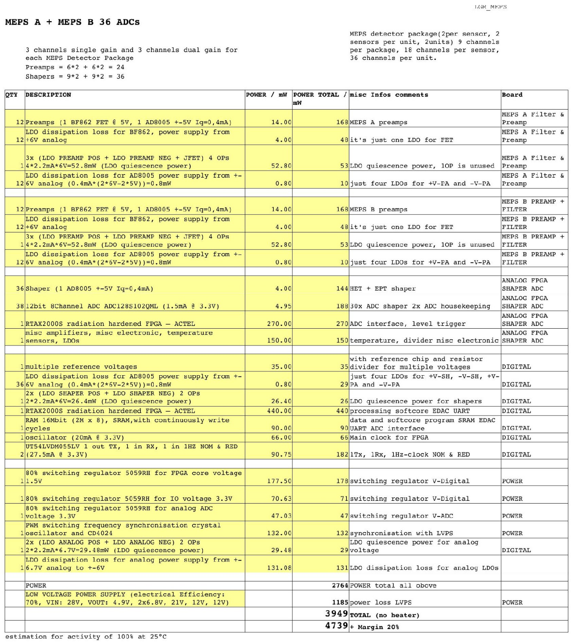

Table 5‑4 MEPS instrument power budget. One unit.

### Data Handling Electrical Interfaces

Refer to DPU ICD

### Harness and Interface Connectors

Refer to DPU ICD

### Instrument Grounding Scheme

MEPS local grounding scheme is shown in Figure 5‑4:

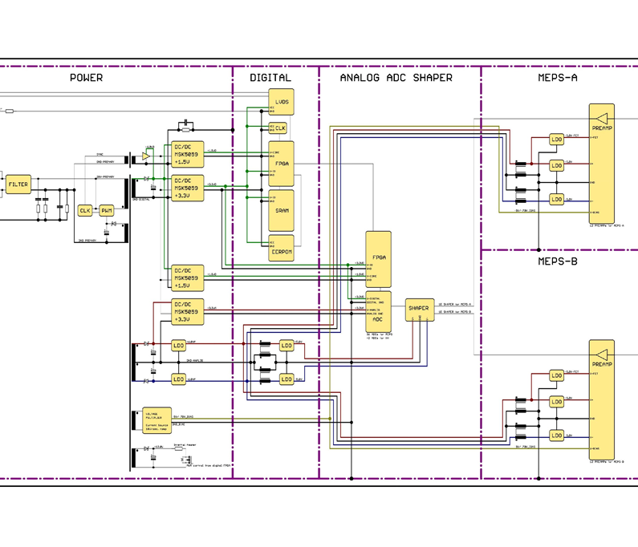

Figure 5‑4 MEPS local grounding scheme

## Data Management Interface and Design Requirements

### General

A MEPS unit can be commanded by either

* LVDS signals through a UART operating at 115,200 baud
* SpaceWire (SpW) at 12Mbps (under development)

In case of SpW communication, the unit accepts spacewire packets with a hardwired address and protocol id as command messages. The bytes following address and pid are parsed as commands (see Sec. 5.6.2).

The unit transmits STF packets (see Sec. 5.6.3) encapsulated in SpW packets with a hardwired address and protocol id prepended to the bytes of the STF packet.

The address and protocol id currently hardwired in the code are

* **0xfe 0xfc** for command messages
* **0xfe 0xfd** for STF packets

These are TBC, and can be changed.

### Instrument Command and Control

All operations of MEPS can be controlled via formatted command messages. A command message consists of

* 16-bit sync word
* 2-bit size tag
* 14-bit address
* 0-bit/16-bit/32-bit/64-bit data word
* 16-bit CRC (CRC-16/CITT)

The address identifies the recipient of the message, and the size controls how many bits of the data payload are interpreted. Only as many data words as specified by the size tag are to be transmitted:

* 0: zero bits
* 1: 16 bits
* 2: 32 bits
* 3: 64 bits

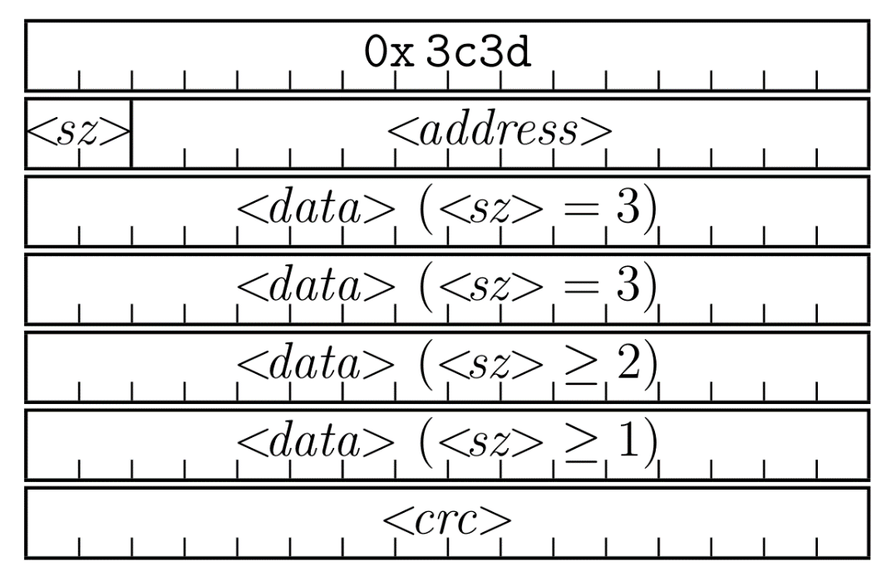

Figure 5‑5 MEPS sensor command message format

### Instrument Telemetry

MEPS TM will be emitted in form of a Sensor Transfer Frame (STF) format previously used for the EPD sensors on Solar Orbiter. A STF packet consists of

* 32-bit sync-word (0xbebacafe)
* 16-bit payload size (n bytes of data + 4)
* 16-bit APID (encodes the STF sender and intended receiver)
* n*8-bit of data payload
* 16-bit CRC (CRC-16/CITT)

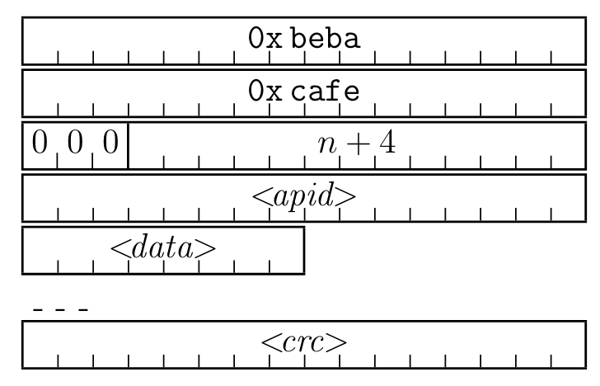

Figure 5‑6 MEPS STF packet format

TM from MEPS includes scientific data products, consisting of histograms of measured particle events (spectra) and Pulse-Height-Analysis (PHA) data. In addition to that, housekeeping and auxilliary data (counters) will be telemetered.

A science data product consists of count rates of specific particles in an energy channel, particle spectra. These spectra can be sent in compressed or uncompressed fashion. The compression takes into account the poissonian statistics of the measurement process, and reduces the telemetry requirement of particle spectra.

A PHA record consists of “raw” event data. Only a statistical subsample of all events analyzed will be telemetered as PHA data. The main purpose of PHA data is diagnostics, to ensure nominal operation and check the particle spectra generation.

Housekeeping (HK) data contains voltages, currents and temperatures of various parts of the sensor, and are critical to monitor the operation of the unit. In addition the status of the configuration is telemetered.

Auxilliary data contains several internal counters. This data is useful for further diagnostics.

MEPS does not require the DPU to perform any analysis of the scientific data. It will be advantageous for the DPU to store scientific data sent by MEPS into internal buffers to allow better control of the telemetry. The DPU can monitor some parts of the HK or auxiliary TM to control and check the nominal operations of MEPS.

A TBC allotment of MEPS telemetry is shown in the following table:

Table 5‑6 MEPS instrument data product summary (for 2 MEPS units)



### Time and Synchronisation

No instrument require SYNC signal to synchronize the power supply switching and electronics readout.

But understand DPU shall circulate a time sync TC to every instrument every TBD min.

### Inter-Instruments Communication

Not required by any instrument so far

### Electrical Interfaces and Redundancy

Refer to DPU ICD

### Bus Interface

Refer to DPU ICD

## Instrument Handling

### Cleanliness

Because of the silicon detectors as well as the sensitive thermal hardware, the cleanliness of the unit is quite important. The unit shall always be handles in an ISO 8 cleanroom or better. The Unit will be assembled in ISO 8 clean room environment and ISO class 6 clean benches before the delivery.

MEPS cleanliness levels at delivery are shown in table 5-7 MEPS cleanliness necessities regarding performance at BOL and EOL are presented in table 5-7 for the different sensitive items

PAC is expressed in ppm, MOC in ng/cm2.

Visibly clean is considered as an obscuration factor smaller than 300 ppm for PAC and A/5 (200 ng cm-2) for MOC

|  |  |  |  |  |
| --- | --- | --- | --- | --- |
| ***MEPS*** | ***Delivery*** | | ***EOL*** | |
| ***PAC (ppm)*** | ***MOC (ng cm-2)*** | ***PAC (ppm)*** | ***MOC (ng cm-2)*** |
| ***Solid State Detectors*** | 300 | 200 | 3800 | 5000 |
| ***Rare earth magnet*** | 300 | 200 | N/A | 5000 |
| ***External surfaces*** | 300 | 200 | N/A | N/A |

Table 5‑7 MEPS contamination requirements derived from performance

**MOC:** Given that 1000 ng/cm² is 10 nm at 1 g/cc. The PIPS dead-layer (Ohmic side) is in the range of 1000 nm at 2.33 (Si) to 2.7 (Al) g/cc. A contamination value below 10000 ng/cm² is acceptable. Including a margin of x2, the value would be 5000 ng/cm². Higher values would act as an additional dead-layer of unknown thickness and will degrade the precision of the energy measurement of solar energetic particles.

Considering the design of the unit, the present values are applicable also to the apertures.

**PAC:** Heritage.

### Physical Handling Requirements

MEPS has sensitive detectors (20um and 300 um thick), sensitive thermal hardware like OSR, SSM and MLI, magnetic sensitive and ESD parts. Hence, the physical handling shall be done by the personnel from the MEPS team or by other personnel but according to the unit provided handling procedure.

The following general precautions shall be respected:

* To apply ESD precautions.
* To apply as minimum ISO 8 cleanliness requirements.
* To use non-magnetic tools if working close to MEPS unit. Note that MEPS contains very strong permanent magnets!
* Do NOT remove unit red-tag covers until integration is finished.
* Do NOT touch SSMs (second surface mirrors).
* Do NOT load MLI standoffs.
* Do NOT load unit purge adaptor unnecessarily.

### Instrument Purging and Contamination Requirements

Depending on the AIT activities, active purging may be required. In addition, BOL (Beginning of Life) and EOL (End of Life) limits are defined in table 5-7 for the unit sensitive surfaces and parts and for the both particular and molecular contaminations.

MEPS presents an opening area of 32 cm2 which is the main entrance to contamination. A purging flow rate of 4l/h of nitrogen is sufficient to keep an overpressure of 0.5 Pa which prevents contamination when covers are applied. MEPS presents one purging inlet and a minimum of 4l/h of nitrogen is required. Maximum allowed flow rate is 60l/h.

During AIT the instrument shall be bagged in nitrogen if red-tag covers are removed and purging is not possible, or the environment shall be otherwise strictly contamination controlled.

MEPS is compatible with an interruption of purging of 6 hours.

Recovery time equals at least the time purge was interrupted.

### AIV Contamination Budget (S/C)

TBD

### Cleanliness and Contamination Control Plan (S/C)

TBD

### Red tag items

The MEPS unit is delivered with red-tag covers installed on both sides of each MEPS sensor, covering in this way all instrument apertures and protecting against contamination. See figure 5-8.

Thus, there is a total of 4 red-tag covers in an MEPS unit. These have been manufactured from Aluminum and are just “hard”. They are easy to handle, remove and install.

These red-tag covers shall be removed before flight and before environmental and accelerator testing (TBC).

The external connectors are protected by dust cups and they are mainly for ESD protection during handling.

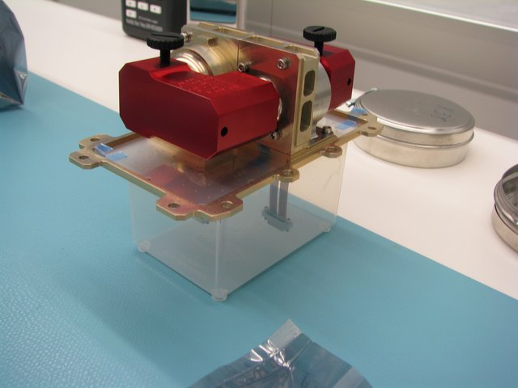

Figure 5‑8 Red-tag covers for one of the MEPS sensors. Picture taken from the Solar Orbiter/EPT instrument.

## Instrument Operations

### Instrument Modes

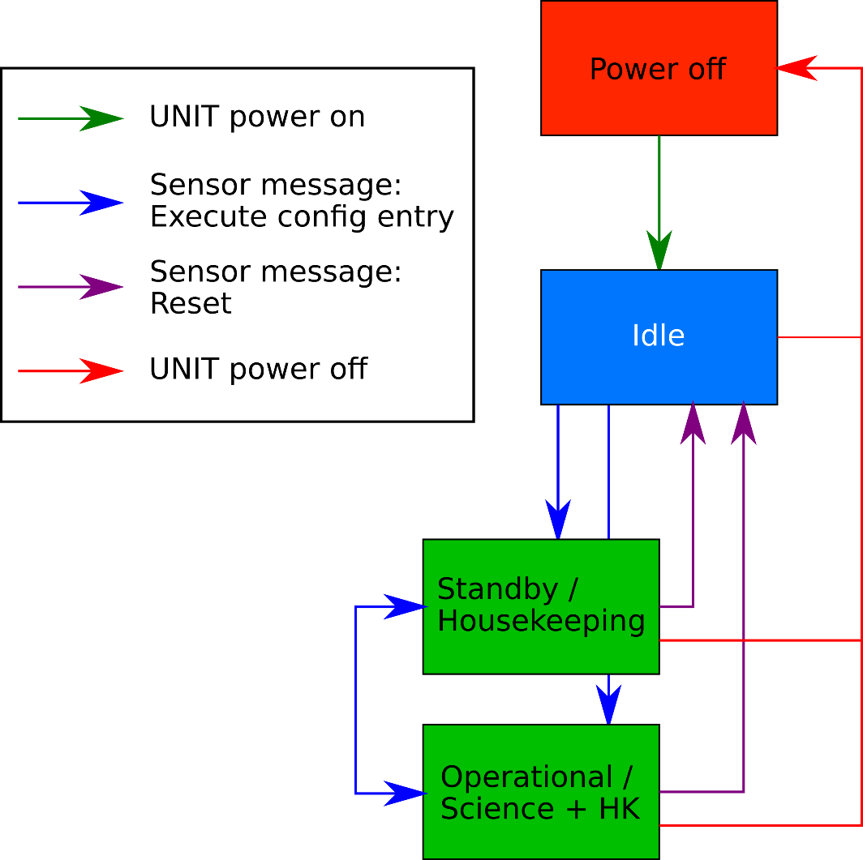

Figure 5‑9 MEPS instrument software operation principle

* **Power off:** Unit is not powered.
* **Idle Mode:** After powering the unit, it will be in this mode. Unit is powered, and can accept commands, but will not emit telemetry. Unit can transition here from any other powered mode by sending a reset command.
* **Standby/Housekeeping:** Can be put from Idle or Operational modes into this mode via commanding. Unit is powered, accepts commands, and emits housekeeping telemetry for monitoring. No science telemetry is generated.
* **Operational:** Can be put from Idle or Housekeeping modes into this mode via commanding. Unit is powered, accepts commands, and emits housekeeping and science telemetry. MEPS can be configured to emit burst science data products in nominal mode. In that case it is up to the DPU how to handle the burst data. Depending on DPU configuration the burst data can be telemered, buffered (for request/telemetry at a later time) or discarded.

### Instruments Operations Support

MEPS can be commanded via command messages as outlined in Sec. 5.6.2. The MEPS team will outline a set of TBC telecommands to allow commanding of MEPS in a general fashion.

### Flight Operations

A large part of the configuration of MEPS is flight-configurable. Specfically the cadence and amount of telemetry can be controlled in a very general fashion by reconfiguring the configuration tables of the unit. The scientific data generation of spectra can be fully reconfigured as well. This adds the possibility to re-configure MEPS during flight in case of anomalies or for measurement campaigns, by using telecommanding as per Sec. 5.8.2.

## Environment

### Ground Environment

#### Contamination

TBD

#### Ground Handling, Transportation and Storage

TBD

#### Verification and Testing

TBD

### Electromagnetic Design and Interfaces

#### General Concept

TBD

#### General EMC/RFC Requirements

TBD

#### Magnetic Cleanliness

TBD

# INSTRUMENT ASSEMBLY, INTEGRATION AND VERIFICATION

## Verification Concept and Methods (at S/C)

**Verification Concept:**

The strategy adopted for verification constitutes a best-possible compromise between schedule, risk, and cost considerations. Noteworthy guiding principles for the approach include:

* The preferred method of verification is test, preferably within the environment under which the article being verified will operate, when feasible. Testing is preferable because:

a) It is a quantitative demonstration of the item being verified.

b) It is insensitive to modeling assumptions.

c) It has the benefit of providing operator experience and testing of adjacent systems.

d) It adds to system reliability by providing hours of operation.

e) It acts as a method of discovery. In other words, one can discover properties about the test item that are beyond the context of the test being conducted.

* Where possible, system requirements verification activities should be conducted and tracked at the highest–possible level of assembly. Testing of top-level performance requirements at the highest level possible brings adjacent systems into play, and thereby more fully addresses and characterizes system-level interactions and behaviors.
* Requirements to be verified via inspection should be closed as late in the process as possible.
* All functional and performance as well as environmental requirements designated for formal verification and closure shall be verified prior to the launch and applicable to the relevant model philosophy.

**Verification Methods:**

The MEPS instrument will employ four primary verification methods to assess functionality and compliance with the requirements:

* Test (including demonstration):

Verification by test involves the direct measurement of performance to show system compliance with a specified requirement.

* Analysis:

Due to cost or physical limitations, some requirements cannot be verified by test, or may not be fully verifiable by testing alone. In such cases, analysis is performed to ensure that the unit will meet its requirements. To the extent practicable, analysis should be validated by correlation to test data.

* Review of design:

Verification by review of design (ROD) consists of using approved records and evidence that shows a requirement is met. For example design documents and reports and engineering drawings can be used in this method of verification.

* Inspection:

This approach applies to requirements that do not describe the performance of the system but instead describe a design characteristic or method. Inspection may also apply to situations where a requirement may be satisfied solely by the review of available documentation or records.

The detailed process of the requirements verification process definition and control will be done based on the multi-lateral agreements between the involved parties. Afterwards, these steps will be defined in the unit engineering plan document or a dedicated AIVT plan document.

## Particular S/C level Testing

TBD

## System Level AIT aspects

TBD